I. Introduction
The CERN Council approved the Large Hadron Collider (LHC) project in December 1994. The LHC will be the next major research tool for particle physics and it is expected to be commissioned in 2006. This new proton beam collider facility will be installed in the existing underground ring tunnel of approximately 27 km circumference at CERN. Within the context of LHC, one of the two major experiments to be built is called CMS (Compact Muon Solenoid).
This experiment, built and funded as an international collaboration between high-energy physics institutes from more than 35 countries and by CERN, consists basically of a massive superconducting magnet equipped with several particle detectors. CMS will be installed around the LHC interaction point I5 in an underground cavern at a depth of 90 meters. Entrance to this area is made via “access shafts” from a surface complex called P5, near the village of Cessy (France). It is expected that the experiment will be operated for at least 15 years.
One of the CMS detectors is the Electromagnetic Calorimeter (ECAL) that in its central region uses 61,200 PbWO₄ crystals to detect energy from penetrating particles which produce scintillation light. The light produced in crystals is transformed into current by two silicon Avalanche Photodiodes (APD) attached to the rear face of the crystals. The signal is then sent to the readout chain for further processing.
The APDs will be biased with a voltage in the order of a few hundred of volts. Biasing is provided by a modular high voltage power supply system located in a control room 110-150 meters far from the detector. Cables will be used to connect the power supply system boards to the ECAL patch panel and from the patch panel to the APDs. The zone between the patch panel and the APDs will be exposed to high radiation doses.

II. Scope of the supply
This specification defines the supply of the cables (HVCABLE in the following) necessary to connect the modular high voltage system to the APDs of the CMS ECAL. The Supplier’s obligations include:
- Cable design and manufacturing
- Connectors procurement
- Cable cutting and labeling
- Connectors mounting and test
This specification describes the baseline characteristics to which the Bidder’s offers must strictly comply in order to be considered a “Conforming Bid”.
The supply is divided in two "packages", named P1 and P2 in section IV of this specification. Each of these two packages can be subdivided in “material supply” and "cabling". The Bidder can restrict his quotation to the packages or sub-packages of his interest . The Bidder is also invited to identify and propose options, specifically where modifications to this specification may lead to substantial technical improvements and/or cost reductions.

III. Technical Description of the High Voltage System

III.1 System Characteristics
The CMS ECAL barrel detector consists of 122400 APDs assembled inside 36 mechanical structures, named Supermodules, containing 3400 APDs each.
The APDs are biased at an average value of 380 Volt, not exceeding 500 V.
Groups of 100 APDs are driven by a single floating High Voltage Channel (called HVC in the following) composed by 4 wires, 2 for the supply ( HV+, HV-) and 2 for sensing the voltage drop over the cable (S+, S-).
Central element of the High Voltage system is a board (HVBOARD) hosting 9 HVCs and the related control electronics. A single female front panel connector on the HVBOARD outputs all the 9x4 HVCs lines.
The entire HV system is composed by 144 HVBOARDs. Four HVBOARDs (36 HVCs) will be supplying one Supermodule, providing the required 34 HVCs (two HVBOARDs using the 9 HVCs and two HVBOARDs using only 8 HVCs) plus 2 spares.
Because of the high radiation dose at the detector, the HVBOARDs will be installed in racks in the accessible control room where radiation is negligible. Cables as well as connectors will be installed in a hostile radiation environment.
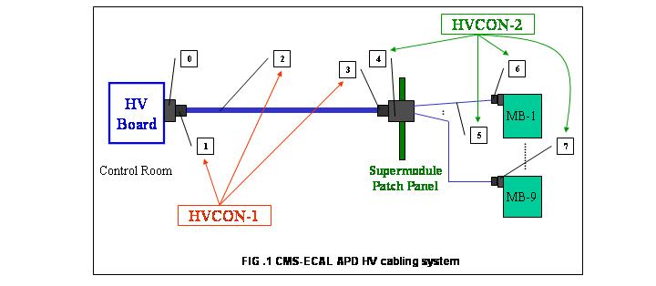
The connection between the HVBOARDs and the APDs is made using a cabling system composed of different parts, as detailed in Fig. 1.
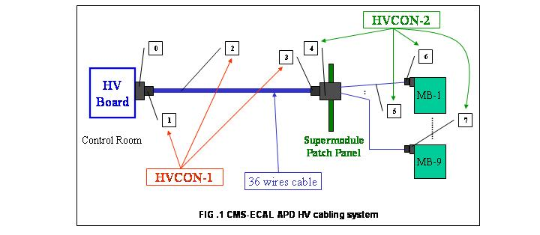

The first connection (HVCON-1) connects the HVBOARD female connector (item 0) with the male connector attached to the Supermodule patch panel (item 4).
Each Supermodule patch panel hosts four connections. The length of the HVCON-1 connection is up to 150 meters.
HVCON-1 is composed of the following elements:
- One male connector (item 1), 36 contacts, to be mounted on the cable (item 2) and plugged on the HVBOARD
- One cable (item 2), 36 wires.
- One female connector (item 3), 36 contacts, to be mounted on the cable (item 2) and plugged on the Supermodule patch panel.
A total of 144 (+ 4 spares) HVCON-1s are required for the entire system.
The second connection (HVCON-2.X) connects the HVCON-1 female connector (item 3) attached to the Supermodule patch panel to either 9 or 8 motherboards (MBs) distributing the HV to the APDs located inside the detector. The length of HVCON-2.X varies from 1 to 5 meters. In the following the approximate lengths are given for the purpose of tendering. Final lengths may differ by up to 20%. The exact measures of each connection will be provided to the Supplier before the production and any resulting cost variation shall be adjusted.
Since either 9 or 8 MBs will be connected through HVCON-2.X, there are two types of this connection, namely HVCON-2.9 and HVCON-2.8 respectively.
HVCON-2.9 is composed of the following elements:
- One male connector (item 4), 36 contacts, to be mounted on the cables (item 5) and plugged on the HVCON-1 female connector (item 3) and fixed on the Supermodule patch panel.
- Nine cables of different lengths (item 5), 4 wires each. The approximate lengths (in cm) are 355, 370, 385, 400, 470, 485, 500, 515, 530.
- Nine pairs of female connectors (item 6), 2 contacts, to be mounted on the cables (item 5) , a pair for each cable, and plugged on each of the MBs male connectors (item 7).
- Nine pairs of male connectors (item 7), 2 contacts, to be mounted on the MBs, a pair for each MB.
A total of 72 (+2 spares) HVCON-2.9 are required for the entire system
HVCON-2.8 is composed of the following elements:
- One male connector (item 4), 32 contacts, to be mounted on the cables (item 5) and plugged on the HVCON-1 female connector (item 3) and fixed on the Supermodule patch panel.
- Eight cables of different lengths (item 5), 4 wires each. The approximate lengths (in cm) are 85, 100, 125, 145, 225, 245, 265, 280.
- Eight pairs of female connectors (item 6), 2 contacts, to be mounted on the cables (item 5), a pair for each cable, and plugged on each of the MBs male connectors (item 7).
- Eight pairs of male connectors (item 7), 2 contacts, to be mounted on the MBs, a pair for each MB.
A total of 72 (+2 spares) HVCON-2.8 are required for the entire system
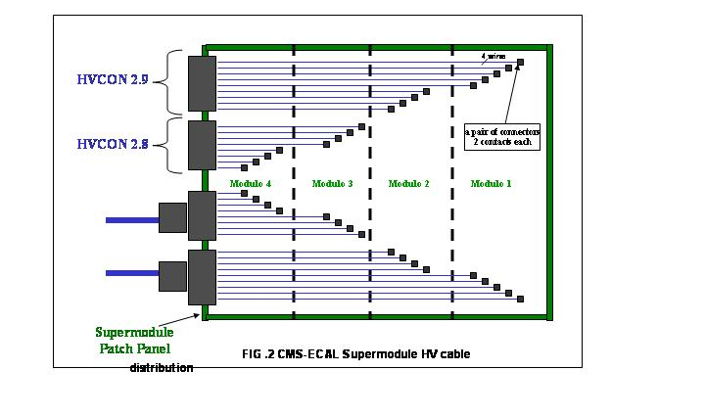
The cable routing of HVCON-2.X from the Supermodule patch panel to the motherboards installed on the four modules comprising a Supermodule is shown in Fig. 2.

The APD high voltage cabling system characteristics are summarized in the following table:

APD High Voltage Cabling System Characteristics
Parameter | Specification | Unit
Maximum Operating Voltage | 500 | V
Maximum Operating Current | 15 | mA
Number of High Voltage Boards (HVBOARDs) | 144
Number of High Voltage Channels (HVCs) per HVBOARD | 9
Number of HVCON-1 | 144 (+4)
Number of HVCON-2.8 | 72 (+2)
Number of HVCON-2.9 | 72 (+2)

All material used must be conform to the
- CERN Electrical Safety Code (C1),
- CERN Safety Instruction 23 (IS 23) regarding the “Criteria for the selection of electrical cables and equipment with respect to fire safety and radiation resistance”,
- CERN Safety Instruction 41 (IS 41) regarding "The use of Plastics and other Non-Metallic Materials at CERN with respect to Fire Safety and Radiation Resistance".
These documents can be found on the internet under: http://tis.cern.ch/.
Cables and connectors are expected to receive a radiation level of 5 kGy and a neutron fluence of 2 x 10¹³ n/cm² with a mean energy of 1 MeV. Before signature of a procurement contract, proposed components must be sent to INFN/Rome for the validation of safety and radiation resistance specifications through the Safety Department of CERN.
The cable Supplier shall perform the following tests on each cable :
- Optical inspection
- Ohmic test
The Supplier shall provide, for each delivery and for each cable, the test results including a description of the instruments used.

III.2 Cable and Connectors Specification
In the following all items described in the previous chapter are specified.

III.2.1 HVCON-1 specification
- HVCON-1 male cable connector (item 1), to be plugged onto HVBOARD
Company AMP :
Part Number (quantity) :
Male Plug Housing : 201310-3 (x1)
Two Piece Shield,:180° Cable Exit, Long 202713-2 (x1)
Corner Guide Socket: 201047-2 (x2)
Corner Guide Pin: 201046-2 (x2)
Long Turnable Jackscrew Female : 201910-1 (x1)
Long Turnable Jackscrew Male : 201911-1 (x1)
Pin 163086-2 (x36)
- HVCON-1 cable (item 2)
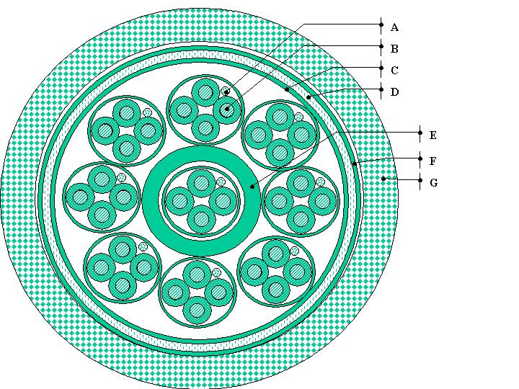
The following sketch (not to scale) shows the cable section. Each element indicated a letter is described below.

Element A: drain wire 0.5 mm²
Conductors: (16*0,2mm) tin plated copper

Element B: 9x4 insulated wires 0.5 mm²
Conductors: (16*0,2mm) tin plated copper
Insulation: TPE-O, halogen free, flame retardant
Colors: Yellow, green, blue, red.
Yellow core printed with black numbers 1-9

Shield: Aluminized polyester tape
Aluminized side to the drain wire, optical coverage 100%

Element C: Shield Aluminized polyester tape
Aluminized side to the braided shield, optical coverage 100%

Element D: Shield braided shield
Conductors: (0,2mm) tin plated copper
Optical coverage 85%

Element E: Inner Jacket TPE-O, halogen free, flame retardant
Color: black

Element F: Binder fire resistant tape

Element G: Outer Jacket TPE-O, halogen free, flame retardant
Color: grey with red band
printed with one black “ECAL APD HV” mark each meter

Electrical Properties
Conductor resistance at 20° C < 40 Ohm/km
Maximum Operating Voltage 500 Volts

Test voltage conductor/conductor 2 kV / DC
Test voltage conductor/shield 6 kV / DC
c’è scritto da qualche parte il massimo d?
c’è scritto da qualche parte il massimo d?

Mechanical Properties
External diameter d < 23 mm
Bending radius
Fixed installation min. 3 × d (d = external diameter)
Flexible installation min. 10 × d

Thermal Properties
Operating Temperature +15 C° to +40 C°

Chemical Properties
Insulation and outer jacket halogen-free at VDE 0472 part 815 / IEC 754-1
Flame retardant in accordance IEC 332-3

- HVCON-1 female cable connector (item 3), to be plugged onto the Supermodule patch panel

Company AMP :
Part Number (quantity) :
Female Plug Housing : 201311-3 (x1)
Two Piece Shield,:90° Cable Exit, Long 202711-3 (x1)
Corner Guide Socket: 201047-2 (x2)
Corner Guide Pin: 201046-2 (x2)
Long Turnable Jackscrew Female : 201910-1 (x1)
Long Turnable Jackscrew Male : 201911-1 (x1)
Socket 163088-2 (x36)

III.2.2 HVCON-2.X specification

- HVCON-2.X male cable connector (item 4), to be plugged onto the Supermodule patch panel

Company AMP :
Part Number (quantity) :
Male Plug Housing : 201310-3 (x1)
Corner Guide Socket: 201047-2 (x2)
Corner Guide Pin: 201046-2 (x2)
Fixed Jackscrew Female : 200875-1 (x1)
Fixed Jackscrew Male : 200874-1 (x1)
Pin 163086-2 (x36)

- HVCON-2.X cable (item 5)
This cable is similar to element B of the cable used in the HVCON-1 (item 2) with the following characteristics:
4 insulated wires 0.34 mm² (AWG 22)
Conductors: (19x0.15mm)tin plated copper
Insulation: TPE-O, halogen free, flame retardant
Colors: Yellow, green, blue, red.
Shield: Aluminized polyester tape
Aluminized side to the drain wire, optical coverage 100%
Outer Jacket TPE-O, halogen free, flame retardant
Color: grey with red band

Electrical Properties
Conductor resistance at 20° C < 60 Ohm/km
Maximum Operating Voltage 500 Volts
Test voltage conductor/conductor 2 kV / DC
Test voltage conductor/shield 6 kV / DC

Mechanical Properties
Minimum bending radius for fixed installation < 30 mm

Thermal Properties
Operating Temperature +15 C° to +40 C°

Chemical Properties
Insulation and outer jacket halogen-free at VDE 0472 part 815 / IEC 754-1
Flame retardant in accordance IEC 332-3
- HVCON-2.X female cable connector (item 6), to be plugged onto the motherboards
Company JST
Model No. (quantity)
Housing BHR-02VS-1 (x2)
Contact SBH-001T-P0.5 (x4)
- HVCON-2.X male board connector (item 7) for the motherboards
Company JST
Model No. (quantity) :
Shrouded Header SM02(4.0)B-BHS-1-TB (x2)

IV. Packages

Bidders are invited to submit their offers for packages and subpackages as defined below.

- Package 1 (P1) concerns the production of 148 HVCON-1

  - Material Supply
- Supply of subpackage 1.1 (PSP11)
Supply of 153 (148 + 5 spare) male cable connectors (item 1) to be connected to the HVBOARD.
Supply of 153 (148 + 5 spare) female cable connectors (item 3) to be connected to the Supermodule patch panel.
- Supply of subpackage 1.2 (PSP12)
Supply of the cable for HVCON-1 (item 2). Quantity to be ordered is between 15 and 22 km.
one

- Cabling
    - Cabling of subpackage 1.1 (CSP11)
- Cable cutting to length which will be exactly specified before signing the order. For tendering purposes the cable length shall be assumed to be between 110 and 150 meters.

- All necessary preparations (i.e. removal of isolation, etc.) and mounting of male cable connectors (item 1) onto cable (item 2).
-
This subpackage includes also the connections of shields on the cables.
- Each cable shall be rolled and properly packaged for transport. The male connectors mounted on the cables shall be safely packaged and protected to prevent damages during transport. Cable label and cable length shall be marked in such a way that it is visible without opening the package.

    - Cabling of subpackage 1.2 (CSP12) [optional]
- All necessary preparations (i.e. removal of isolation, etc.) and mounting of female cable connectors (item 3) onto cable (item 2).

-This subpackage includes also the connections of shields on the cables.
- The female connectors mounted on the cables shall be safely packaged to prevent damages during transport.

This subpackage will not be ordered in case that the female connectors will be mounted in situ during the cable installation activities at the CMS site.

- Package 2 (P2) concerns the production of 74 HVCON-2.8 and 74 HVCON-2.9

  - Material Supply
    - Supply of subpackage 2.1 (PSP21)
Supply of 153 (148 + 5 spare) male cable connectors (item 4) to be connected to the Supermodule patch panel.
    - Supply of subpackage 2.2 (PSP22)
Supply of the cable for HVCON-2.8 and HVCON-2.9 (item 5). Quantity to be ordered is between 3 and 5 km.

    - Supply of subpackage 2.3 (PSP23)
Supply of 1358 (1258 + 100 spares) pairs of female cable connectors (item 6).
Supply of 1358 (1258 + 100 spares) pairs of male board connectors for the motherboards (item 7).

- Cabling
    - Cabling of subpackage 2.1 (CSP21)
- Cable cutting to 17 different lengths which will be exactly specified before signing the order.

- Labeling of both extremities of each of the seventeen four wires cables of HVCON-2.8 and HVCON-2.9. The label will consist of six characters and will be used to identify the module and the MB to be connected. The label shall be printed using a non-wipeable black ink on a short yellow shrinkable sleeve generally used for these purposes.

- All necessary preparations (i.e. removal of isolation, etc.) and mounting of male cable connectors (item 4) onto cable (item 5).
- All necessary preparations (i.e. removal of isolation, etc.) and mounting of female cable connectors (item 6) onto cable (item 5).
- This subpackage includes also the connections of shields on the cables.

- Cables shall be grouped in suitable quantities and properly packaged for transport. The connectors mounted on the cables shall be safely packaged and protected to prevent damages during transport. Cable labels and cable lengths shall be marked in such a way that it is visible without opening the package.

