CMS
Document
2002-018
DOCUMENT

ECAL
EC-ENDCAP

CMS ECAL EDR-6

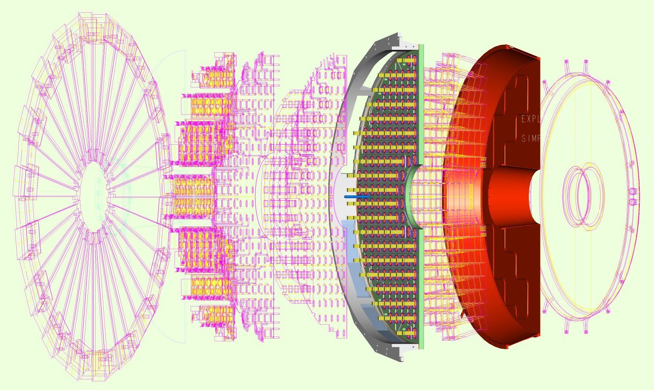

ECAL Endcaps – Major Mechanics
Submitted by J Greenhalgh
CERN September 3, 2002

