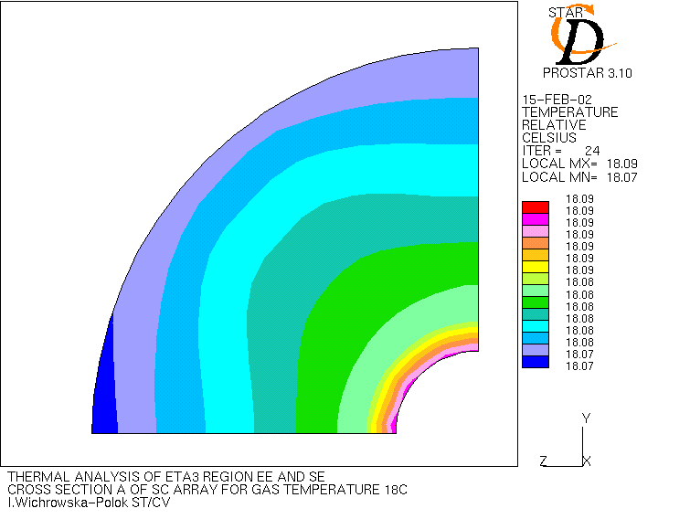 | 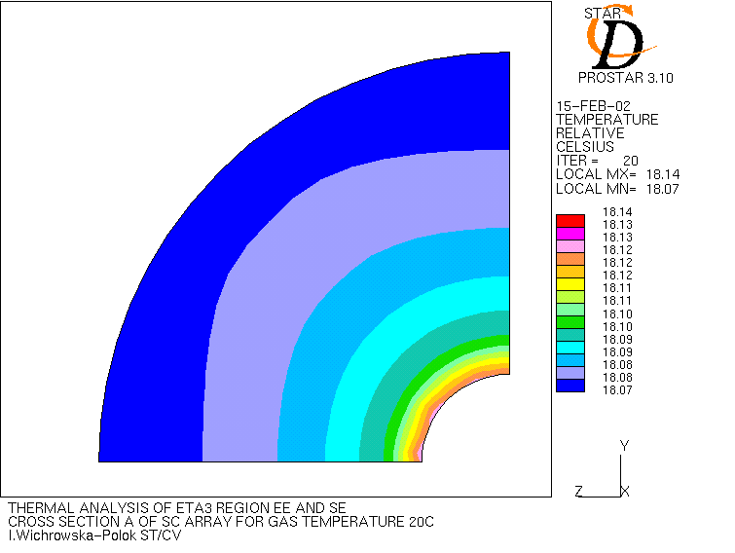
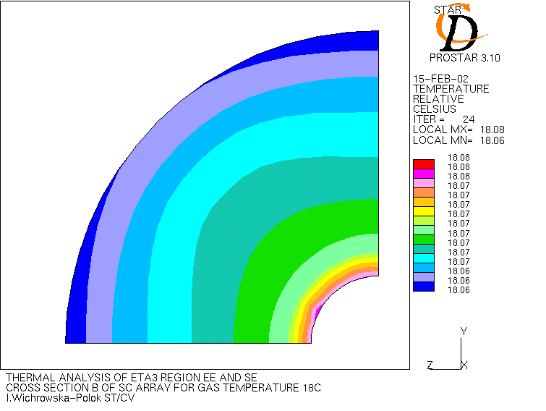 | 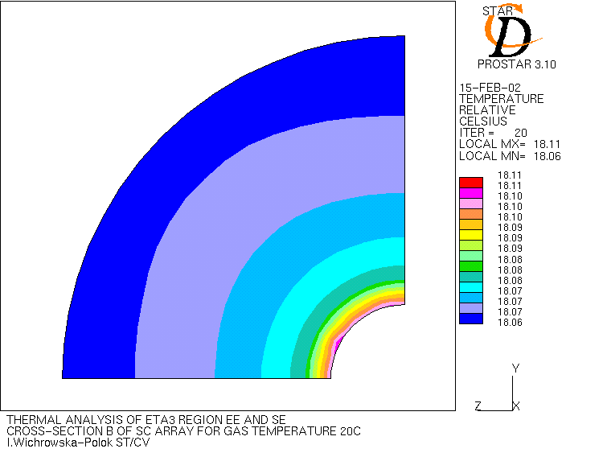
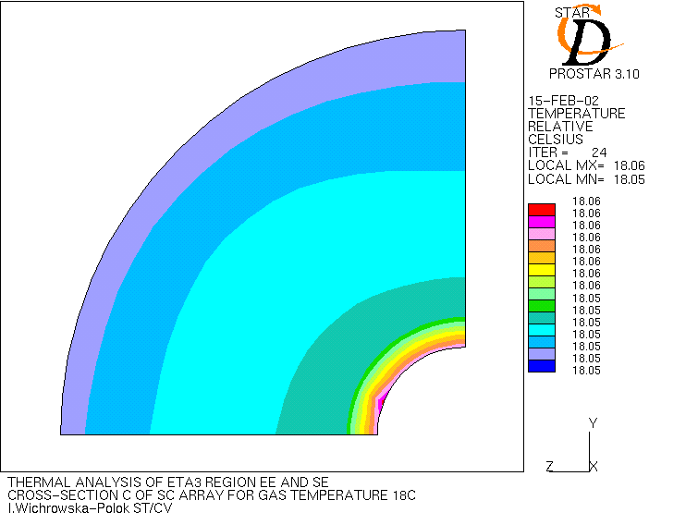 | 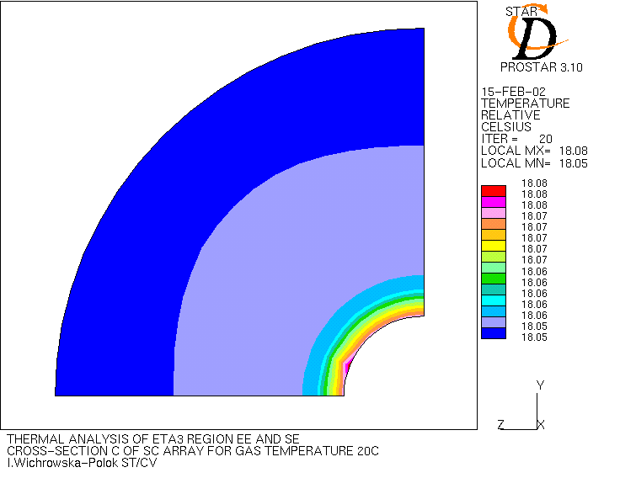
Figures present the cross-sections of SC array for nitrogen temperature 18ºC(on the left) and 20ºC (on the right (case without insulation of SE cone).
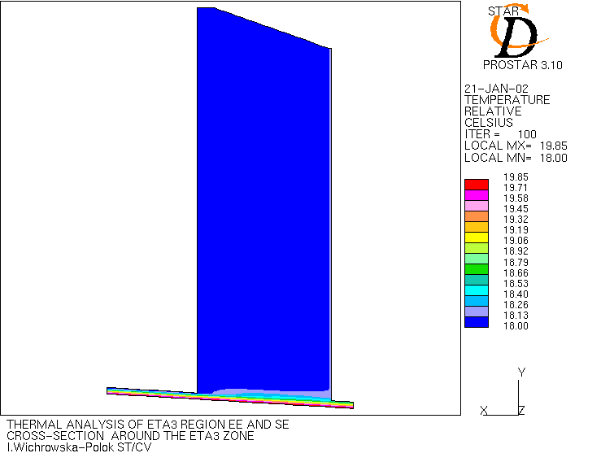

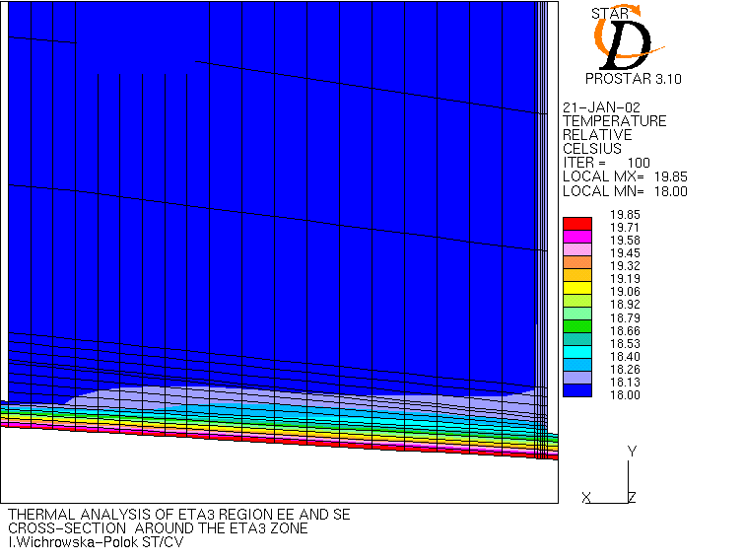

Figures present the cross-sections of the eta3 zone for the case with insulation. We can observe the effect of the insulation. The 5 lowest layers represent the insualtion layer. The next layer is SE cone. It can be seen, that maximal temperature of SE cone is only 18.5ºC. For the air sourrouding SC array maximal temperature is about 18.3ºC.

