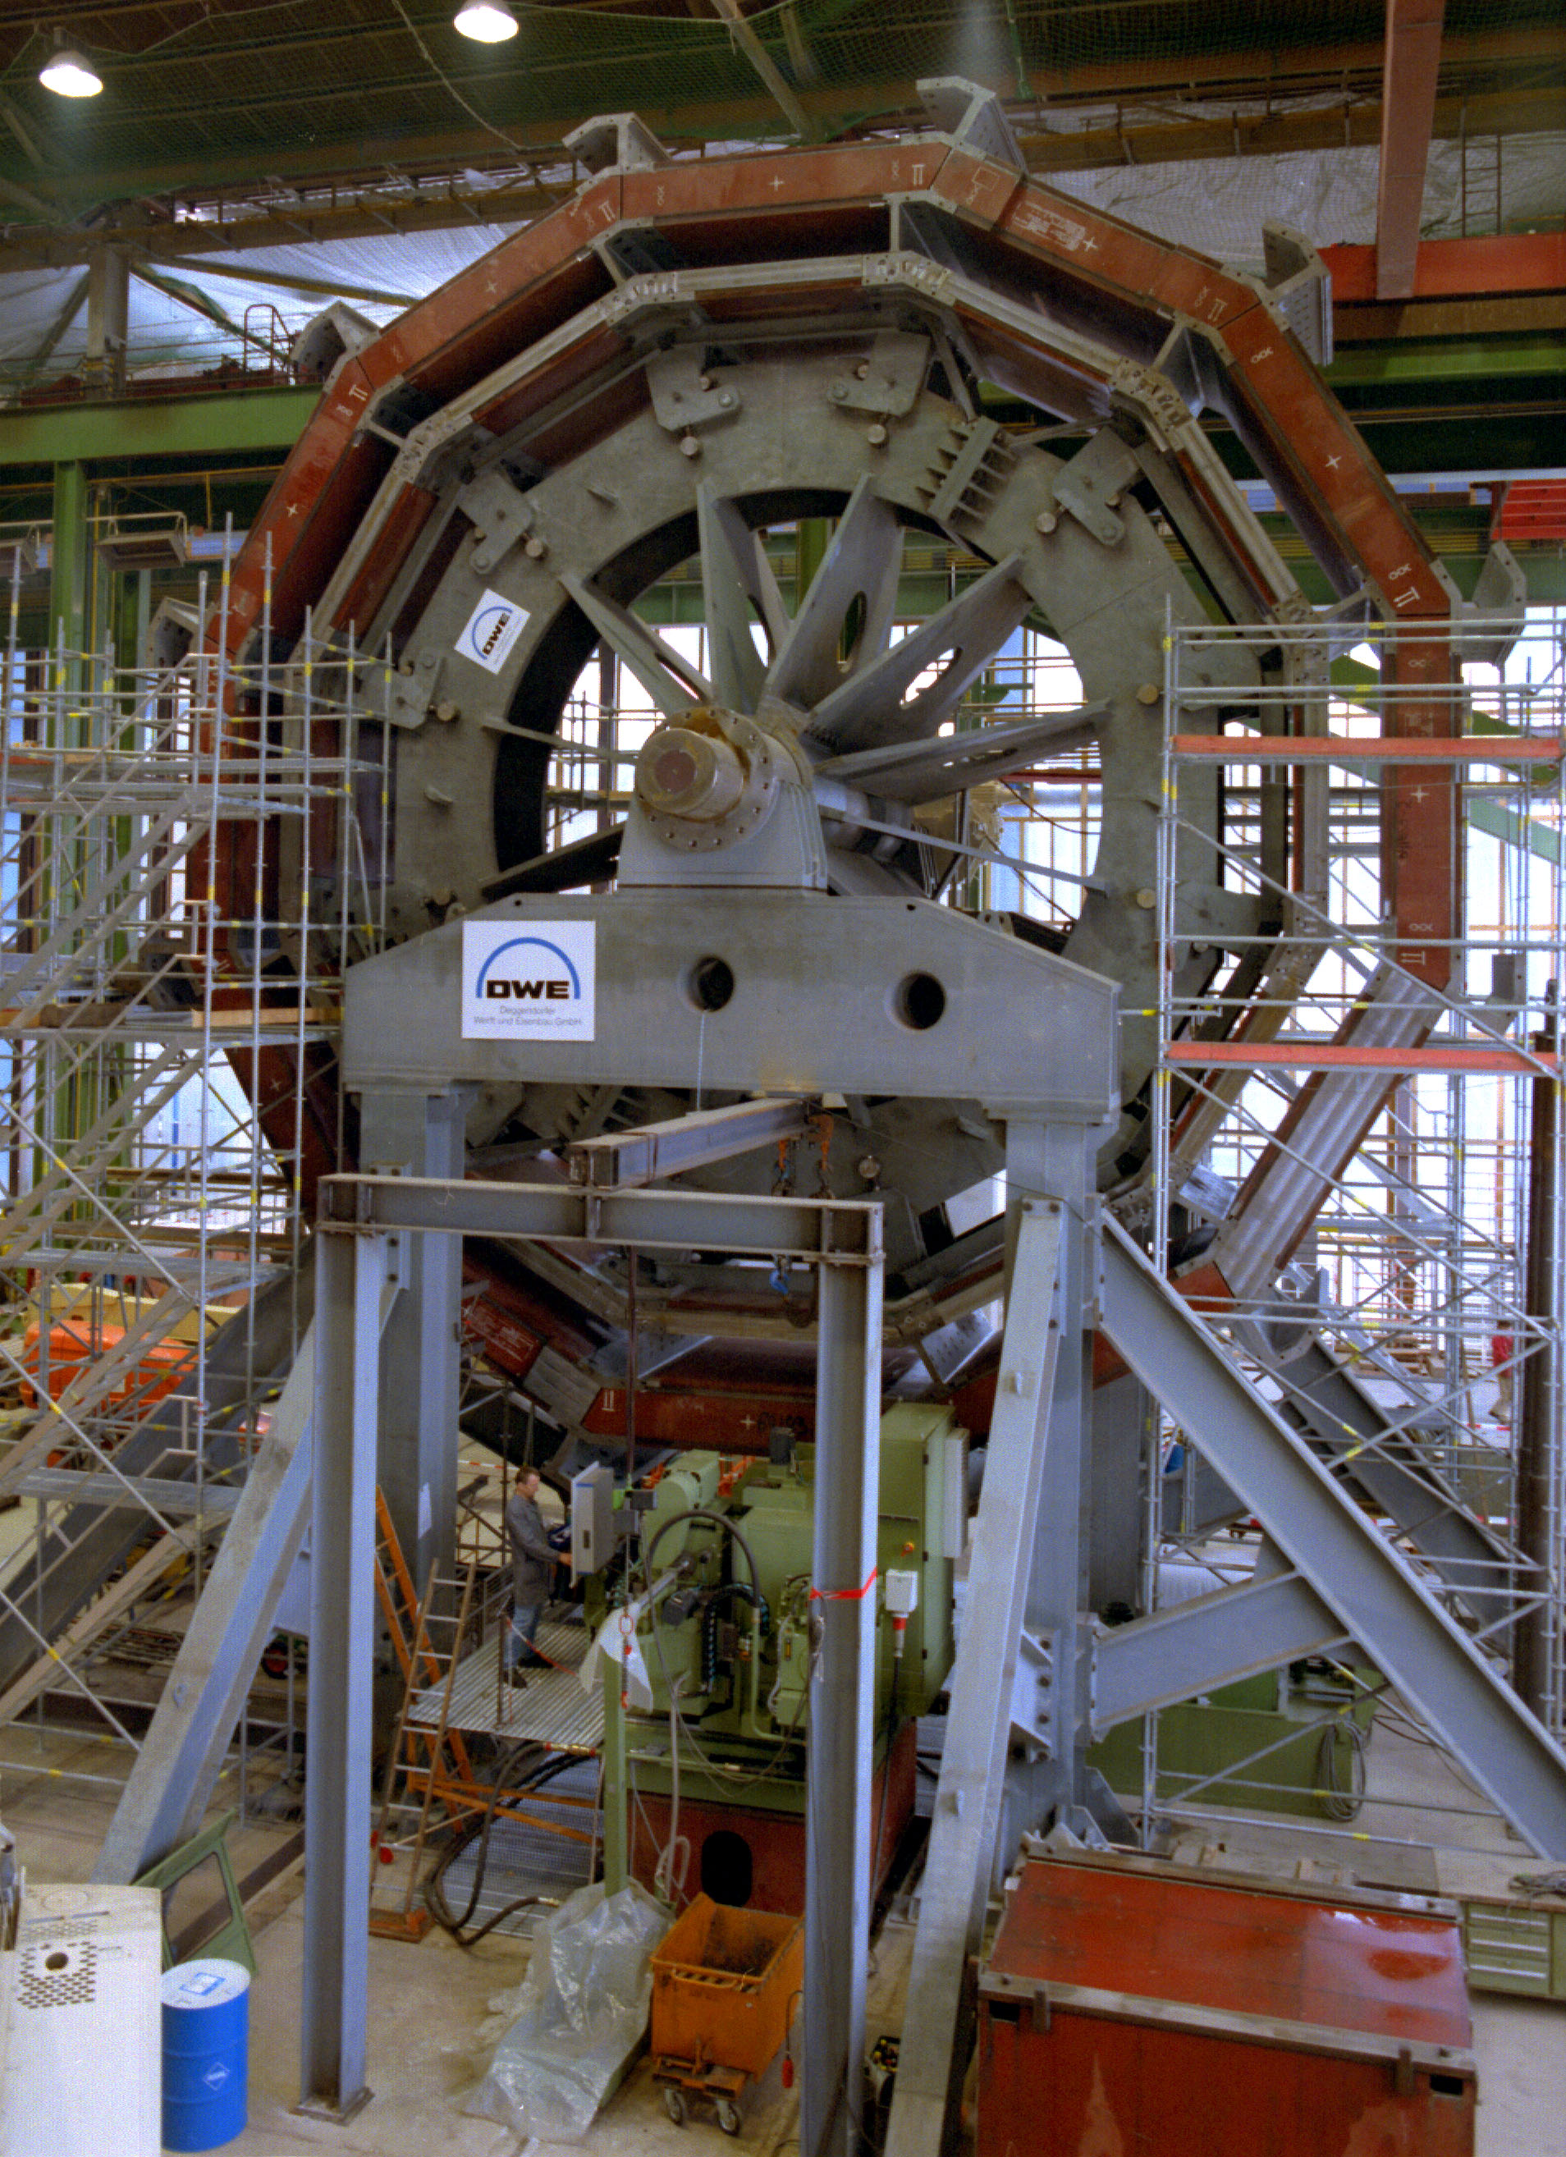
Figure 1: The first section of the barrel yoke of the magnet being assembled at the factory

