(a)
(b)
(c)
(b)

Figure 5: (a) The spectrum of signals from a beta source, and the noise
measured in a CMS MSGC at CERN using the APV chip;
- The impulse response of the APVM measured in peak mode, compared with simulated results;
- The measured and simulated impulse response of the APVM in “algorithm” mode.

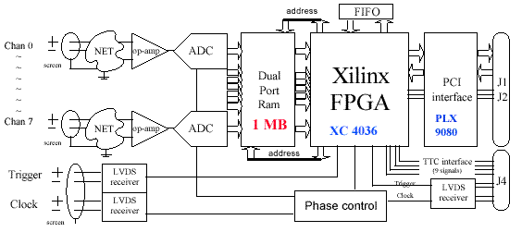
Figure 6: The basic functionality of the PMC version of the CMS Tracker Front End Driver

