THE COMPACT MUON SOLENOID (CMS) DETECTOR

PROPOSAL 892

UNITED KINGDOM
Bristol University; Brunel University; Imperial College, London; Rutherford Appleton Laboratory, Univ of the West of England*, Univ of Strathclyde*

OTHER CERN MEMBER STATES
AUSTRIA: HEPHY, Vienna; BELGIUM: Univ Libre, Brussels; Vrije Univ, Brussels; Univ Cath. Louvain, Louvain; Univ Antwerpen, Wilrijk; Univ Mons Hainaut, Mons; CERN; FINLAND: Helsinki Inst. Phys., Helsinki; Phys. Dept., Helsinki Univ, Helsinki; Helsinki Univ Tech, Helsinki; Jyväskylä Univ, Jyväskylä; Oulu Univ, Oulu; Tampere Univ of Technology, Tampere; FRANCE: LAPP, Annecy; Inst. Phys. Nucl., Lyon; LPNHE Ecole Polytechnique, Palaiseau; DAPNIA, Saclay; CRN-ULP, Strasbourg; GERMANY: I. Phys. Inst., RWTH Aachen, Aachen; III. Phys. Inst. A, RWTH Aachen, Aachen; III. Phys. Inst. B, RWTH Aachen, Aachen; Humboldt University, Berlin; Inst. Exp. Kernphysik, Univ Karlsruhe, Karlsruhe; GREECE: Univ Athens, Athens; NRCPS Demokritos, Attiki; Univ Ioannina, Ioannina; HUNGARY: KFKI, Hung. Acad. Sci., Budapest; Inst. Nucl. Res. ATOMKI, Debrecen; Kossuth Lajos Univ, Debrecen; ITALY: Dip. Fisica dell’Univ and Sez. dell’INFN: Bari; Bologna; Catania; Firenze; Genova; Legnaro∗; Padova; Pavia; Perugia; Pisa; Roma I; Torino; POLAND: Inst. Experim. Physik, Univ Warsaw, Warszawa; Soltan Inst. Nucl Studies, Warszawa; PORTUGAL: LIP, Lisbon; SLOVAK REPUBLIC: Slovak Inst. Technology, Bratislava; SPAIN: CIEMAT, Madrid; Univ Autonoma, Madrid; Cantabria Univ, Santander; Univ Oviedo; SWITZERLAND: Univ Basel, Basel; PSI, Paul Scherrer Institute, Villigen; ETH, Eidgen. Techn. Hochschule, Zürich; Univ of Zurich, Zurich

NON-MEMBER STATES (Except USA)
ARMENIA: YerPhI, Yerevan; BELARUS: INP, Byelorussian State Univ, Minsk; NCPHEP, Nat. Sci. and Educ. Centre of P’cle and High Energy Physics, Minsk; RIAPP, Research Inst. Appl. Phys. Probl., Minsk; Dept. of Physics, Byelorussian State Univ, Minsk; BULGARIA: Inst. Nucl. Res. + Nucl. Energy, Sofia; Univ of Sofia, Fac. of Phys., Sofia; CHINA PR: Institute of High Energy Physics, Beijing; Peking Univ Beijing; Univ of Science & Technology of China, Hefei; CHINA (TAIWAN): National Central University, Chung-Li; National Taiwan University (NTU), Taipei; CROATIA: Univ of Split, FESB, Elect. and Mech. Eng. Dept; Univ of Split, PMF, Dept. of Natural Sciences; Tech Univ Split; CYPRUS: Univ of Cyprus, Nicosia; ESTONIA: Inst. Chemical Physics and Biophysics, Tallinn; GEORGIA: Inst. Phys. Academy of Science, Tbilisi; Inst. HEP, Tbilisi State Univ; INDIA: Bhaba Atomic Res. Centre, Tata Institute (HECR), Tata Institute (EHEP), Mumbai; Panjab Univ, Chandigarh; Univ of Delhi South Campus, Delhi; KOREA: Cheju Nat. Univ, Cheju; Chungbuk Nat. Univ Chongju; Kangwon Nat. Univ, Chunchon; Wongwang Univ, Iksan; Chonnam Nat. Univ, Kwangju; Dongshin Univ, Naju; Seonam Univ, Namwon; Kon-Kuk Univ, Seoul; Korea Univ, Seoul; Seoul Nat Univ, Seoul; Seoul Nat. Univ Educ., Seoul; Kyungpook Nat. Univ, Taegu; PAKISTAN: Quaid-I-Azam Univ, Islamabad; G I Khan Inst, Swabi; RUSSIA: JINR, Dubna; INR, Moscow; ITEP, Moscow; Lebedev Physical Institute, Moscow; MSU, Moscow; IHEP, Protvino; Petersburg Nucl. Physics Inst., St. Petersburg; RFNC-VNIITF, Snezhinsk∗; TURKEY: Cukurova Univ, Adana; Middle East Tech. Univ, Ankara; Bogazici University, Istanbul; UKRAINE: Kharkov State Univ; NSC-KIPT, Kharkov Inst. of Phys. and Tech., Kharkov; Inst. of Monocrystals, Kharkov; UZBEKISTAN: INR, Uzbekistan Acad. of Sciences, Tashkent

USA
Boston University; Caltech, Pasadena; Univ of California at Davis; Univ of California at Los Angeles; Univ of California at Riverside; Univ of California at San Diego, La Jolla; Carnegie Mellon Univ, Pittsburgh; Fairfield Univ, Fairfield; Fermilab, Batavia; Florida State Univ, Tallahassee; Univ of Florida, Gainesville; Johns Hopkins Univ, Baltimore; Univ of Illinois, Chicago; Univ of Iowa, Iowa City; Iowa State Univ; Univ of Maryland, College Park; Massachusetts Institute of Technology, Boston; Univ of Minnesota, Minneapolis; Univ of Mississippi; Univ of Nebraska-Lincoln, Lincoln; Northeastern Univ, Boston; Northwestern Univ, Evanston; Univ of Notre Dame; Ohio State Univ, Columbus; Princeton Univ, Princeton; Purdue Univ, West Lafayette; Rice Univ, Houston; Univ of Rochester; State Univ New Jersey, Rutgers; Univ Texas, Dallas; Texas Tech Univ, Lubbock; Virginia Polytech. Inst. and State Univ, Blacksburg; Univ of Wisconsin, Madison

INTRODUCTION and overview
CMS, the Compact Muon Solenoid experiment, is a general purpose detector for the Large Hadron Collider currently under construction at CERN. CMS will identify muons, photons and electrons, and measure their momenta and energies with high precision. The detector will be capable of studying the full range of LHC physics, and is optimised to search for the Higgs boson over the mass range from 90 GeV/c² to 1 TeV/c².

The CMS project has made substantial progress during the past year. A major 'infrastructure' milestone was met with the delivery, on schedule, of the surface hall SX5. The civil engineering for the underground cavern, UX5, has been delayed by 5 months, because of ground water problems encountered when sinking the 12 m access shaft. However, the underground assembly schedule will be adjusted to match the first delivery of beam collisions in the LHC.

Construction of the superconducting magnet is proceeding well, and remains within budget with all of the major contracts now placed. All pieces of the 10000 t barrel yoke have been delivered to CERN, and final assembly of the first of the 5 rings has been completed in SX5. The super-conducting coil schedule is now firmly defined by contractual dates; however, there is a 5 month delay with respect to the original schedule. At present this slippage is covered by the shadow of the delay in civil engineering.

Pre-assembly of the absorber for the first 'half-barrel' of the Hadron Calorimeter was successfully completed in October at the factory in Spain, and 10 of the 18 wedges have now been delivered to CERN. The pre-production of 6000 crystals for the barrel ECAL was successfully completed in Russia and one of the main orders has now been placed. The crystal delivery schedule is on the critical path of the ECAL project, however there has been encouraging progress in technical developments aimed at accelerating the production rate.

On 15 June, the CERN Research Board approved the 'All-Silicon Tracker' for CMS, to be built in a single stage. The layout has been optimised with the removal of the central support tube between the inner and outer Tracker regions and the rearrangement of the forward detectors into single disks. The role of the UK in the Tracker project has remained essentially unchanged. However, the responsibilities of many institutes elsewhere have been revised, and a draft addendum to the Memorandum of Understanding (MoU), formalising the changes, was circulated to members of the Resources Review Board in October.

It has taken longer than planned to launch production of the Drift Tube Chambers for the Barrel Muon system, and a second assembly line will therefore be installed in Torino to accelerate the manufacture. A pre-production chamber is being built at CIEMAT in Madrid, and the assembly lines at Legnaro and Aachen are now well advanced. Twelve Cathode Strip Chambers for the End-caps have been manufactured at Fermilab.

The Trigger-Data Acquisition project passed a major milestone with the submission of the Trigger Technical Design Report at the end of 2000. A major effort was undertaken to study the performance of the software High Level Trigger, using OO code. This led to the successful demonstration that a factor 5-10 reduction in the Level-2 rate with respect to Level-1 could be achieved using only the Calorimeter and Muon data. The CMS software and computing activities have been re-organised into two separate projects, with the titles 'Physics Reconstruction and Selection', and 'Core Software and Computing'.

During the past year, Bulgaria and Korea have signed their Memorandum of Understanding, and groups from China-Taiwan have been accepted into the Collaboration (National Central University and National Taiwan University) and will contribute to the ECAL Endcap preshower detector. Pakistan has signed an addendum to its MoU, increasing its contribution to CMS. This will allow it to contribute to the construction of Resistive Plate Chambers and associated electronics for the Forward Muon system. Two new groups from Kansas have joined the US effort on the Tracker.

Discussions on possible membership of CMS are taking place with institutes in Brazil (A Santoro), Ireland (University College, Dublin) and Iran (University of Teheran). The University of Strathclyde (M Roper, Department of Computer Studies) has been accepted as an Associate Institute of the Collaboration, and will work on the problem of software verification.

There were two candidates in the election, held in June 2000, to choose the CMS Spokesperson for the three year period starting 1 January 2001. Michel Della Negra was re-elected to the post with a clear majority.

The remainder of this report focuses on the progress made by UK groups in CMS.

TRACKER AND DATA ACQUISITION

Overall Tracker Progress
Since the last report there has been a major change in the tracker design, which was to abandon the MSGC technology planned for the outer tracker. This important decision was to a large extent made possible by the very successful implementation of the APV25 chip by the UK team, as reported last year, for readout of the microstrip tracker. The APV25 is produced in an IBM 0.25µm CMOS technology and provides lower noise, more reliable yields and, most important for this application, very large cost savings. These decisions were made by the Tracker community at the end of 1999, and 2000 has seen the repercussions and progress which have followed from them.

Despite this painful choice, which put to one side enormous progress made developing MSGCs for CMS, the Tracker Collaboration remained intact and has impressively refocused on the modified project. In February 2000 an Addendum to the TDR was submitted to the LHCC by the Tracker Collaboration with the new all-silicon design. The design is a simple evolution of the TDR layout, replacing MSGCs with silicon detectors, but with no other major modification. This Addendum was approved in June 2000. In parallel a task force evaluated possible layout evolutions taking advantage of the uniform technology. The design was approved by the Tracker Collaboration in April 2000. The main difference compared to the Addendum design is the absence of horizontal separation between the inner and outer tracker. From preliminary studies there is confidence that the physics performance of the new layout is improved in comparison to the Addendum.

The sharing of responsibilities for the construction of the Silicon Strip Tracker (SST) was revised after the decision on the outer tracker technology. This had little direct impact on the UK since there is no essential change in the UK deliverables and role. Responsibilities on individual items have been taken by typically one or a few institutes across the whole project. The construction of about 16000 silicon detectors using 26000 6-inch wafers is indeed a challenge and requires extensive infrastructure, an organized production scheme in several production centres and careful co-ordination and supervision. Working groups on common items (acceptance test of the sensors, automated module assembly, bonding, testing) have been established to ensure uniformity of procedures in different construction sites.

A Draft of a new Memorandum of Understanding (and money matrix) describing the SST construction responsibilities was approved by CMS in June 2000. A new schedule and list of milestones was produced. The construction of the silicon detectors takes 2.5 years and is foreseen to start in the final quarter of 2001. The market survey for the procurement of sensors is finished and the tender of the sensors will be sent soon to qualified firms. Contracts for pre-production sensors have been placed.

The final major milestone before production can begin is production of 200 modules and a system test of a modest number of modules assembled together in a sub-unit (Outer Barrel Rod) of the system. An important milestone of the project passed in June 2000 was therefore the Procurement Readiness Review of silicon sensors in which approval was given for procurement of the 200 pre-production modules. Orders have since been placed for the 400 sensors needed which will arrive at the end of 2000; the first modules will be assembled in the first quarter of 2001.

The construction of these pre-production modules will follow the same procedures as final module production. These modules will be equipped with UK-developed front-end electronics of the final design procured in recent engineering runs. Starting production lines and testing production procedures six months before the start of mass production is only one aspect of this important milestone. One of the most important uses of the modules will be to perform system tests on groups of modest size groups, such as rods, assembled together, powered and read out by the data acquisition system in a realistic way.

An Engineering Design Review (EDR) of the project took place in November 2000 and was also successfully passed, which allowed a green light to be given for completion of the production sensor tendering process. The procurement of front-end integrated circuits will be done in the framework of a CERN frame contract which has already been signed. Construction of the mechanical structures of the SST was scheduled to start soon after the EDR and the delivery of the supports for the modules (shells, rods and petals) is foreseen to start in the first half of 2002.
In parallel particular attention is now being devoted to Quality Control and Assurance with several documents specifying all procedures. Detectors with close-to-final design have been tested in test beams during the last year. The electronics (APV6 with opto-link prototypes) and control chain have been successfully tested using an SPS beam with a 25ns bunch structure. A full size large module equipped with APV25s from the first engineering run has been tested at high rate at the Paul Scherrer Institute (PSI) and performs to specifications. A significant number of tests (radiation tolerance, single event upset, technology robustness, etc) have been carried out to maximise confidence in the components in the system.

Progress in the UK
The UK involvement in the detector hardware is principally in the electronic readout of the microstrips. Analogue readout will be used in CMS, based on the APV25 chips developed by RAL and Imperial College. Each microstrip is read out by a charge sensitive amplifier whose output voltage is sampled at the 40 MHz beam crossing rate. Samples are stored in an analogue pipeline and, following a trigger, are processed by an analogue circuit to further filter the signals, then multiplexed from pairs of front-end chips over a short distance of twisted pair cable to a laser driver. A laser converts electrical signals to infra-red light levels which are transmitted approximately 100 m over a fibre optic cable to the counting room where digitisation and data reduction are carried out by the Front End Driver (FED) module. The APV chips and the FED are the two items which the UK has taken a significant responsibility to deliver.

APV developments
One year ago, the early results from the first APV25-s0 run in a shared Multi-Project Wafer processing run were reported. In the early part of the year many more detailed measurements, including performance under irradiation, were obtained. The results were extremely good. Several APV25-s0 were irradiated in the IC x-ray system to 20Mrad with no change in performance, and to 80Mrad in a linac electron beam. As expected, high fluence neutron irradiations have no effect on the circuit.
A few minor improvements were identified. The most important was the observation of high track resistance between input pads and amplifier inputs which gave rise to a noise variation across the chip. This was corrected with an improved layout in the APV25-s1 (see Figure 1).

A large number (approximately 500) of APV25-s0 chips were probe tested - individually! Figure 2 shows a die under test in the probe station. The measured yield of flawless chips was 84% of the total delivered, which is impressive, although this should be regarded as indicative at this stage since they are not from all parts of the wafers. Figure 3 demonstrates that good uniformity is also observed.

Single Event Errors (SEE) have been investigated in some detail during 2000. SEEs are changes of logic state of individual logic elements in chips due to a very heavily ionising particle transit into a silicon chip. Most of them will be due to rare, but inevitable, energetic silicon ions dislodged from their lattice position in the chip by a charged particle or neutron in the experiment. They will occur at different rates everywhere in the experiment and their most important effect will be on control circuits. Simulations of the CMS environment have been made but it is also necessary to make experimental measurements of SEE effects in real circuits, such as the APV25, exposed to severe conditions, such as encountered in a heavy ion beam.

Figure 1. Equivalent Noise Charge (electrons) of APV25-s1 plotted as a function of load capacitance (pF) for several input channels demonstrating the uniformity across the chip.

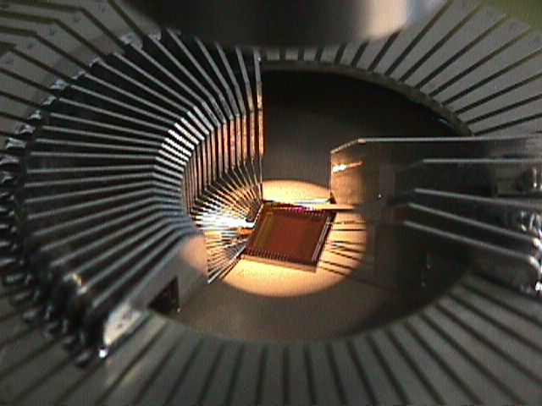
Figure 2. An APV25-s0 die under test on the automated probe station.

Figure 3. The currents drawn by the APV25-s0 from the VSS and VDD supply rails (in arbitrary units). The box indicates the range of acceptable currents and clearly shows that relatively few chips are outside this range.

The APV25 was tested for Single Event Upset effects during February and July using a range of heavy ions in INFN Legnaro with promising results, illustrated in Figure 4 and Figure 5. These extend well beyond the fluences and Linear Energy Transfer (surface dE/dx) which will be encountered in CMS. From the measurements made, combined with simulations of particle fluxes in the tracker, typically 100 SEU events are expected per hour of high luminosity running. Many of these will produce nearly unobservable effects and it should be a simple matter to control the system by occasional resets at convenient intervals. The data also set limits on Single Event Gate Rupture, already improving on statistics for 0.25µm technologies available in the literature. They convincingly demonstrate that this is unlikely to be a concern for CMS.

Cross-section (cm²)
Figure 4. Simulation results, from a three-dimensional modelling of APV25 circuits, of the expected APV25 pipeline logic Single Event Upset cross-section as a function of heavy ion Linear Energy Transfer.

Cross-section (cm²)
Figure 5. Experimental results of APV25 pipeline logic Single Event Upset cross-section as a function of Linear Energy Transfer, measured using heavy ions at INFN Legnaro. The similarity to the predictions is noteworthy.

A further SEU test was completed in December in a pion beam at PSI, in which conditions close to those expected in CMS could be experienced. Data are being analysed and should verify SEE rate estimates based on simulations using heavy ion data.

Figure 6 shows an APV25-equipped full size detector module of 17cm length which was tested by Vienna in a PSI pion beam with excellent results. The chip is also in use by the COMPASS experiment, which is purchasing some of the spare APV25-s0s for MSGC and silicon detector modules.

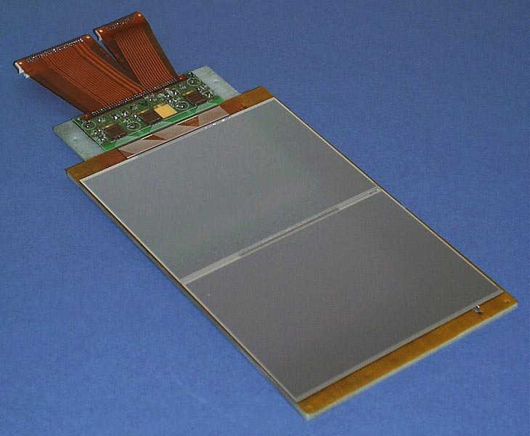
Figure 6. A detector module constructed using sensors from two 6-inch silicon wafers, with a total length of 17cm, read out by three APV25-s0 chips. The module was tested by Vienna in a PSI pion beam.
An engineering run of 4 wafers dedicated to the APV25-s1 and the APVMUX-PLL chip (along with standard test structures), which are both located on the detector module hybrid, was submitted in May 2000. The first chips were delivered to the UK in early September. The modifications to the APV25 appear to have been completely successful. The irradiation results shown in Figure 7 confirm detailed observations of the performance of the first version of the chip.

Before irradiation
After irradiation

Figure 7. APV25-s1 pulse shapes measured in peak mode (dark) and deconvolution mode (light) before and after irradiation with a 50keV x-ray source to 10Mrad. Each time division is 25ns.

The APVMUX multiplexes outputs from two APV25s onto a single electrical output line which is converted to optical signals close to the detector hybrid. Unfortunately a minor problem was identified with the APVMUX resulting from a subtle technological feature used to achieve high speed performance for certain circuits in the process. It required only a modification to a single mask layer to correct. The design was resubmitted on a MPW run in October and is expected in January 2001, at which point a larger pre-production order can be placed.

Automatic 8-inch wafer probe stations are now in operation at Imperial College and RAL, and procedures for production testing of APV25 wafers are in place. Most procedures had been verified on 4-inch APV6 wafers and essentially the same tests are foreseen for the APV25. The first 8-inch APV25-s1 wafer was tested shortly before Christmas 2000. This is intended to be the final stage before production wafers are tested; with regular operation of two probers the entire production volume could be tested in one year if necessary.

FED and DAQ Developments

Prototype FED-PMC

The RAL and Imperial College groups are also responsible for the design and manufacture of the Front End Driver (FED) modules which digitise and zero-suppress the analogue signals from the APVs.

A PCI Bus Mezzanine Card Front End Driver (FED-PMC) was developed in 1998/9 to provide a flexible module for system developments over the next few years and match advances in commercial off-the-shelf processors. In May 2000 several FED-PMC prototypes were used successfully for the Tracker readout in the LHC-like 25ns structured test beam at CERN.

In order to operate the readout in these LHC like conditions, the FED-PMC functionality was significantly improved. This was made possible by exploiting the flexibility of its FPGA based design. The most important design change enabled the FED-PMC to handle short bursts at the highest expected trigger rates, corresponding to a trigger separation of 3 LHC bunch crossings. The FED-PMCs provided data capture and vital monitoring of the performance of the front-end electronics.

A selection of results from this beam test are shown in Figure 8, Figure 9 and Figure 10. The test was an important step forward in understanding the major practical problems in implementing the elegant but complex tracker readout and control system. UK personnel from RAL and Imperial played a large part in promoting and ensuring the success of these tests. Next year’s pre-production milestone 200 will continue this effort.

Subsequent to the beam tests, the FED-PMC was ported from VME to desktop PC based systems, running WNT and Linux, which will shortly be employed in several large-scale silicon module burn-in stations. In anticipation of these stations, the FED-PMC readout speed has been boosted by a factor of 10 by exploiting the fast-burst readout mode capabilities of the PCI bus. RAL is currently producing a further 30 FED-PMCs.

Final FED
Work has begun to elaborate the design of the final 96-channel FED. This is being modelled using VHDL code. The VHDL will be made suitable for synthesis to an FPGA, allowing post-ADC FPGA algorithms to be evaluated for size and cost.
One role of the final FED is to reduce the data volume substantially by applying a clustering algorithm to the APV data. Only for those channels associated with a cluster is the digitised pulse-height information sent to the DAQ. For this to work reliably, the FED must also estimate and subtract common-mode noise. This year, several possible FED clustering and common-mode algorithms have been implemented in the CMS OO Monte Carlo. Detailed studies have been made comparing their performance in terms of cluster finding efficiency and output data volume.

Considerable effort has also been devoted to defining how the FED should interface with the data acquisition system (DAQ). In particular, a protocol has been established which is common to all readout subsystems. The DAQ itself is also taking shape, with work having been done to evaluate the event builder networks and studies made of high level filters. Furthermore, contributions are being written for the CMS Data Acquisition Technical Design Report, which is due to be published next year.

Radiation Hardening of Silicon Detectors
The UK groups in CMS have contributed significantly to the RD48 collaboration which has worked on radiation hardening of silicon detectors. RD48 is a joint R&D project with participants from all major LHC experiments, and elsewhere, with a UK CMS co-spokesman. The programme of RD48 was formally completed during 2000 and discussions are under way as to how best to continue investigations of hardened detectors.
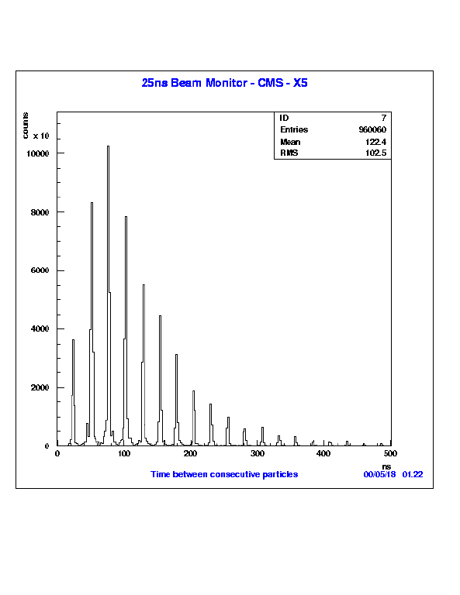
Figure 8. The measured distribution of times between beam bunches which contained at least one particle in the LHC-like test beam. Data were taken at the maximum rate, corresponding to gaps between triggers of 75ns.

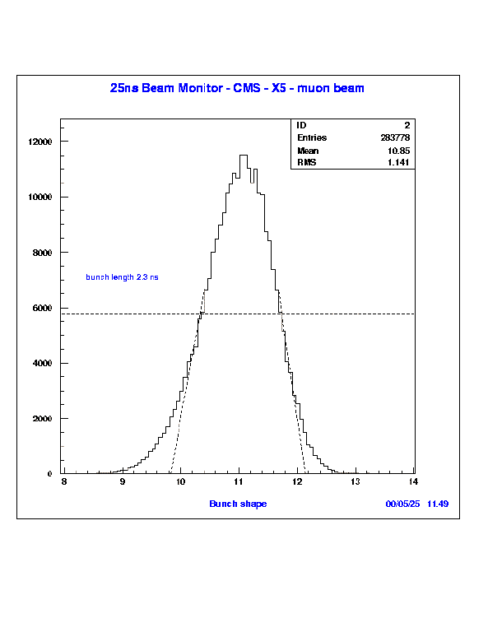
Figure 9. The distribution of measured particle arrival times relative to the 40MHz clock in a 10000 particles/spill beam.
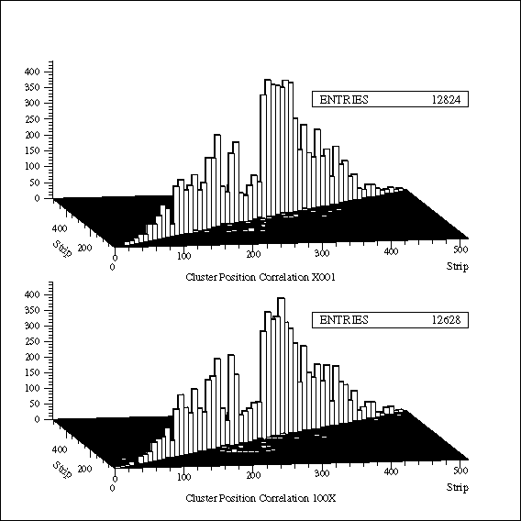
Figure 10. Correlation between hits in three of the modules in the LHC-like test beam, using trigger conditions with 75ns spacing. The two plots show the measured correlation observed in the first and second trigger respectively.
RD48 has shown that the addition of oxygen into the silicon at levels of greater than 10¹⁷ cm⁻³ improves radiation tolerance to charged hadron irradiations. This effect was predicted by Brunel and Imperial College, based on defect kinetics simulations following removal of atoms from their lattice sites by high energy particles. Work has continued on improving the simulations and modelling the detailed properties of irradiated detectors, accompanied by experimental measurements of irradiated detectors.

Recent work at Imperial College has centred around cryogenic investigations of inter-defect charge transfer, a novel phenomenon which is believed to be responsible for a significant fraction of the radiation damage incurred by silicon detectors in fast particle radiation fields. Since the defects in the silicon lattice involved are intrinsic, rather than impurity-related, it is possible that this fraction of the radiation damage cannot be mitigated by defect-engineering, which has important consequences for the future direction of radiation-hardening R&D. Strenuous efforts are therefore being made to understand the charge transfer mechanism more completely.

ELECTROMAGNETIC CALORIMETRY

Overview
The UK has the lead responsibility for the design and construction of the CMS crystal Endcap Electromagnetic calorimeters (EE). This work is being carried out in close collaboration with institutes from Russia together with groups providing common items which will be used throughout the barrel and endcap regions of the detector.

The endcap calorimeters comprise a total of 16000 slightly tapered lead tungstate crystals, each approximately 3x3x22 cm³ in size, read out with one inch diameter Vacuum Phototriodes (VPTs). The EE has made significant progress over the past year. It has evolved from the R&D phase to the pre-production phase for the VPTs, EE crystals, and mechanics.

A tender exercise for the pre-production of 500 VPTs was completed in April 2000. The contract was awarded to Research Institute Electron (RIE), St Petersburg, Russia. Other bidders were Electron Tubes, Hamamatsu and Photonis. RIE have successfully delivered the 500 VPTs by the contract date of November 2000. The devices are being appraised in the UK in the recently commissioned 4.0 Tesla and 1.8 Tesla VPT test rigs at Brunel and RAL; these test rigs are described in more detail below.

The Russian EE crystal R&D programme has been successfully concluded with the delivery of a total of 120 crystals from Bogoroditsk. The optical and scintillation properties, and radiation tolerance, of these crystals are on a par with the laterally smaller crystals being produced for the ECAL barrel (EB) section of CMS. Plans for the pre-production phase are now being discussed with the objective of establishing a continuous production line in Russia. Plans for the production of EE crystals in China are also being discussed. Possible suppliers are the Shanghai Institute of Ceramics (SIC) and the Beijing Glass Research Institute (BGRI).

The EE crystals are contained within 5x5 units, known as supercrystals (SCs), by thin walled (400 μm) carbon fibre alveolar structures. A successful Engineering Design Review (EDR) was held at CERN on 28/29 November 2000, to appraise and approve the production of the mechanics for the SCs. A pre-production run of SC mechanics will commence in early 2001 for 25 – 30 SCs. The full production of SC mechanics will be launched in 2002.

Approximately 150 SC alveolar structures have now been made by Myasichev (Moscow). About 30 have been extensively measured. A complete SC was made with one of these units and loaded with brass dummy crystals to simulate the gravitational load. The cantilevered SC deflected by less than 30 μm, fully satisfying the design goal for the overall rigidity of the structure.

The SCs will be produced at a Regional Centre at RAL. The room for this facility has recently been refurbished, with kitting out to be completed by Jan 2001. A set of jigs and tooling is ready for the production of SCs.

At Imperial College, the radiation tolerance, light yield and transmission properties of the first Russian pre-production crystals have been studied in the Crystal Laboratory. A substantial number of the pre-production crystals will now be studied for the uniformity of light yield along the crystal length.

Bristol undertook major responsibility for the SC test beam work at CERN in 2000. They provided the very front end electronics cards and a differential drive and receiver system to reduce coherent noise.

An important result from the testbeam studies shows that the response of the detector can be monitored from 0 Tesla to 3 Tesla to a precision of better than 1% using a 430nm LED. This is an important proof of principle, although the final system will use a laser at 420 nm, for carrying the pre-calibration constants measured at 0 Tesla at the EE H4 testbeam at CERN, to CMS at 4 Tesla with a precision target of better than 2%.

Bristol have also undertaken the mechanical evaluation of supercrystal components before and after irradiation.

VPT testing
Automated test rigs have been developed at RAL and Brunel to carry out acceptance tests on the VPTs in high magnetic fields. The RAL rig provides a variable field from 0T to 1.8T and a variable angle, while the Brunel rig operates at a fixed field of 4T and a fixed angle of 15°.

RAL test rig
The test rig at RAL is based on a conventional magnet providing fields up to 1.8T over an area of approximately 0.5m². Figure 11 is a view of this magnet showing the rail system which guides the VPT rig between the pole tips. The vertical distance between the pole tips is approximately 10cm. VPTs are held in rows of 8 aluminium cans which may be rotated to present the VPTs to the magnetic field at any desired angle up to 90°. The photograph shows a single row of 8 cans installed in the rig. As the rate of VPT delivery increases during the course of 2001, a further five rows will be added, allowing 48 VPTs to be measured simultaneously.

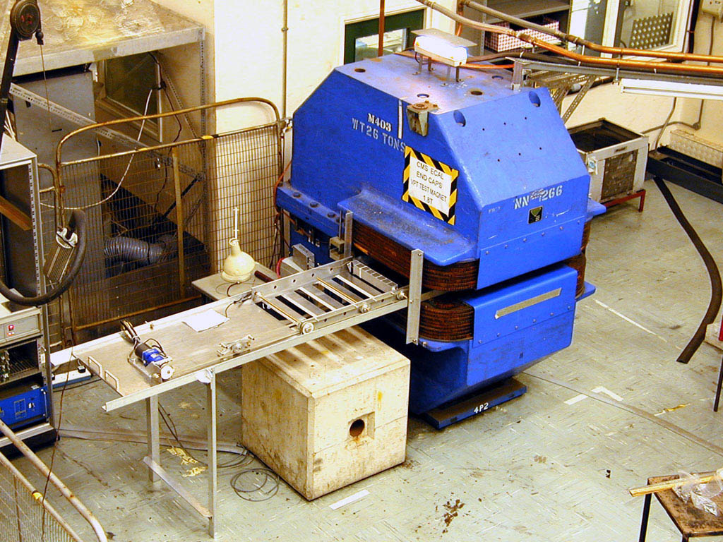
Row of 8 “cans”
Figure 11. A view of the RAL VPT testing area, showing the 1.8T magnet with the VPT rig ready to slide between the pole tips.

Given the constraint that the available space in the magnetic field is limited, considerable care has been taken to illuminate the photocathodes as uniformly as possible. Each VPT is illuminated by a diffuser equipped with four 430nm LEDs, providing even illumination across the whole of the photocathode area.

Brunel test rig
Brunel have designed and built an automated system for evaluating the response of VPT devices at full CMS field (4.0T). Tubes are held in a “torpedo” which is then placed in a superconducting solenoid magnet (see Figure 12). The tubes are tested at 15° to the field and their relative gain measured. Other parameters, such as leakage and dark current are also recorded. The system is controlled by a number of IEEE-488.2 instruments controlled using LabView on a PC running Windows-NT. A number of pre-production tubes have recently been measured in the prototype torpedo. A new torpedo, holding six tubes simultaneously, is under construction as is a new optical fibre delivery system to provide the pulsed blue LED light to each VPT.

Detailed measurements of radiation induced faceplate absorption and the uniformity of the photocathodes of individual VPTs have also been carried out at Brunel.

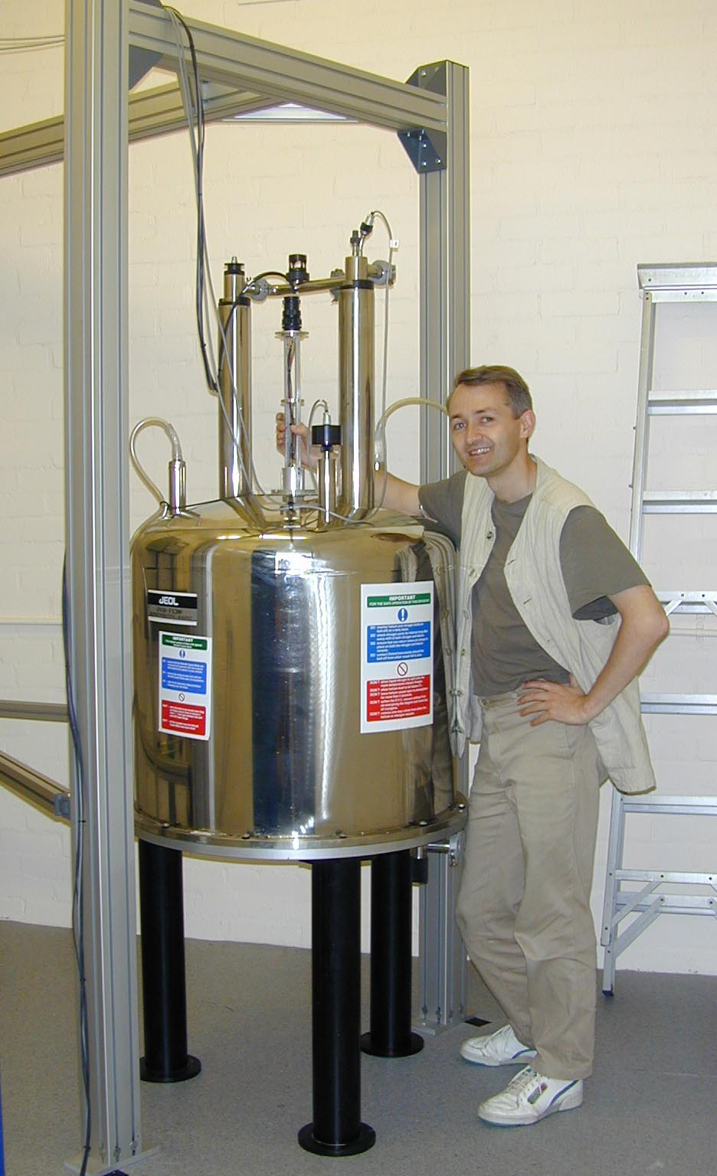
Figure 12. A view of the Brunel VPT testing area, showing the 4.0T magnet with the torpedo ready to slide down the bore of the solenoid.

Acceptance test results
The RAL test rig allows the behaviour of VPTs to be studied as a function of both the applied magnetic field from 0T to 1.8T and the angle between the field and the VPT axis. These measurements are illustrated in Figure 13 and Figure 14, which show field and angle scans on a small sample of tubes. The field scans show that the performance of the VPTs is stable at high fields, and that the loss in output from 0T to 1.8T is rather small. The angle scans are generally satisfactory, with only a small loss in output as the angle is increased to 30° (the maximum angle in CMS will be approximately 25°). The periodicity which the VPTs display in these scans arises from the interaction between the synchrotron radius of the spiralling electrons and the spacing of the anode grid.

The VPT response measured at RAL is found to correlate extremely well with the response expected on the basis of performance data supplied by the manufacturer.

Figure 13. Response of a sample of VPTs as a function of magnetic field at an angle of 15°.

Figure 14. Response of a sample of VPTs as a function of angle to a 1.8T magnetic field.
The Brunel VPT testing system is designed to evaluate the gain, noise, and leakage current of tubes operating at nominal HT in the full CMS field. The tubes are positioned at the mean angle in the CMS endcap of 15°. Figure 15 shows the distribution of relative gains for the first batch of pre-production tubes. It can be seen that all tubes easily pass our field-dependence acceptance criterion of 80% relative gain at 4.0T.

Figure 15. Distribution of relative gains for the first batch of pre-production VPTs

Glue studies
Gluing studies have continued, concentrating on glue dispensing systems and module assembly. A reliable dispensing system has been developed and a prototype gluing rig manufactured which for mass production of VPT crystal assemblies.

There has been close collaboration with CERN and the CERN barrel detector group are now using the same glue (Dow RTV3145) as the UK end-cap detector.

Thermal stability
A critical aspect of the design of the end cap calorimeter is thermal stability. The light yield of the PbWO₄ crystals is sensitive to temperature variations with a coefficient of –2 % / ºC. It is therefore necessary to maintain the crystals at a stable temperature during data taking.

Although the temperature of the endcap calorimeter is controlled by a cooling system, other detectors in close proximity run at different temperatures and impose heat loads. Whilst a fixed heat load results in constant gradients and does not compromise stability, transient heat loads could result in thermal instabilities. Experimental studies are now being undertaken at RAL to support design calculations in determining the limiting transient heat loads from these external detectors that can be tolerated.

Table 1 shows the results of an initial experimental study. A radiator plate (simulating an adjacent detector) was placed 20 mm from an endcap supercrystal. The table shows the temperature changes in the crystals resulting from a 15ºC rise and a 2ºC fall in temperature of the radiator plate.

 | + 15ºC change in radiator | -2ºC change in radiator
20 mm along crystal | 3.0ºC | 0.35ºC
110 mm along crystal | 1.6ºC | 0.17ºC
220 mm along crystal | 0.8ºC | 0.05ºC
Table 1. Data obtained on the temperatures at the centre of an insulated 5 x 5 supercrystal separated by 20 mm from a radiator, initially heated from 21ºC to 36ºC, then reduced to 34ºC. The cooled back plate was at 21ºC

With 20 mm separation from the radiator and no thermal screening, the maximum temperature excursion in the front of the crystal was 18% of that in the plate. The data also showed that it took more than 3 hours for the temperature change to reach 90% of its asymptotic value in the front 20 mm of the crystal and substantially longer near the back face. This test showed that, provided the average temperature fluctuation over an hour in an adjacent detector was less than +/- 1.0 ºC, and any excursions were short, the crystals would be stable to +/- 0.1 ºC.

Further tests are planned with a thermal barrier between the simulated detector and the calorimeter crystals to reduce radiative and convective heat transfer. This should further reduce the sensitivity of the calorimeter to transient external heat loads.

Damage to VPTs by helium diffusion
In normal conditions in CMS, the VPTs will be operated in a nitrogen atmosphere.
However, some quench modes of the magnet system could result in a transient exposure to helium gas. Studies have therefore been carried out to understand better the susceptibility of VPTs to the external presence of helium.

The pressure P_{I}(t) within a tube after a time t, immersed in an atmosphere with helium at partial pressure P_{E} tends exponentially towards P_{E} with a time constant c given by c = 10⁵ D A (T/273)/d. Here A is the aspect ratio of the VPT, defined as the ratio of the surface area of the envelope to the enclosed volume (A ≈ 2 cm⁻¹ for 25 mm diameter VPTs), T is the absolute temperature, and d is the thickness of the glass envelope (of order 1 mm). D is the helium diffusion coefficient and is temperature dependent. For borosilicate glass at 20^{O}C it has the value∗:

D = 5.7x10⁻¹⁶ (cm³ at NTP)/s/cm²/(Pa/mm thickness)

Thus, after 10 years exposure to an atmosphere containing helium at the normal ambient pressure of 0.7 Pa, the pressure inside a 25 mm VPT would have risen to 2.6x10⁻² Pa.

In order to gain a better understanding of the likely mode of failure of a VPT subjected to prolonged exposure to helium, an empirical investigation was made. For this test, a tube with a UV-transmitting glass window was enclosed in a gas-tight box, and excited with a pulsed LED light source.

Initially the tube was operated for several days under dry nitrogen to allow the system to stabilise. The gas supply was then changed to pure helium. However, it was discovered that electrical breakdown rapidly occurred within the enclosure (external to the tube) under this condition. The test was therefore continued with a mixture of 70% helium and 30% nitrogen. The measured anode current as a function of time is shown in Figure 16.

No discernible effect was visible for approximately the first 5 days of helium operation. After that, the current started to increase, rising by 10% of the initial value during the next 5 days. This increase in the mean current was clearly associated with the appearance of a tail, with a time constant of several tens of nanoseconds, on the trailing edge of the pulse signal. In the following 20 days the current in the tube rose dramatically, reaching ten times the starting value before internal breakdown finally occurred after 50 days. By that time, the anode pulses induced by the LED were of order 1μs long. The analysis described above predicts that helium pressure in the tube would have reached approximately 20 Pa when breakdown occurred.

Although there was a significant delay before serious degradation occurred, with a helium concentration that was 10⁵ times greater than the normal concentration in the atmosphere, the results must be interpreted with caution, since it will have taken several days for the helium to diffuse through the glass envelope and start to contaminate the vacuum. Nevertheless, it is reassuring to note that even after the first onset of a detectable effect, an additional five days elapsed before a 10% tail had been added to the signal pulse. Furthermore, the deterioration was progressive and was not characterised by early catastrophic discharges.

In view of the relative graceful failure of the VPT in the above test, and the precautions that will be taken to avoid exposure of the VPTs to helium in CMS, it is concluded that helium ingress does not pose a significant threat for this application.

Figure 16. The evolution of anode current with time for a VPT illuminated with a pulsed light source and operated in a helium-rich environment.

Endcap design and prototyping.

Steady progress has been made during the year on the layout inside the Dee units. A major milestone was reached when the design principles were endorsed at the ECAL Endcap Engineering Design Review held at CERN in November 2000. The choice of partial supercrystals around the outer periphery is now finalised, and a final resolution should be close for the inner periphery (η = 3) area. Work in 2001 will focus on the following prototypes:

- four supercrystals, using the mechanical components as approved at the EDR. Two to be used in the thermal/electrical test model (see below), two to be used in test beam work;
- a thermal/electrical test, which will consist of a small section of a Dee with all components (backplate, thermal screen, moderator, electronics cooling, VFE readout modules, rear cooled moderator) housed in a thermal enclosure. This will allow tests of thermal control and of electronic performance - especially noise performance. We will use barrel electronic readout cards if available;
- a full-scale wooden model of a Dee, which will allow the investigation of ways to route and support internal services.

A program of radiation hardness tests has been carried out on the resistors and capacitors for the HV filtering cards and on the carbon fibre composite material of the alveolars. No effects have been seen which would threaten the performance of the systems.

RAL Regional Centre

Construction work on phase 1 of the regional centre, consisting of around 100m² of class 100000 clean room, is very nearly complete and handover is in progress. The regional centre is expected to be ready for production at a limited level in the summer of 2001. The final approval from the Engineering Design Review is needed before production can begin; this approval should be obtained in January 2001. Phase 2 of the regional centre, which is a further 100m² intended for use as a receiving, packing, and refurbishing area, is planned to be handed over during 2001.

Global Calorimeter trigger

The UK has sole responsibility for a part of the Level-1 calorimeter trigger electronics, the Global Calorimeter trigger (GCT). This produces summary information for each beam crossing to be used in the Level-1 trigger decision, based on input provided by earlier stages of processing in the Regional trigger logic.

These earlier processing stages provide two types of trigger information: electron/photon and jet candidates, collectively known as trigger "objects"; and sums of transverse energy and its components over the whole region up to |η|=5. Energy sums are also produced for the forward calorimeters. The baseline function of the GCT is to sort the different types of object, passing on the best four of each type for use in the Level 1 decision, and to calculate total and missing energy for the whole detector.

The design concept for the GCT underwent a major revision in early 2000. Previously design work had assumed that custom ASICs would be required for the major processing operations, object sorting and energy summation. A fast Sort algorithm was devised and tested in an ASIC implementation. However, advances in programmable logic technology mean that the same algorithm can now be performed using field programmable gate arrays (FPGA), allowing for a considerable reduction in electronics design effort. The design of the GCT is now based upon a single type of processor module, containing FPGAs that can be programmed as required to perform different trigger functions. The new baseline design has been written up in the Trigger Technical Design Report, published towards the end of 2000. The release of this document represents a significant milestone for the trigger project as a whole, and its preparation involved a substantial effort for several UK physicists during the year.

The FPGA family that has been chosen is the Virtex-E family from Xilinx, which includes devices with up to 3 million logic gates and approaching 1000 input/output connections. A generic test module, containing two mid-range Virtex-E devices, has been designed and produced in collaboration with ATLAS-UK and algorithm testing is due to start in early 2001.

Progress has also been made on the choices of technology for transferring data into the GCT system and between modules within the system. The data rate requirements are severe. At the input, over 3000 bits of data must be received from the Regional trigger logic every 25 ns. Within the system, data rates of around 40 Gbits/s must be sustained into each processor module to achieve a compact processing architecture. The technologies chosen are differential ECL signal transmission from the Regional crates, which will be located up to 25m distant from the GCT electronics; and differential LVDS, using the National Semiconductor “Channel Link” chipset, for communication within the GCT. A series of tests has been performed to verify that data can be received reliably over the required distances. The board used to perform these tests is shown in Figure 17, and some test results in Figure 18.

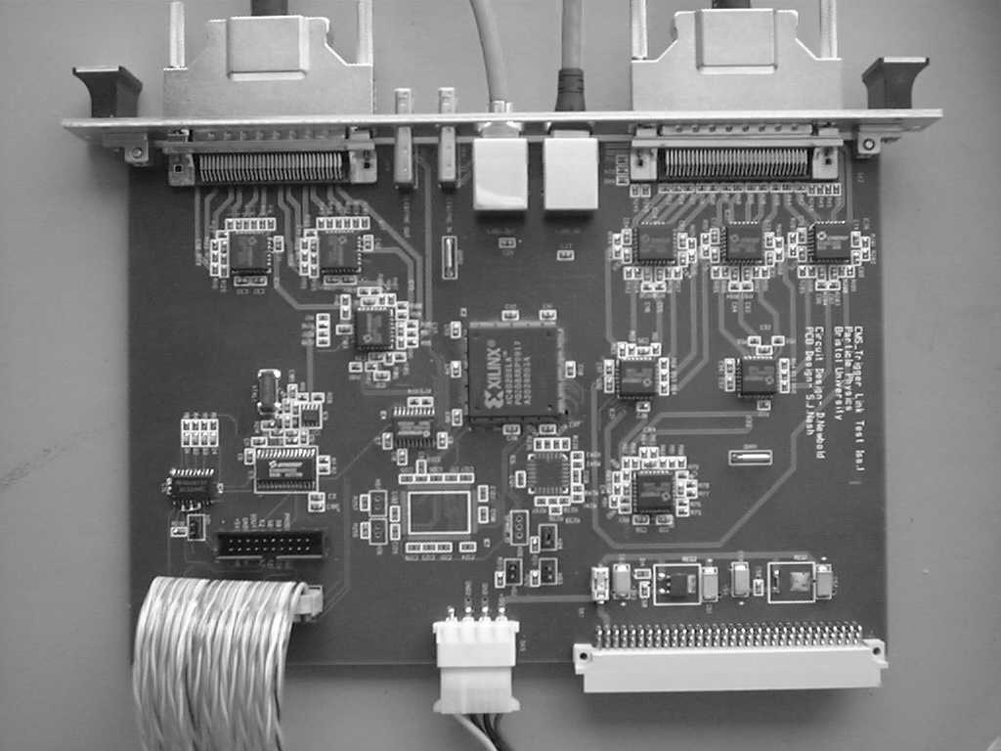
Figure 17: Global Calorimeter Trigger Link Test Board
(a) 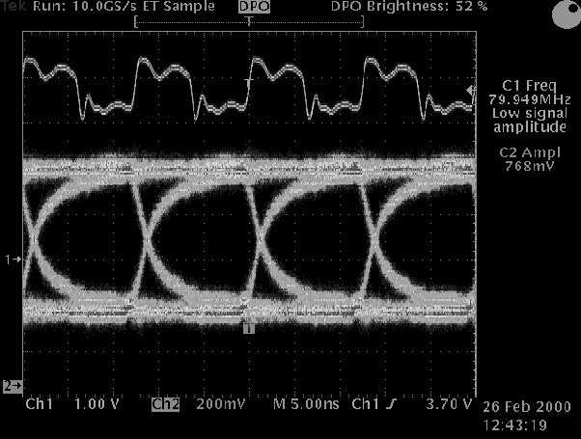 (b) 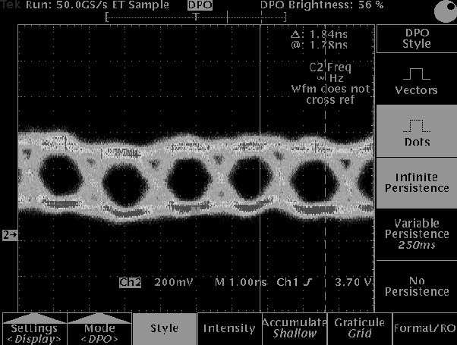

Figure 18: “Eye diagrams” showing signal quality (a) for one half of a differential ECL signal at 80 MHz, received over 25 metres of cable, and (b) for one half of a differential LVDS signal at 560 MHz, received over 2 metres of cable.

Further technology evaluation is continuing into 2001, to identify connector/cable combinations that allow the required signal density to be reached without compromising signal quality. The design of full scale prototype modules will be undertaken during 2001, and production of the final boards should begin in 2002.

PHYSICS AND COMPUTING

Physics Reconstruction and Selection

Much work has been accomplished in the collaboration, in the last year and a half, in the areas of core and physics software. After some delays the Software/Computing team and the Physics Reconstruction and Selection (PRS) group successfully passed the first Higher Level Trigger (HLT) milestone. This milestone was to measure the Level-2 rate. This is the rate obtained after reduction of the Level-1 (hardware) trigger rate, using calorimeter and muon data alone, using software which will run (eventually) on a processor farm. Obtaining this result required the full simulation of very large data samples.

The next step in the development of Physics Reconstruction and Selection software will involve bringing in the tracker information (Level-3). The simulated data sample required for this step is larger, and the UK is contributing effectively to the world-wide effort to provide the data samples of several million events, fully simulated with GEANT in the CMS detector, by generating the 600,000 jet background events required by the e/γ group, in addition to 250,000 signal and single particle events.

Keeping step with this large emerging field of effort there has been an evolution of the CMS organisational structure in this area. In November 2000 the PRS activity was established as a CMS Project, on a level with other sub-systems, and having the following scope:
- Simulation of detector signals
- Online reconstruction and physics selection (HLT)
- Offline reconstruction
- Calibration of detectors

Internally the PRS is split into four groups: ECAL-e/γ, HCAL-jet/\o(E,/)_{T}, Muon, and tracker-b/τ. The scope of the work of each group is the complete chain of detector reconstruction software. The PRS project is special in that it has no institutional resources: it must obtain its resources from the detector projects.

The UK groups aim to play an increasingly important role in this development which will pave the way to a rapid and effective contribution to physics results as soon as the data begins to flow from the CMS detector at LHC startup. A UK physicist is co-ordinator of the ECAL-e/γ group, and the UK groups are well placed to exploit the synergy between software activities: testbeam, calibration, simulation and reconstruction etc. It is to be expected that UK activity will focus on the ECAL-e/γ group and the Tracker-b/τ group. Increasingly students will be expected to work on physics topics where they can make an effective contribution to the emerging reconstruction software.

The LHCC milestones that have been set the ECAL-e/γ group refer to continuing development of the HLT selection software to demonstrate the reduction of the data rate to that which will be written to permanent storage. There is a also a requirement to demonstrate an in-situ calibration scheme for the ECAL, using the high rate of high p_{T} electrons which will be recorded by CMS.
The next HLT milestone involves the reduction of the Level-1 trigger rate by a factor of about 500, and essentially the complete reconstruction of the event in the CMS detector. Results from full simulation of this reduction are required for the HLT section of the CMS DAQ TDR, which will be submitted by the end of 2001. In the longer term, a very important step for the PRS project will be to obtain results to be presented in the Physics TDR which will be submitted at the end of 2003. This will contain comprehensive documentation of physics object reconstruction, calibration, selection efficiency and detector response, followed by detailed physics analysis of all major signals that can be foreseen or imagined for LHC.

Core computing
As part of the restructuring of software and computing activities described in the preceding section, the existing software and computing project was renamed ‘Core Software and Computing’ (CSC). The CSC project has the following responsibilities:

- To develop and support the complex software framework which underlies all physics and reconstruction tools
- To review technologies and approaches, and make policy decisions on their use
- To build the world-wide computing infrastructure which will be needed for all CMS activities
- To manage resources in order to support the present-day and future computing needs of the collaboration
- To test the CMS software and computing approach and infrastructure, and to demonstrate that it performs at the necessary level to support the planned analysis activities from LHC startup.

Both the CSC and PRS projects work in close cooperation with the Tridas project, which is responsible for trigger and data acquisition infrastructure and the hardware Level-1 trigger.

The UK collaboration has been increasingly active in the CSC project over the last year, with activities centred around the large-scale use of existing computing facilities to support the CMS PRS activities. We have also achieved good progress in the planning for our computing infrastructure in the LHC era, and have established a programme of work leading to the integration of Grid technologies into our software tools.

UK physicists and support staff made a valuable contribution to the CMS computing and physics activities by participating in the large Autumn production of Monte Carlo data. The data produced will be used over the next few months for analysis of trigger and reconstruction algorithms by the e/γ and jet/met PRS groups. This production effort was the largest yet attempted by CMS, and was largely successful, whilst revealing several limitations of our current approach. The UK produced almost the entire dataset required by the e/γ group, and this data will be used in turn by UK physicists working within this area over the coming year. The production made use both of central UK HEP computing facilities at the ATLAS centre (the CSF farm and Datastore) and of local computing facilities at Bristol. The total dataset produced in the UK was around 1 Terabyte in size, of a total of 4 TB from the whole production. We hope to participate to an even greater extent in the upcoming Spring production; we anticipate the use of significant additional resources at Imperial College for this effort, and the use of basic Grid tools to manage the production.

The additional expertise and experience gained by CMSUK physicists during the production efforts will directly enhance our contribution to the CMS PRS project. In order to further support this work, it is necessary to allow UK physicists to perform their software development and analyses using local computing facilities. This entails the provision and support of both the CMS software tools and a variety of large datasets within the UK. During the latter half of 2000, we have made considerable progress towards this goal, with up-to-date versions of the CMS CMSIM simulation code installed at Bristol, RAL and Imperial College, and the full CMS ORCA reconstruction suite (a much more complex piece of software) installed at Bristol. We have requested and recently received additional dedicated storage resources at the ATLAS computing centre to allow us to store copies of important Monte Carlo data in the UK for easy access from all CMSUK institutes. We have started the installation of a medium-scale computing farm at Bristol to support PRS work and the study of L1 trigger algorithm performance by UK physicists; this work has been undertaken in conjunction with the BaBar UK collaboration, with clear advantages gained for both groups from taking a common approach. Imperial College has recently received a large grant from the JREI fund to allow the construction of a larger computing farm which will be constructed along similar lines, and the planning for this started during 2000.

A major focus of activity with the CSC group during 2000 has been the contribution to the CERN review of LHC computing (the ‘Hoffmann review’). The UK delegate to the CSC project board played a full role in the preparation and evaluation of the CMS input to the review process. A presentation by J. Gordon on behalf of the UK collaborations of the our approach to the provision of LHC computing resources was well received by one of the main review panels. The review process is now drawing to a close, and the conclusions will be presented in public during the early part of 2001.

Within the UK, planning for the provision of CMS computing infrastructure in the period leading up to the start of the LHC has been taking place. CMSUK plans to provide and support one of the four or five Tier-1 regional computing centres which CMS will require. The CMS computing model is intrinsically distributed in nature, and so the provision of such a computing centre in the UK is essential to support the activities of UK physicists. During 2000, we started the process of careful analysis of the necessary scale of such a computing centre, and estimation of the attendant costs and personnel requirements. This planning will continue, and will take account of the ongoing refinements in the collaboration’s understanding of the chosen computing approach.

A highly significant event during 2000 was the introduction of Grid technologies as a new approach within particle physics computing, and the provision of new resources to allow the full investigation and development of these techniques. CMSUK physicists are highly involved in both the UK Grid project and the EU-funded DataGrid project. The CMS collaboration is enthusiastic about the Grid approach, and it is foreseen that CMS software will constitute the first large-scale application to be run on a HEP Grid Testbed, both within the UK and world-wide. Discussions within CMSUK of our approach to the full exploitation of Grid technologies, and of the attendant resources, are under way.

Physics studies

B-meson flavour tagging study
The B-meson flavour tagging efficiency using electrons in the decay $B_{d}→J/ψ K_{s}\text{μμππ}$ was investigated for low luminosity running at CMS by a student at Imperial College. An event sample containing b-quarks was generated using the PYTHIA simulation software, and a preselection made using a simple model of the muon acceptance for the di-muon trigger. The detector response and event reconstruction was simulated using GEANT3. The electron tagging efficiency was found to be $e_{\text{tag}}=2\text{.}\text{09}±0\text{.}\text{07}\text{\%}$ with a dilution factor of: $D_{\text{tag}}=0\text{.}\text{387}±0\text{.}\text{034}\text{.}$ If an 8:1 signal to background ratio is assumed then the statistical sensitivity of CMS to the time-integrated measurement of the CKM phase sin2β in this channel, using only electron tagging and after one year of low luminosity running, is estimated to be: δ(sin2β) = 0.066 ± 0.006_{stat}.

Time evolution of the B_{s} meson system
A Bristol student has carried out a study of the time evolution of the neutral B_{s} meson system. The Standard Model predicts a large mass difference of approximately 20 % between the physical eigenstates B₋ (CP-odd) and B₊ (CP-even) of the neutral B_{s} meson system. This mass difference leads to rapid oscillations in the time evolution of the tagged B_{s} decays. However access to the basic CP violating processes may be obtained without the need for flavour tagging. In untagged non-leptonic decays the time evolution of the system depends only on the widths Γ₊ and Γ₋ through the combination of two exponentials exp(-Γ₊t) and exp(-Γ₋t), and not on the rapid oscillations associated with the mass difference. The time evolution is shown in Figure 19.

The transition B_{s} → J/ψ φ leads to final states that are admixtures of CP-even and CP-odd configurations due to orbital angular momentum. This lack of knowledge of the final state CP parity dilutes the measurement of CP asymmetry. The B_{s} is spinless, but the decay products J/ψ and φ both carry spin and decay through the CP conserving interactions J/ψ → e⁺e⁻), φ → K⁺K⁻, and so a transversity analysis on the angular distributions of the decay products allows separation of the two CP parities and determination of the Wolfenstein parameter ν, and the width difference ΔΓ.

Figure 19. Temporal development of angular distributions for the heavy (CP-odd) and light (CP-even) eigenstates of the $B_{s}^{0}{\bar{B}}_{s}^{0}$ system. The two distributions develop as exp(-Γ_{H} t) and exp(-Γ_{L} t), where Γ_{H} and Γ_{L} are the widths of the heavy and light states, allowing the two CP states to be separated.

Electroweak physics at the LHC
A physicist at Brunel made a significant contribution to the CERN Yellow report on the prospects for Standard Model Physics at the LHC. Most of the analysis work contributed was carried out in 1999, but the final writing and editing of the appropriate report section (over 100 pages) was carried out in early 2000. This report will stand as a major reference work for the next few years, and UK physicists made important contributions to the topic of anomalous vector-boson couplings and background reduction.

Detector simulation
Monte Carlo studies of the endcap calorimeters have continued at RAL as the mechanical design of the detector has approached its conclusion. The focus during the past year has been on the position and size of the partial supercrystals which are used to achieve a near-circular profile at the outer edge of the endcap. There are severe restrictions on the space available in this region of CMS. Simulation studies have shown that only those partial supercrystals indicated in Figure 20 are required in order to maintain the desired physics performance of the detector.

Figure 20. Schematic view of the ECAL endcap. The essential partial supercrystals at the outer edge are indicated by dark shading.

Radiation monitoring system

A Brunel physicist has played a substantial role in developing a radiation monitoring system to provide maps of ionizing radiation dose and hadron fluences,. The system will be required to provide real-time dosimetry over a wide range of doses and fluences. The information provided will be used to determine machine related backgrounds, check the correct operation of the shielding system and apply
safety standards for the handling and maintenance of the detectors.

The first step toward the definition of this system was a programme of irradiation of candidate dosimeters with various particle beams using facilities at CERN and at PSI during summer 2000.

The dosimeters tested were RadFETs, neutron diodes and Optically Stimulated Luminescent (OSL) films and crystals. The RadFETs are p-channel MOSFET transistors with a calibrated sensitivity to radiation; the dosimetric parameter is the increase in threshold voltage of the transistor at constant current. The neutron diodes are specially designed p+/n/n+ diodes with wide intrinsic region; the dosimetric parameter is the change in forward voltage when biased with a constant current. The OSL films are rare-earth-doped alkaline sulphides; the dosimetric parameter is the light emitted following optical stimulation. Both RadFETs and OSL films are sensitive to ionizing radiation dose, while the neutron diodes are sensitive to hadron fluence. The difference in sensitivity for RadFETs and OSL make them complementary.

The RadFETs were provided by three different suppliers: NMRC (Ireland), REM.(UK), and Thomson and Nielsen (Canada). The neutron diodes were provided by the University of Wollongong. The OSL films were provided by the University of Montpellier.

The programme included irradiations with the following beams:

- 300 MeV π⁻ - RadFETs
- 500 MeV e⁻ - RadFETs, neutron diodes and OSL films and crystals.
- 3.6 GeV π⁻ - RadFETs, neutron diodes and OSL films
- 23 GeV protons - RadFETs, neutron diodes and OSL films
- neutrons - RadFETs

The RadFETs and neutron diodes were read out online, while the OSL films were sent back to Montpellier for passive readout. An online readout of an OSL crystal was implemented using an LED to stimulate the crystal and a photo-multiplier to detect the light in output: this test proved the feasibility of online dosimetry with the OSL detectors.

The irradiation of the RadFETs and neutron diodes was intended to demonstrate that these dosimeters can be used to monitor mixed radiation fields up to very high doses and fluences. An example of a response curve for the RadFETs is shown in Figure 21, while Figure 22 shows the response curve for the neutron diodes (one of the two diodes was not centred to the beam, and received only half the fluence).

Another round of irradiations is foreseen for summer 2001. The aim will be to define in a more quantitative way parameters like the sensitivity, to study room temperature annealing and to reach higher hadron fluences.

Figure 21. Response curves for RadFETs irradiated with 500 MeV e⁻ at CERN: a) average over 3 A1, A2, A3; b) average over 3 B; c) average over 2 C.

Figure 22. Response curves for two neutron diodes irradiated with 500 MeV e⁻ at CERN. a) Curves for the total fluence reached; b) zoom in the linear region, up to 3.6×10¹³ e/cm².

Conclusion and summary

The CMS Collaboration has made considerable progress during 2000 towards the goal of installing a working detector in time for the first LHC collisions. Construction of the infrastructure at the experimental site is under way, and the major contracts have been placed for the fabrication of the superconducting magnet, the most expensive single component of the detector.

Of the major subdetector systems, delivery of components for the Hadron and Electromagnetic calorimeters is proceeding satisfactorily, while the “All-Silicon” Tracker design has received approval from the CERN Research Board.

The resources of the Collaboration have been enhanced by new collaborators from Korea, China-Taiwan and the US, and it is expected that further groups will join the experiment in the near future.

The UK groups have had a successful year. The Imperial College and RAL groups have conducted a series of very successful tests on the APV25-s0 chip, showing excellent radiation hardness. Prototypes of the Front End Driver modules have produced very encouraging results in beam tests using an LHC-like beam at CERN.

The Electromagnetic Endcap Calorimeter project has taken two major steps forward
during the year. Firstly, the supercrystal design was rigorously examined in the Engineering Design Review in late 2000. While the written report on the review is not yet complete, it is expected that the design will be approved without significant modifications. Secondly, the UK groups took delivery of a preproduction batch of 500 Vacuum Phototriodes from RIE, St Petersburg. The RAL and Brunel groups have commissioned automated test rigs to appraise the performance of these devices before placing a tender for the supply of 16000 VPTs to equip the whole detector. Tests have been carried out to study the thermal stability of the detector, and to determine the sensitivity of the VPTs to accidental exposure to helium. At RAL, a large clean room for supercrystal assembly is almost complete.

The Bristol group have continued to take a leading role in undertaking beam tests of ECAL prototype modules, and developing algorithms for the global calorimeter trigger.

With most of the major design issues now decided, the coming years will see the UK groups, in common with the rest of the CMS Collaboration, moving into the construction phase of the experiment. Increasing effort will also be devoted to developing computing infrastructure to analyse the data, and to physics studies, so that UK physicists and students will continue to play a major role in CMS when data-taking begins in 2006.
PUBLICATIONS

Journal papers

A study of the monitoring of radiation damage to CMS ECAL crystals, performed at X5-GIF,
G. Davies, C. Seez, A. Singovski and J.P. Peigneux,
J. Phys. G: Nucl. Part. Phys. 26 (2000) 1735-1749

Test Results of Heavily Irradiated Si Detectors
S. Albergo, et al
Nucl. Instr. And Meths A422 (1999) 238-241.

The CMS silicon microstrip detectors: research and development,
N. Bacchetta, et al
Nucl. Instr. and Meths. A426 (1999) 16-23

Defect kinetics in Novel Detector Materials.
B C MacEvoy, G Hall.
Presented at the 1st ENDEASD Workshop, Santorini, April 21-22 1999.
Accepted for publication in Materials Science in Semiconductor Processing.

Defect Engineering Rad-Hard Tolerant Silicon Detectors: The role of impurities and inter-defect charge exchange
B. MacEvoy, A. Santocchia, G. Hall
Presented at the 20th International Conference on Defects in Semiconductors, Berkeley, July 26-30 1999.
Physica B: 273-274 (1999) 1045-1049..

LHC front end electronics
G. Hall
Invited paper presented at INSTR99, Hamamatsu, Japan, November 1999.
Nucl. Instr. & Meths. A453 (2000) 353-364

Design and results from the APV25 Deep Sub-micron Readout Chip for the CMS tracker.
M. J. French, L. L. Jones, Q. Morrissey, A. Neviani, R. Turchetta, J. Fulcher, G. Hall, E. Noah, M. Raymond, G. Cervelli, P. Moreira
Hiroshima STD Symposium, March 2000.
To be published in NIM

The CMS Tracker APV25 0.25 μm CMOS Readout Chip
M.Raymond, G.Cervelli, M.French, J.Fulcher, G.Hall, L.Jones, L-K.Lim, G.Marseguerra, P.Moreira, Q.Morrissey, A.Neviani, E.Noah
Paper presented at 6th Workshop on Electronics for LHC Experiments, Krakow, September 2000.
LHC Electronics _Board Workshop. CERN Report CERN 2000-010 (2000) 130-134.

The CMS Tracker front-end and control electronics in an LHC-like beam test.
W.Beaumont, M.Bozzo, C.Civinini, J.Coughlan, F.Drouhin, P.Figueiredo, L.Fiore, A.Giassi, K.Gill, J.Gutleber, G.Hall, L.Latronico, C.Ljuslin, M.Loreti, C.Maazouzi, A.Marchioro, N.Marinelli, C.Paillard, T. Parthipan, P.Siegrist, L.Silvestris, I.Tomalin, A.Tsirou, P.G.Verdini, P.Walsham, B.Wittmer, A.Zghiche, F.Vasey
Paper presented at 6th Workshop on Electronics for LHC Experiments, Krakow, September 2000.
LHC Electronics _Board Workshop. CERN Report CERN 2000-010 (2000) ***

Single Event Upset Studies on the APV25 Front End Readout Chip
J. R. Fulcher, E. Noah, G. Hall, M. Raymond, D. Bisello, A. Paccagnella, J. Wyss, M. J. French, L. Jones, M. Huhtinen, F. Faccio
Paper presented at 6th Workshop on Electronics for LHC Experiments, Krakow, September 2000.
LHC Electronics _Board Workshop. CERN Report CERN 2000-010 (2000) 260-264.

Total Dose Irradiation of a 0.25µm Process
E. Noah, N. Bacchetta, D. Bisello, A. Candelori, I. Dindoyal, P.G. Fuochi, M.J. French, G. Hall,
M. Raymond, M. Vassanelli
LHC Electronics _Board Workshop. CERN Report CERN 2000-010 (2000) 555-559.

Design of the Front-End Driver Card for CMS Silicon Microstrip Readout.
- Baird, K. Bell, J. Coughlan, R. Halsall, W. Haynes, I. Tomalin.
Paper presented at 6th Workshop on Electronics for LHC Experiments, Krakow, September 2000
LHC Electronics _Board Workshop. CERN Report CERN 2000-010 (2000) 444-448.

The APV25 0.25μm CMOS Readout Chip for the CMS Tracker
M.Raymond, M.French, J.Fulcher, G.Hall, L.Jones, K. Kloukinas, L-K.Lim, G.Marseguerra, P.Moreira, Q.Morrissey, A.Neviani, E.Noah
IEEE 2000 Nuclear Science Symposium, Lyon, France.

The CMS silicon strip tracker
Focardi E, et al
Nuclear Instruments & Methods In Physics Research A 435 (1999) 102-108

R&D for the CMS silicon tracker
Feld L, et al
Nuclear Physics B-Proceedings Supplements 78 (1999) 322-328

The R&D program for silicon detectors in CMS
Tonelli G, et al
Nuclear Instruments & Methods In Physics Research A435 (1999) 109-117

The silicon microstrip tracker for CMS
Pandoulas D, et al
Nuclear Physics B-Proc. Suppl. 78 (1999) 315-321

High-voltage breakdown studies on Si microstrip detectors
Albergo S, et al
Nuovo Cimento Della Societa Italiana Di Fisica 112: (1999) 1271-1283

The silicon microstrip tracker for CMS
Albergo S, et al
Nuovo Cimento Della Societa Italiana Di Fisica 112: (1999) 1307-1316

Performance of CMS silicon microstrip detectors with the APV6 readout chip
Meschini M, et al
Nucl. Instr. and Meths. A447 (2000) 133-141.

New results on silicon microstrip detectors of CMS tracker
Demaria N, at al
Nucl. Instr. and Meths. A447 (2000) 142-150.

Numerical simulation of neutron radiation effects in avalanche photodiodes.
Osborne MD, Hobson PR, Watts SJ
IEEE Transactions on Electron Devices, vol.47 (2000) 529-36

The Development of Vacuum Phototriodes for the CMS Electromagnetic Ca;lorimeter
Bell KW, Brown RM, Cockerill DJA, Flower PS, Hobson PR, Imrie DC, Kennedy BW, Lintern AL, Pattison CAX, Sproston M, Williams JH
Accepted by Nucl Instr and Meths A

Conference contributions

Front end electronics Developments for Particle Physics: Paradigm or Paradox?
G. Hall
Invited paper published in ICFA Instrumentation Bulletin, Vol 20, Spring 2000.
http://www.slac.stanford.edu/pubs/icfa/

Proceedings of the 1999 Standard Model Workshop on Standard Model Physics (and more) at the LHC
Haywood S, Hobson PR, Hollik W., Kunszt Z et al, edited by G Altarelli and M Mangano
CERN Yellow Report CERN-2000-004
hep-ph/0003275
Gamma radiation tolerance of vacuum phototriodes for Particle Physics applications
Camanzi B, Hobson PR, Imrie DC, Ionescu S,
Les journees Techniques du RADECS 2000 (11-13 Sept 2000), Resume, pp 87-90
The Lead Tungstate Calorimeter for CMS
Brown RM
IX International Conference on Calorimetry in Particle Physics, Annecy Oct 9-14 2000
To be published in Frascati Phyics Series

Refereed CMS Notes

The Effect of Tracker Material on The Level-1 Electron Trigger
C. Seez
CMS Note 2000/031
A Stabilised Blue-Violet LED for VPT Photocathode Evaluation
Hobson PR, Selby CW
CMS NOTE 2000/023
Tests on 1999 Vacuum Phototriodes for the CMS Ecal Endcaps
Camanzi B, Ergun G, Hobson PR, Imrie DC
CMS NOTE 2000/010
Monte Carlo Studies of the CMS Electromagnetic Endcap Calorimeter
Kennedy, B W
CMS NOTE 2000/030
CMS ECAL Endcap geometry specification
Kennedy B W
CMS NOTE 2000/029
Energy Leakage in the Barrel/Endcap Transition Region of the ECAL II: Simplified Endcap Designs and Hadronic Energy Containment
Kennedy B W
CMS NOTE 2000/012

 Associated institute

 Glass Science, R H Doremus, John Wiley & Sons Inc, 2nd edn (1994), p.141.

