THE COMPACT MUON SOLENOID (CMS) DETECTOR

PROPOSAL 892

UNITED KINGDOM
Bristol University; Brunel University; Imperial College, London; CLRC Rutherford Appleton Laboratory; Univ of the West of England*; Univ of Strathclyde*

OTHER CERN MEMBER STATES
AUSTRIA: HEPHY, Vienna; BELGIUM: Univ Libre, Brussels; Vrije Univ, Brussels; Univ Cath. Louvain, Louvain; Univ Antwerpen, Wilrijk; Univ Mons Hainaut, Mons; CERN; FINLAND: Helsinki Inst. Phys., Helsinki; Phys. Dept., Helsinki Univ, Helsinki; Helsinki Univ Tech, Helsinki; Jyväskylä Univ, Jyväskylä; Oulu Univ, Oulu; Tampere Univ of Technology, Tampere; FRANCE: LAPP, Annecy; Inst. Phys. Nucl., Lyon; LPNHE Ecole Polytechnique, Palaiseau; DAPNIA, Saclay; CRN-ULP, Strasbourg; GERMANY: I. Phys. Inst., RWTH Aachen, Aachen; III. Phys. Inst. A, RWTH Aachen, Aachen; III. Phys. Inst. B, RWTH Aachen, Aachen; Humboldt University, Berlin; Inst. Exp. Kernphysik, Univ Karlsruhe, Karlsruhe; GREECE: Univ Athens, Athens; NRCPS Demokritos, Attiki; Univ Ioannina, Ioannina; HUNGARY: KFKI, Hung. Acad. Sci., Budapest; Inst. Nucl. Res. ATOMKI, Debrecen; Kossuth Lajos Univ, Debrecen; ITALY: Dip. Fisica dell’Univ and Sez. dell’INFN: Bari; Bologna; Catania; Firenze; Genova; Legnaro∗; Padova; Pavia; Perugia; Pisa; Roma I; Torino; POLAND: Inst. Experim. Physik, Univ Warsaw, Warszawa; Soltan Inst. Nucl Studies, Warszawa; PORTUGAL: LIP, Lisbon; SLOVAK REPUBLIC: Slovak Inst. Technology, Bratislava; SPAIN: CIEMAT, Madrid; Univ Autonoma, Madrid; Cantabria Univ, Santander; Univ Oviedo; SWITZERLAND: Univ Basel, Basel; PSI, Paul Scherrer Institute, Villigen; ETH, Eidgen. Techn. Hochschule, Zürich; Univ of Zurich, Zurich

NON-MEMBER STATES (Except USA)
ARMENIA: YerPhI, Yerevan; BELARUS: INP, Byelorussian State Univ, Minsk; NCPHEP, Nat. Sci. and Educ. Centre of P’cle and High Energy Physics, Minsk; RIAPP, Research Inst. Appl. Phys. Probl., Minsk; Dept. of Physics, Byelorussian State Univ, Minsk; BULGARIA: Inst. Nucl. Res. + Nucl. Energy, Sofia; Univ of Sofia, Fac. of Phys., Sofia; CHINA PR: Institute of High Energy Physics, Beijing; Peking Univ Beijing; Univ of Science & Technology of China, Hefei; CHINA (TAIWAN): National Central University, Chung-Li; National Taiwan University (NTU), Taipei; CROATIA: Univ of Split, FESB, Elect. and Mech. Eng. Dept; Univ of Split, PMF, Dept. of Natural Sciences; Tech Univ Split; CYPRUS: Univ of Cyprus, Nicosia; ESTONIA: Inst. Chemical Physics and Biophysics, Tallinn; GEORGIA: Inst. Phys. Academy of Science, Tbilisi; Inst. HEP, Tbilisi State Univ; INDIA: Bhaba Atomic Res. Centre, Tata Institute (HECR), Tata Institute (EHEP), Mumbai; Panjab Univ, Chandigarh; Univ of Delhi South Campus, Delhi; KOREA: Cheju Nat. Univ, Cheju; Chungbuk Nat. Univ Chongju; Kangwon Nat. Univ, Chunchon; Wongwang Univ, Iksan; Chonnam Nat. Univ, Kwangju; Dongshin Univ, Naju; Seonam Univ, Namwon; Kon-Kuk Univ, Seoul; Korea Univ, Seoul; Seoul Nat Univ, Seoul; Seoul Nat. Univ Educ., Seoul; Kyungpook Nat. Univ, Taegu; PAKISTAN: Quaid-I-Azam Univ, Islamabad; G I Khan Inst, Swabi; RUSSIA: JINR, Dubna; INR, Moscow; ITEP, Moscow; Lebedev Physical Institute, Moscow; MSU, Moscow; IHEP, Protvino; Petersburg Nucl. Physics Inst., St. Petersburg; RFNC-VNIITF, Snezhinsk∗; TURKEY: Cukurova Univ, Adana; Middle East Tech. Univ, Ankara; Bogazici University, Istanbul; UKRAINE: Kharkov State Univ; NSC-KIPT, Kharkov Inst. of Phys. and Tech., Kharkov; Inst. of Monocrystals, Kharkov; UZBEKISTAN: INR, Uzbekistan Acad. of Sciences, Tashkent

USA
Boston University; Caltech, Pasadena; Univ of California at Davis; Univ of California at Los Angeles; Univ of California at Riverside; Univ of California at San Diego, La Jolla; Carnegie Mellon Univ, Pittsburgh; Fairfield Univ, Fairfield; Fermilab, Batavia; Florida State Univ, Tallahassee; Univ of Florida, Gainesville; Johns Hopkins Univ, Baltimore; Univ of Illinois, Chicago; Univ of Iowa, Iowa City; Iowa State Univ; Univ of Maryland, College Park; Massachusetts Institute of Technology, Boston; Univ of Minnesota, Minneapolis; Univ of Mississippi; Univ of Nebraska-Lincoln, Lincoln; Northeastern Univ, Boston; Northwestern Univ, Evanston; Univ of Notre Dame; Ohio State Univ, Columbus; Princeton Univ, Princeton; Purdue Univ, West Lafayette; Rice Univ, Houston; Univ of Rochester; State Univ New Jersey, Rutgers; Univ Texas, Dallas; Texas Tech Univ, Lubbock; Virginia Polytech. Inst. and State Univ, Blacksburg; Univ of Wisconsin, Madison

INTRODUCTION and overview

CMS, the Compact Muon Solenoid experiment, is a general-purpose detector for the Large Hadron Collider currently under construction at CERN. CMS will identify muons, photons and electrons, and measure their momenta and energies with high precision. The detector will be capable of studying the full range of LHC physics and is optimised to search for the Higgs boson over the mass range from 90 GeV/c² to 1 TeV/c².

The CMS project has made excellent technical advances in 2001 and there has been important progress in the provision of the experimental infrastructure. A key feature of the underground construction is the enormous pillar that separates the experimental hall from the underground service cavern. The construction of this was delayed by three months because of geological problems, but it has now been completed and excavation of the two caverns is well under way. The service buildings on the surface at IP5 have been handed over to CMS.

Major elements of the experiment are taking shape in the main surface building. All of the 12,000 tons of steel for the magnet yoke has been delivered to CERN and assembly of the five barrel sections and one of the endcaps has been finished. The hadron calorimeter passed an important milestone in December with the completed assembly of the first half-barrel, shown in Figure 1.

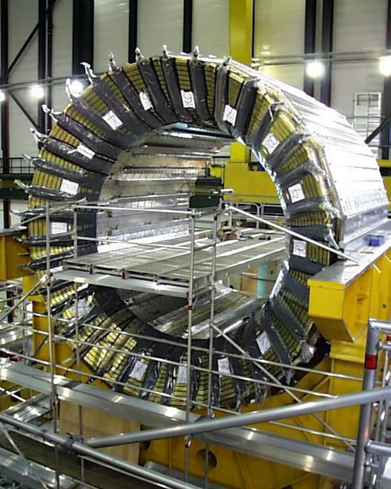
Figure 1. View of the CMS hadron calorimeter in a surface building at IP5.

The delivery of conductor components for the coil is proceeding well. Cables of very high quality have been fabricated from the superconductor strands and real ‘inserts’ have been produced by co-extruding the cables with pure aluminium. The electron beam welding line that reinforces the inserts with aluminium alloy has been commissioned and a 2.6 km length of conductor has been produced for the coil winding prototype. Overall, the magnet project is on schedule for completion of the magnet test in the surface building in July 2004.

Despite the difficult financial situation at CERN, within CMS and within the UK, the physics goals of the project are as compelling as ever and morale within the collaboration remains high.

The following sections of this report record the impressive progress made on the UK project with CMS over the past year.

TRACKER AND DATA ACQUISITION

General tracker progress and project status

The last year has seen steady progress towards large scale construction of the CMS silicon microstrip tracker. Construction is now expected to ramp up considerably during 2002. Following approval in CERN and the various funding agencies concerned in the financing, the two contracts for the sensors have been negotiated and agreed. The first of these, with Hamamatsu, has now been signed and the second is expected to be signed in the very near future. The commercial development of the front end hybrid is well under way and a series of modules equipped with all the final electronics has been installed and operated very successfully in CERN test beams, including an LHC-like 25ns beam in November.

Tenders for almost all of the optical link components have been received and have been endorsed by the CERN Finance Committee, leading to contracts in early 2002. Given the complexity and scale of the contractual process, this is an important step forward since now all the major tender actions are practically complete and commitments can be made to large scale purchases. In addition the overall budgetary outcome has been close to that foreseen, with significant savings in some areas offsetting extra costs elsewhere. The remaining ASICs required for the tracker were delivered from engineering runs in August and all the designs were very successful, including the first iteration of a complex digital control chip, the CCU. Thus the set of custom chips required for the tracker is essentially complete. Verification of full operation in system tests is underway and it is hoped that this will lead to submission of large scale engineering runs defining final masks early in 2002.

An effort has been made to reduce the material budget of the Tracker. Studies of detailed engineering designs have been performed using detailed GEANT simulations, and small improvements have been adopted which have beneficial consequences.

The Annual Review by the LHCC in September 2001 was very positive about the progress which had been achieved in the last year and complimented the project management, although recognising that the completion schedule is still an aggressive one. The tracker is organised, from the production viewpoint, geographically into three major areas: outer barrel (largely USA and CERN), inner barrel (Italy) and endcaps (remainder Europe). The UK is one of the countries not associated with a specific area because of its cross-detector responsibilities for electronics.

In the UK, considerable effort has been spent during 2001 on the implementation of the APV25 and APVMUX multiplexer chip in system tests and modules, development of the final CMS Front End Driver and software development activities. The status of the various items is summarised below.

Preparation for module construction
Sensor testing centres are now operational. Some automated assembly gantries are operational, others progressing as expected. Bonding is not seen as problematic and a production database is also progressing well. Multi-module testing to reach an average rate of 40 modules/day will be limited in the near future by the availability of some components of the readout chain and infrastructure such as power supplies. Figure 2 shows an assembly gantry, while a closer view of the gluing tool is shown in Figure 3. A completed module can be seen in Figure 4.

The problem of testing many individual modules is gradually being overcome, as well as the need to commission sub-structures of the tracker and to operate a few tens to a few hundred modules at the same time. For efficiency, this must be done using the same read-out chain and the same power supplies as for operation in CMS. This imposes important constraints on the FED and power supply schedules.

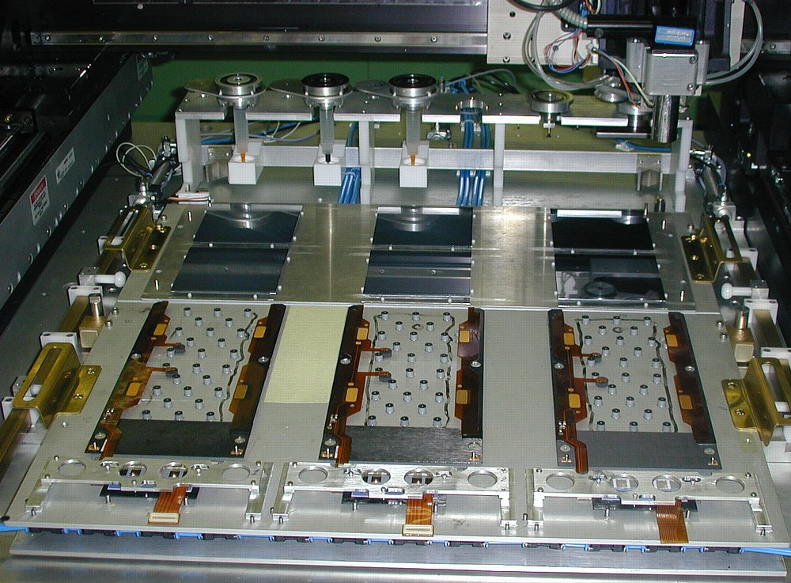
Figure 2. A CMS Tracker gantry system for automatic module assembly.

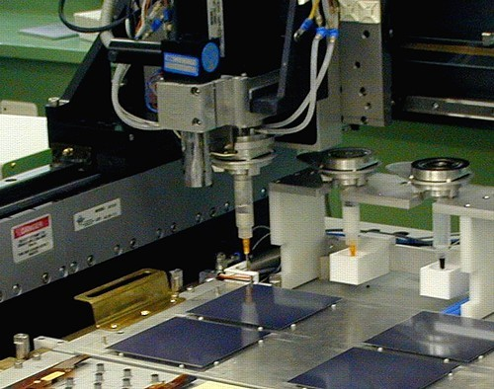
Figure 3. A close-up of the gantry system showing the tool head ready to dispense glue.

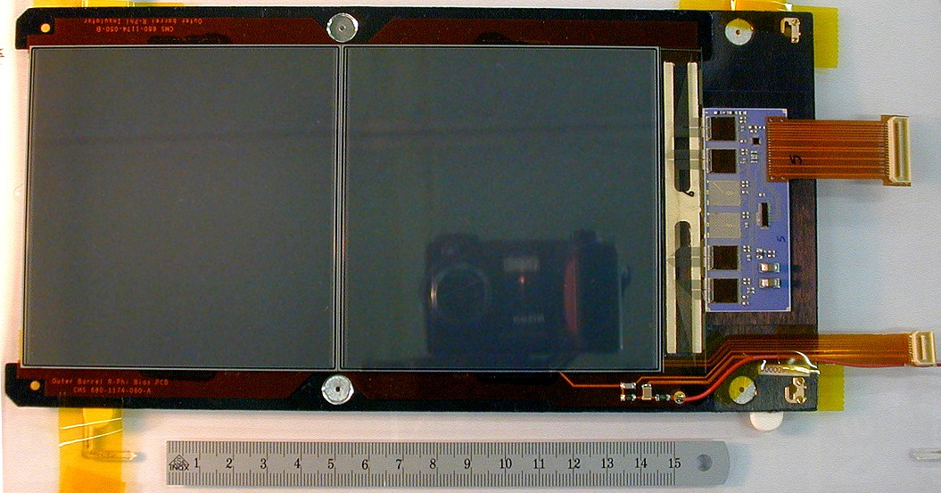
Figure 4. A silicon tracker module after assembly. The 4 APVs are mounted on a standard hybrid which can take up to 6 chips. The smaller rectangular chip is the APVMUX while the square chip is the DCU.
Module production is the major item which cannot be compressed much to keep pace with the overall CMS and LHC schedule. Even though there is excess production capacity within the collaboration, there are expected to be bottlenecks in testing which could limit the throughput.

The performance of the assembled modules is monitored using a β source. Examples of the pulse height spectra are shown in Figure 5.

Figure 5. Pulse height spectra from an assembled silicon tracker module taken in the laboratory at Imperial College using beta particles.

Sensors
The first milestone sensors, ordered following the PRR (Procurement Readiness Review) in June 2000, have been received and the quality is good. Sensors from the final production are now being delivered. A special contract was made with one of the vendors of the milestone sensors to continue the production of Outer Barrel sensors at a low rate until the start of final production. This should ensure a steady flow of sensors to keep production lines moving.

Front End Electronics

APV25 and APVMUX development
An engineering run of four wafers dedicated to the APV25 and the APVMUX-PLL chip and standard test structures was submitted in May 2000. The first chips were delivered to the UK in September 2000. A purchase of 6 additional wafers was subsequently possible which provided a reasonable number of wafers for probe testing and APV25 die (~300 per wafer). Figure 6 shows a 0.25μm wafer on the automatic probe station.

The final modifications to the APV25 were completely successful. All tests have been extremely positive and the chip is considered complete. Nine complete wafers have been probe tested with an average yield of ~75%. Only perfect chips are accepted so this is an impressive result for such a large and complex circuit. An order of 48 wafers has recently been placed to allow large scale milestone and early production modules to be constructed.

A Single Event Upset (SEU) test of the APV25 was carried out in a 300MeV/c pion beam at PSI in December 2000. There is good agreement between predictions based on heavy ion data and these measurements. The SEU rate is very low so there is no concern for operation in LHC. The 0.25µm technology was also demonstrated to be very robust. Eight APV25s were each exposed to twice the fluence expected from 10 LHC high luminosity years. No permanent damage was seen. Although only 8 chips, a more relevant number is the 4 million transistors in which no damage was seen. One can be especially confident of the digital logic scrutiny, and ~200,000 transistors can very confidently be asserted to have no permanent damage.

A problem was identified with the APVMUX produced on the APV25 wafers, traced to a subtle technological feature used to achieve high speed performance for certain circuits in the process, and not picked up by Design Rule Checks. The design was resubmitted in a May 2001 MPW run and returned in August. A monitoring circuit, the DCU, designed in CERN and Italy, was also finalised in the same iteration.

Figure 7 shows the results of noise measurements made on the APV25 chip as a function of temperature. The APV25 now meets the requirements of CMS.

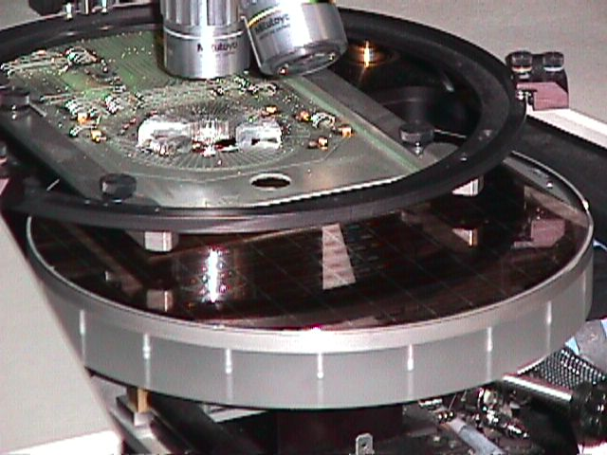
Figure 6. A photograph of an 8-inch diameter 0.25µm CMS wafer containing APV25 die on the automatic probe station.

Figure 7. Results of APV25 noise measurements as a function of chip temperature.

Front end hybrid
The first hybrid prototype of the most difficult hybrid (Inner Barrel with 6 APV) was produced in October 2000 by Strasbourg. During the first tests, instabilities were seen when operating the hybrid with 6 APVs. This was attributed to some features of this very compact layout. In particular two of the pads of the APV should be connected to very low impedance (few mΩ) power lines and the resistance was higher than anticipated. It was a good idea to test directly the most complex case since the problem could subsequently have occurred at the system level via a feedback path in the power lines. The reason for the fault was identified by the UK team who proposed, simulated and tested a solution which has been shown to be very robust at the system level.

The first, apparently satisfactory, results from the corrected TOB hybrid prototype were available in April 2001 and production of larger quantities is now under way. In parallel the procurement of hybrids in industry has begun for Milestone 200 which foresees the construction of 200 modules. A market survey for the FE hybrid has been undertaken, aiming for final production to commence at the beginning of 2002.

Opto-electronics
A successful Procurement Readiness Review was held in May. The presentations to the PRR Committee clearly demonstrated many years of very careful development. The Committee was satisfied that the Analogue Optical Links factorise, i.e. there is no risk to the Tracker project by proceeding with the link procurement. The committee recommended the procurement of the Tracker analogue Optical Links. They concluded that this is very professionally engineered by a very competent team.

Front End Driver developments
A batch of 30 further PCI Mezzanine Card (PMC) FEDs has been constructed to cover the requirements for beam tests and module testing during production. Construction of the final FED must begin soon to be ready for next year. This module is needed for testing large assemblies of rods, petals and TIB sub-units, but it could not be finalised until the analogue optical link receiver was defined. This now only awaits final contract. To be compatible with Tracker module assemblies the next version of the FED must include an optical interface. The modelling of FED buffers and memory requirements is well advanced. The FPGA requirements are being modelled in detail; these are for data processing (clusters, zero suppression, pedestals, etc) and for data management (packing, communications with DAQ and internal buses, etc). There is now a strong RAL-IC team in place and the target is for a pre-production final FED in mid-2002, available in small quantities for limited numbers of sites in 2003. A User Requirements Document defining the final functionality has been written and approved by the Tracker community.

System developments
A major milestone for 2001 is the production of 200 complete modules in order to demonstrate the completion of the production facilities and to provide modules for a system test of an Outer Barrel rod, followed by similar tests of Inner Barrel and End Cap units. A system of final components is being constructed in a CERN lab with a UK staff member on LTA playing significant roles. Several electronics reviews have taken place in 2001, leading to an Electronics System Review before large production quantities are ordered.

Software
One year ago, the Tracker community decided to restructure the organisation of its software development. It organised internal MoUs, both for the on-line and off-line software, so that institutes would make long-term commitments to particular activities in this shared enterprise. This is now progressing well. The proposed UK contributions follow naturally from our hardware role, in that they are closely related to the APV and FED. This also provides a natural path to the physics.

Regarding on-line software: the UK proposes to produce software for APV and FED system related functions, such as that used to control, calibrate, readout and monitor the final Tracker FEDs. Continued participation in test-beams will be necessary to test this software during its development.

Off-line software is organised within the context of the CMS CPT (Computing, Physics and Triggers) software group. The UK has taken charge of the CMS Tracker Data-Handling group. This is responsible for providing the basic tools used for off-line analysis of test-beam data, and will ultimately also ensure that data from the final Tracker can be accessed by the off-line reconstruction software. The group will also play a role in preparing the DAQ TDR, and in proposing the data processing algorithms which will be used by the FED and FED crate controller. Staff from RAL and Imperial are already actively involved and it is planned that an RA from Brunel will join this activity shortly. There is also a wish to become involved in physics preparation activities, as effort permits.

ELECTROMAGNETIC CALORIMETRY

Overview
The UK has the lead responsibility for the design and construction of the CMS crystal Endcap Electromagnetic calorimeters (EE). This work is being carried out in close collaboration with institutes from Russia together with groups providing common items that will be used throughout the barrel and endcap regions of the detector.

The endcap calorimeters comprise a total of 14,648 slightly tapered lead tungstate crystals, each approximately 3x3x22 cm³ in size, read out with one inch diameter Vacuum Phototriodes (VPTs). The majority of the EE crystals are contained within identical 5x5 units (25 channels) known as supercrystals (SCs). The crystals are supported within the SCs by thin walled (400 μm) carbon fibre alveolar structures. The final arrangement of the SCs on a quadrant of a CMS endcap is shown in Figure 8. This arrangement was concluded in April 2001 after detailed Monte Carlo studies to optimise the physics response at the inner and outer perimeters of the detector.
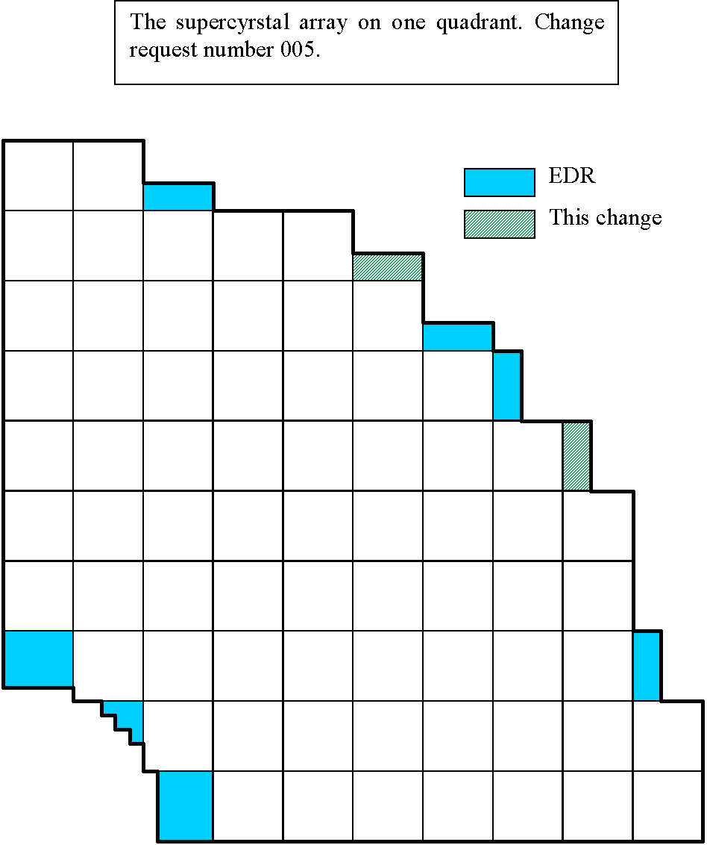
Figure 8. The final arrangement of complete and partial supercrystals on an endcap quadrant. The shading indicates the most recent revision of the design.

The EE has made significant progress over the past year. 500 pre-production VPTs were appraised in the test rigs at Brunel and RAL with most meeting the performance requirements of CMS. Figure 9 shows a VPT, with a pen alongside to illustrate the compact size. More details of the appraisal procedure are given below. A final contract specification for the mass production of VPTs was agreed with the producer, RIE (Research Institute Electron, St Petersburg, Russia), in May 2001. The final contract was signed with RIE in October 2001, for 15,000 devices. In December 100 production VPTs were shipped to the UK. The delivery rate is expected to be 4000 devices per annum.

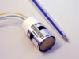
Figure 9. An example of a 1-inch VPT from the preproduction batch.
The first pre-production set of 100 EE crystals was delivered to CERN in May 2001 from the Bogoroditsk plant in Russia. The crystals have been extensively studied at the Crystal Laboratory at IC and also by CERN, ETH-Zurich and Rome. The optical and scintillating characteristics of most of these crystals are close to meeting the requirements of CMS.

A total of 250 alveolar structures for the SCs have now been made by the aerospace company Myasichev which is situated near Moscow. This quantity represents 90% of the number required for one complete endcap in CMS. A further 100 alveolar structures are expected in 2002. An example of an alveolar structure and its associated components is shown in Figure 10.

Following the engineering design review in Nov 2000, CMS gave the green light to launch the tender action for the mass production of the SC mechanics in April 2001. Final detailing for the tender action is close to completion. The SCs will be produced at the Regional Centre at RAL. The laboratory area has been completed and the facility is now being fitted out with jigs, tooling and test equipment.

Preparations have been made for the tendering and purchase not only of the SC mechanics but also for the large EE mechanical items such as the Dee backplates, the support flanges to the endcap HCAL (HE), and the environmental screens. This has involved the appraisal of a number of Russian companies, prior to the next engineering design review of EE expected in summer 2002.

The detailed design work on the backplates has been complemented by the construction of a prototype through section of the EE comprising a backplate, 2 cantilevered full sized SCs, their 50 cm readout lines and readout electronics, representing as closely as possible the final electrical layout on CMS. Data have been taken with the set-up to study electrical noise and pickup.

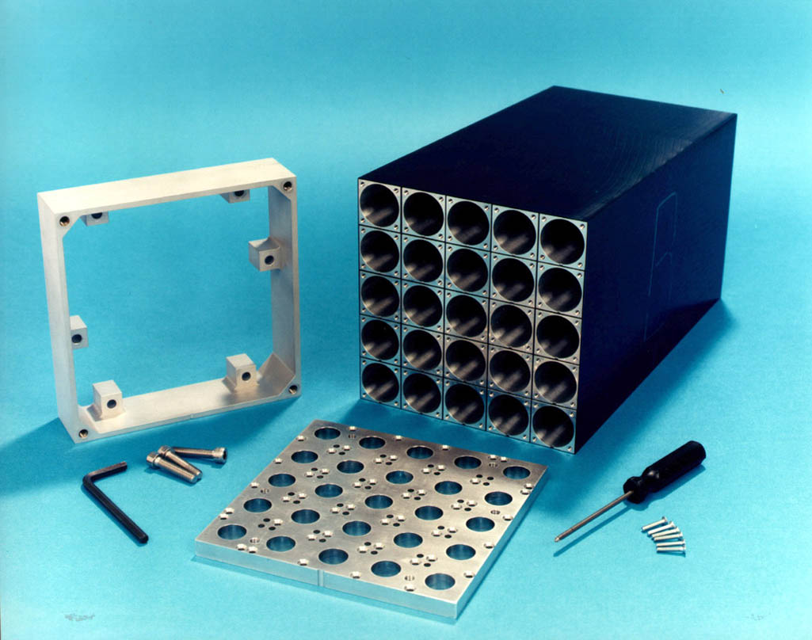
Figure 10. An alveolar structure and associated mechanical components.

Endcap design and prototyping
Work has concentrated on firming up the design wherever possible, subject to uncertainties in the electronics heat output, the low voltage power supply scheme, and the arrangements for fibre optic data lines. A new mechanical engineer has joined the team to replace a retired engineer, and he has continued to work on the 3D solid model of the Dee mechanics. We have started to visit potential manufacturers of the mechanical items. A valuable collaboration has been established with our Russian colleagues which is resulting in important work on mechanical and thermal finite element analysis and detailed mechanical design. Work on the thermal design is close to a conclusion on the requirements for cooling pipes; this information has been requested by CMS in order to allow for the early installation of some of the pipes.

An electronic test rig has been produced, comprising a section of the backplate, two supercrystals (with a possibility to increase this number to four), and associated mechanics. This model has been used to test the electronics as far as possible, including a comparison of the two potential designs of the umbilical cable. Work on the electronics was somewhat delayed by the announcement late in the year that the heat output from the VFE (very front-end electronics) cards may be higher than expected. This is likely to require significant reworking of our designs, and clarifying this issue will be an important area of work in early 2002.

Work in the coming year will focus on:

- Clarifying the design of the VFE arrangements, especially as regards knock-on effects on the endcap backplate and support structures.

- Holding an Engineering Design Review to clear production of the major mechanical items in late summer 2002.

- Continuing electronic and thermal tests in support of the work above.

- Resolving the mechanical arrangement of the VFE components, and pushing forward agreement with the CMS integration group on the number and types of services running to the EE and their routing.

VPT testing
The preproduction batch of 500 VPTs has been subjected to a detailed testing procedure at RAL and Brunel, to ensure that the devices operate as required in a strong magnetic field. Automated test rigs have been constructed at both sites. The RAL rig allows up to 16 VPTs to be tested simultaneously in magnetic fields up to 1.8T, and at any desired angle to the field. The rig is being upgraded to take up to 24 VPTs in a single run, and this can be increased to a maximum of 48 as the delivery rate increases. The Brunel rig, based on a superconducting solenoid, tests a single VPT at an angle of 15° to a 4T field, though it can be upgraded to test up to 6 tubes simultaneously if necessary. The two testing rigs are shown in Figure 11 and Figure 12. All of the VPTs will be measured in the 1.8T rig at RAL, while the 4T rig will be used for sample testing.

Two of the most important parameters determining the physics performance of the VPTs are the signal size and the ratio of the gaussian width of the signal to the mean value. The distribution of these parameters for the preproduction batch of 500 VPTs are shown in Figure 13 and Figure 14 respectively. The shaded histograms represent different sub-samples of the batch. The figure also shows the same parameters measured for two older VPTs which were previously studied as components of a full-size supercrystal in a test beam at CERN. These devices are known to perform to the level required in CMS. It is therefore very encouraging to see that the majority of the preproduction batch both give a larger signal and have a smaller relative signal width than these two devices.

Regional Centre
Phase one of the regional centre has been handed over, and work is in hand to kit it out with assembly equipment. Work will continue during 2002 in order to allow full production of supercrystals to start in 2003. As part of this effort, four supercrystal units will be produced in order to demonstrate the validity of the assembly procedures and tooling. Phase 2 of the regional centre, which is a further 100m² intended for use as a receiving, packing, and refurbishing area, should become ready for use in 2002.

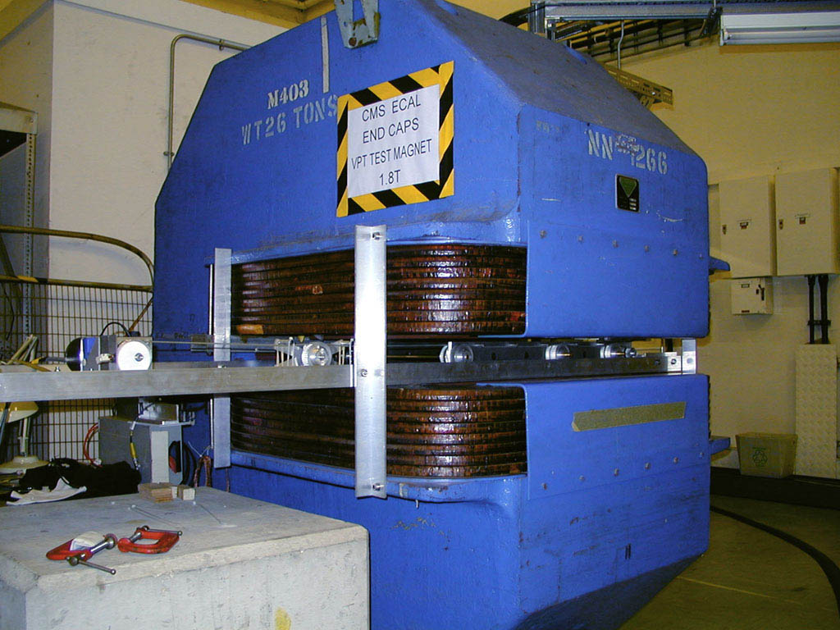
Figure 11. The 1.8T test rig at RAL.

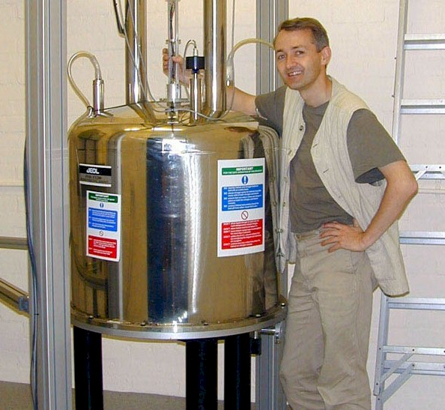
Figure 12. The 4T VPT test rig at Brunel University.

Figure 13. Response to standard light pulse for 500 preproduction VPTs.
Figure 14. Ratio of gaussian width to signal size for 500 preproduction VPTs.

Evaluation of crystal properties
The CMS Crystal Lab at IC is now fully functional and investigating various issues connected with the optical properties of the lead tungstate crystals. In the spring, the commissioning of the hybrid-photomultiplier rig was completed allowing light-yield data to be taken. A photograph of the rig is shown in Figure 15. The photodetector is housed in the black cylinder and a crystal is mounted on top surrounded by a copper block to help maintain thermal stability. The Co⁶⁰ source can be scanned up and down the length. In the foreground, another crystal sits within the thermally controlled enclosure attached to an LED and diode, replicating the monitoring geometry. Comparison of data from the LED/diode and the HPMT taken as crystals recover from irradiation yields important information for the future in-situ monitoring of the crystals during LHC operation.

The next task was to develop a fitting procedure to extract the average number of photoelectrons from the complex spectra obtained. Figure 16 shows an example of the data and the fit. The peaks correspond to integer numbers of photoelectrons and they sit on a background that arises primarily from the backscattering of multiple photoelectrons from the diode. The shoulder on to the right of each peak is the result of a single photoelectron backscattering from the next-higher peak. The fit also includes the effects of Compton scattering, detector resolution, pile-up, and background.

The ability to precisely measure the average photoelectron yield along the crystals allows the front-non-uniformity (FNUF) parameter to be measured. The FNUF is required to be less than 0.35%/X₀ if it is not to dominate the constant term in the energy resolution of the calorimeter. Unfortunately, measurements made at CERN on the 2001 end-cap crystals have shown an average FNUF of 0.43%/X_{o}. The Crystal Lab at IC has produced preliminary evidence that that the measured FNUF depends upon the wrapping of the crystal and that for crystals close to the end-cap configuration the average FNUF is an acceptable 0.3%/X_{o}. The rig is currently being adapted to make measurements with crystals in exactly the end-cap configuration.

The Crystal Lab also makes precise measurements of both the longitudinal and transverse transmissions of the crystals. A correlation has been established between the gradient of the transverse transmission and either the front or rear light collection non-uniformities. This may provide a useful tool for rejecting high FNUF crystals as the transmission measurements are much quicker than direct FNUF scans and transmission is a parameter readily measured by the producers.

The 0.85TBq Co⁶⁰ radiation source at Brunel University has been used on a regular basis to investigate the radiation hardness of the crystals. Typically, the irradiations are for 24 hours at 15 Gy/h, which represents the upper limit of the dose expected in the end-caps. The 2001 crystals have been seen to be less radiation hard than the 2000 crystals, and this is the subject of ongoing investigations. The radiation damage has been shown to be primarily associated with the formation of two colour centers, one at about 400nm and the other at about 530nm. The time-constants associated with the recovery can be extracted from a series of measurements of the longitudinal transmission as the crystals self anneal.

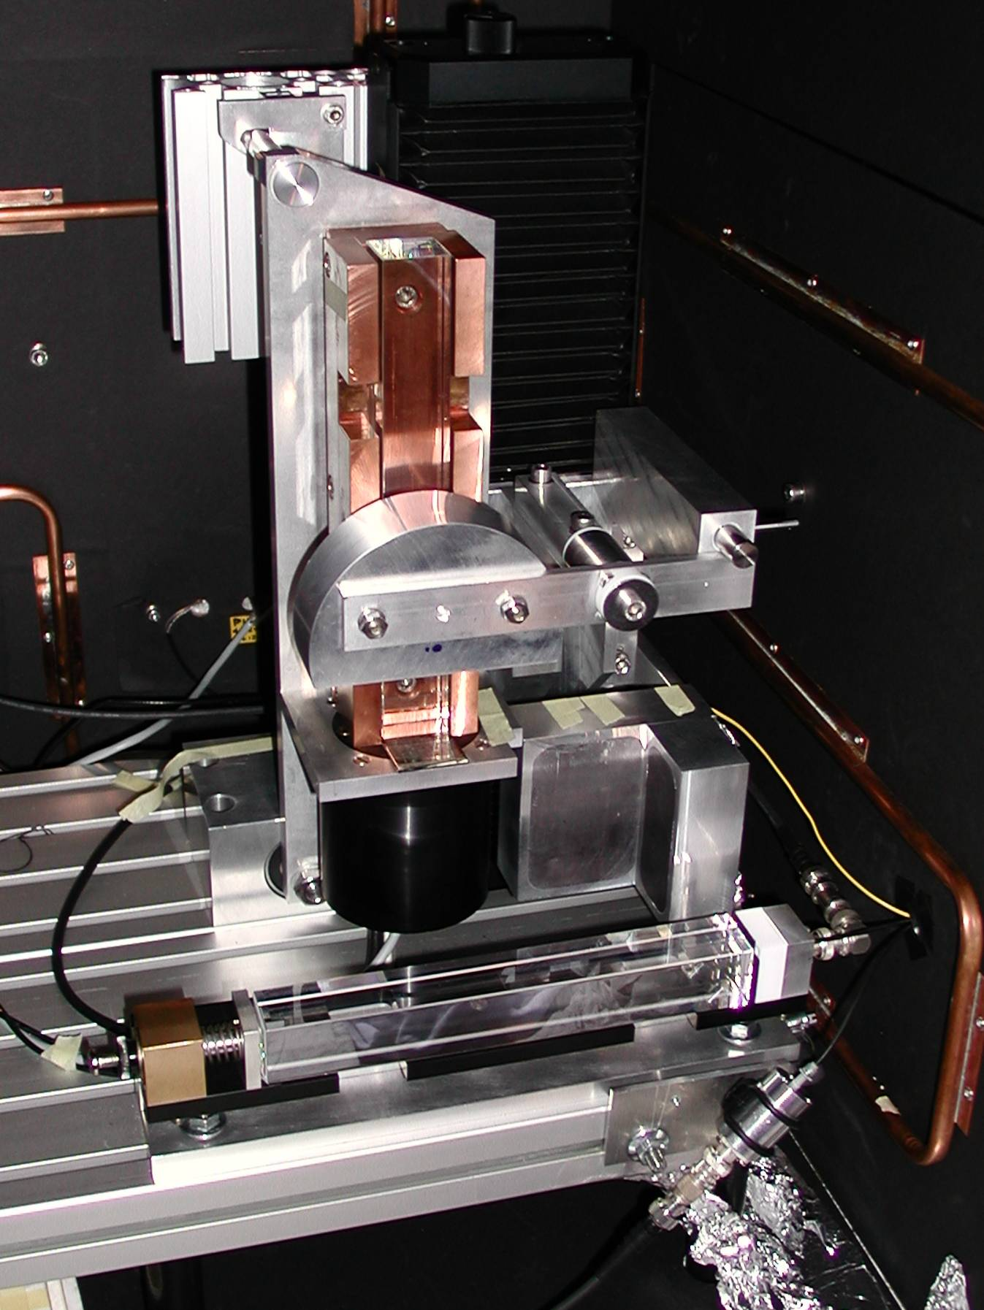
Figure 15. HPMT rig at Imperial College.

Figure 16. HPMT data and fit.

Global Calorimeter Trigger

Introduction

The UK has responsibility for the design and construction of the Global Calorimeter Trigger (GCT) for CMS. The University of Bristol trigger group is carrying out this work, in collaboration with RAL engineers.

The GCT system is a central component of the first-level trigger hardware. Its purpose is to carry out all steps of data reduction and processing that require data from the entire CMS calorimeter system. The functionality includes:

- Identification and sorting of the highest E_{T} electron/photon candidates found by the regional calorimeter trigger systems
- Identification and sorting of central, forward and top-quark candidate jets.
- Calculation of total and missing transverse energy

It was confirmed by the CMS collaboration two years ago that a proposed improvement to the jet-finding algorithm (the introduction of a full sliding-window approach) should be implemented in hardware. It now seems likely that the GCT will carry this responsibility, pending a full internal review of the system design, and we are in the process of amending the system design accordingly. Further minor changes to the trigger functionality are foreseen in the period leading up to construction, in response to our improved understanding of the conditions and of the range of accessible physics channels at the LHC. The GCT is designed to be highly flexible in functionality, both before and after the start of running; we are therefore confident that such changes can be absorbed with no serious impact on cost or complexity.

Hardware Tests

The main thrust of our work in 2001 was the validation of our design approach through the construction of realistic ‘technology demonstrator’ systems. The GCT relies on several novel technologies to achieve the design goals of high performance and reliability at minimal cost. These include:

- The use of leading-edge 0.15μm FPGAs for all processing functions
- The use of 3.2Gbit/s copper links as a replacement for the traditional trigger backplane
- The use of embedded processors to encapsulate into real-time software a large amount of traditionally ‘hardwired’ functionality
- The inclusion of comprehensive self-test capability at the system, board and component level.
- The use of a single flexible module design to carry out a wide variety of system functions

All of these technologies must be thoroughly evaluated and shown to achieve the desired performance and cost targets, before final system design and construction can begin.

In 2001, we received our first working units of the RAL-designed Generic Test Module (GTM). The specification of this module was developed in collaboration with the Atlas experiment. The module is based on the 2001 generation of FPGA devices (Xilinx Virtex-E), and is designed to provide the infrastructure, timing, control, stimulus, and data-acquisition facilities required for the testing of a variety of high-performance submodules. These submodules take the form of standard form-factor CRC daughterboards, two of which can be accommodated on a single GTM. In parallel with GTM development, the RAL CMS group designed and constructed the first of these daughterboards, which will allow us to test high-speed serial LVDS links, used in the GCT for data output to the Global Trigger and DAQ systems. Both the GTM module and the daughterboard have now been fully tested, and shown to meet the initial design goals. The multiple GTM modules we now have at our disposal will form the backbone of our prototyping system up until the production of our first full prototype board towards the end of 2002.

In late 2001, we received a completed unit of a second GTM daughterboard designed at Bristol. This unit is designed to test our approach for the reception and synchronisation of GCT input data. This data is carried in 80Mbit/s parallel form from a number of remote and geographically dispersed regional trigger systems. We therefore require a synchronisation scheme that is robust with respect to the inevitable jitter and timing spread between signals. Tests of this subsystem have so far proved successful, and are continuing.

In addition to submodule tests, the GTM allows trigger algorithm logic to be tested in FPGAs in a realistic way. We are currently engaged in the process of comparing data gathered from hardware tests with our VHDL simulations, in order to demonstrate the correct function of the algorithms ‘in silico’, and to evaluate the performance margins. In addition, we are investigating various approaches to high-speed data transfer between processing FPGAs; it appears that parallel data transfer at 160Mbit/s or 320Mbit/s using a modern high-speed single-ended logic standard is feasible, and this will dramatically reduce the cost and complexity of our final PCB designs.

Final system design studies

In parallel with our hardware test programme, we have been working throughout 2001 to finalise the specification of the final system in preparation for the design phase proper, starting with schematic capture for our full prototype.

The incorporation of jet clustering logic into the GCT has encouraged us to reoptimise both the number of trigger boards in our system, and the distribution of logic between them. In addition, the large increase in data communication between trigger boards has required us to find a more compact and reliable means of data transfer within the system. The traditional solution to this problem is the design of a monolithic system backplane. However, there are several disadvantages to this approach: the cost of such a backplane would dominate that of the entire system; a fixed backplane does not allow much flexibility in the system functionality in response to altered requirements after the start of running; and it would force us to completely finalise our system layout and requirements this year, since we would not be able to afford more than one prototype unit. We have instead decided to investigate the use of 3.2Gbit/s copper cable links between boards for data transfer.

Since 3.2Gbit/s is currently the upper limit of commodity copper transmission technology, we have attached some importance to a proper market survey and discussion with manufacturers; the chipsets and cables capable of sustaining this performance are not widely available, or are in prototype stage. In order to test our approach, we have acquired sample quantities of the necessary components for inclusion onto a suitable GTM daughterboard. The daughterboard is currently in the final stage of design at Bristol, and we hope to complete tests of the data links in early 2002.

As part of the system design study, we have also optimised the physical system layout to reduce space, power and cabling requirements. The data input circuitry will now be housed on vertically-stacked 6U high boards attached directly to the front of the processing boards in a ‘depth and half’ crate configuration. This will require the construction of a small amount of customised crate hardware, which will be produced through modification of a CMS standard 9U crate in the Bristol mechanical workshop. As a result, the entire GCT system can now be housed in one 12U-high crate position, allowing substantially more flexibility in the layout of the critical central trigger racks. One immediate advantage is that the main L1 trigger DAQ system can now be housed adjacent to the GCT, obviating the need for costly high-speed optical links between the two systems.

We are currently examining the remaining issues of system control and monitoring, based upon our experience with our ongoing hardware tests. Upon the successful test of the 3.2Gbit/s link technology, we will finalise our prototype specification and start the schematic capture phase. We hope to have a fully working trigger board prototype in late 2002.

Simulation studies

The CMS trigger group is engaged in a semi-continuous process of review of the requirements on the L1 trigger system, based on realistic simulation of a variety of physics channels. As a result of studies carried out in conjunction with the jets/missing-energy physics group, we have defined a number of possible improvements that could be made to the trigger functionality, in order to improve efficiency in some channels with potential for Higgs or SUSY discovery. The implications of such changes for the system design and overall performance are now under study within the UK and elsewhere.

In addition, UK physicists are involved in the improvement of the existing L1 trigger simulation in the CMS object-based reconstruction code (ORCA), and are planning to take the lead in 2002 on the development of a fast trigger simulation code, to be used within the CMS fast simulation package (OSCAR). This latter development will also allow a more direct comparison between results from simulation and hardware tests.

PHYSICS AND COMPUTING

The ECAL-e/γ Physics Reconstruction and Selection (PRS) group, led by an Imperial College physicist, made significant progress in 2001.

The PRS project is split into four groups: ECAL-e/γ, HCAL-jet/missing E_{T}, Muon, and tracker-b/τ. The scope of the work of each group is the complete chain of software: on-line, Higher Level Trigger, offline, test beam, simulation, calibration etc, together with related physics studies. The PRS project is special in that it has no institutional resources: it must obtain its resources from the detector projects.

The important milestone for 2001 was the delivery of a complete selection chain, from the Level-1 trigger to the final sample of events that will be written to permanent storage. The study for this was done with a large sample of fully simulated and digitised (including pile-up corresponding to low luminosity, 2x10³³ cm²/s) jet background events (0.6M events), together with a large range of samples of signal events and single particles similarly simulated and digitised (more than 1M more events). The milestone was delivered in the December CMS week and we gave a detailed breakdown of the signal and background in an event rate of 36Hz written to off line storage coming from electromagnetic triggers, together with details of the cuts, thresholds and algorithms needed to achieve this. The efficiency of the chain for signal events, together with plots of efficiency versus background rejection, for most of the selection cuts, was also presented. Table 1 shows the breakdown of the rate output to permanent storage, at 2x10³³ cm²/s, as presented in December.

In order to achieve this improvements were made, during the year, to the ECAL-alone reconstruction algorithms for electrons (Bremsstrahlung recovery), a Level-2 'pixel matching' algorithm was developed, searching for hits in the pixel detectors corresponding to a reconstructed electron in the ECAL, and track finding for electrons, seeded by the pixel hits, was developed. A Brunel student studied ECAL isolation cuts.

Trigger | Signal | Background | Total
Single e | W→eν: 9.7 Hz | π±π⁰ overlap: 4 Hz  π⁰ conversions: 5 Hz  b/c→e: 8.5 Hz | 27 Hz
Double e | Z →ee: 1 Hz | ~0 | 1 Hz
Single γ | ~0 | 3 Hz | 3 Hz
Double γ | ~0 | 5 Hz | 5 Hz
Total |  |  | 36 Hz
Table 1: Breakdown of final output rate from electron/photon triggers at 2x10³³ cm²/s (starting from Level-1 3.9 kHz).

The group was also required to provide rapid feedback to the CMS management concerning the effect of staging or delaying the deployment of the end caps. Figure 17, from a study by a UK physicist, shows the acceptance for H→ZZ* decaying into 4 electrons, 2 electrons and 2 muons, or into either of those two channels, when the ECAL coverage is limited to a smaller pseudo-rapidity region, relative to that which would be obtained by the full design pseudo-rapidity coverage. The shaded area of the plot represents the end caps. With a single end cap the acceptance is 76% in the 2e+2μ channel 64% in the 4e channel, and 77% for the combined channels (4e,2e+2μ,4μ). Similar studies for the Higgs decay to photons were also made, and results presented to the CMS steering committee.

Further activities of the group involved the improvement and updating of the geometry description for the ECAL, where an Imperial College physicist has overall responsibility. The end cap description is the responsibility of a RAL physicist. Preparations are being made for the transition to GEANT 4 (OO detector simulation and particle transport).

Immediate milestones for 2002 include the presentation of a credible scheme for ECAL calibration. Work is underway on many aspects of this problem, and includes important contributions by a Bristol student. Detailing the data format and data flows in the early part of the readout chain is another requirement for early 2002. The studies needed here involve a detailed simulation of the Selective Readout and Zero Suppression algorithms which must reduce the raw data volume from the ECAL by a factor of about 15, with little or no impact on the reconstructed physics objects. An Imperial College student has been studying this and has written powerful and flexible software which will be used in the large Monte Carlo data production, where hitherto a crude 2σ (noise) cut had been causing small, but confusing, effects and making details of the ECAL reconstruction unnecessarily hard to understand.

In the longer term, a very important step for the PRS project will be to obtain results to be presented in the Physics TDR which will be submitted at the end of 2004. This will contain comprehensive documentation of physics object reconstruction, calibration, selection efficiency and detector response, followed by detailed physics analysis of all major signals that can be foreseen or imagined for LHC. It is intended that the work for this document, which will begin at the end of 2002, will be done with the final software tools intended for use with real data - reconstruction, analysis and plotting tools, together with Monte Carlo simulation tools, both full simulation and fast simulation. It is intended that this will serve as a broad testing and training exercise, facilitating acquisition of knowledge, skills and techniques which will be needed for rapid exploitation of real data by a large number of physicists when CMS turns on. CMSUK physicists intend to make an important contribution to this effort.

Figure 17. Effect of reduced ECAL coverage on the relative acceptance for H→ZZ*

Conclusion and summary
2001 has been a successful year for the CMS collaboration, with substantial progress being made in crucial areas of the project. Good progress is being made on the excavation of the experimental caverns; the construction of the magnet yoke is well under way, and all of the 12000 tons of steel have been delivered to CERN; the production of the reinforced superconductor for the magnet is proceeding well.

In common with the rest of the collaboration, the UK groups have embarked on the construction phase of the project, following several years of detector development. In both the Tracker and the ECAL projects, major contracts have been placed with industrial suppliers for important components, and more are expected to be signed in the coming year. The UK groups have played leading roles in this work, both in the negotiations and in the technical work of evaluating prototypes and setting up assembly and testing equipment for the construction phase. In addition, the UK continues to play a leading role in designing and implementing the CMS global calorimeter trigger system.

UK physicists and students are active in preparing for the physics exploitation of the experiment, both in studies of particular physics channels and in the creation of the analysis and simulation software which will be needed to analyse the experimental data

PUBLICATIONS

Journal papers
Probing the nature of matter with CMOS6: The APV25 Readout Chip for the CMS Tracker
M. French, L. Jones, G. Hall
IBM Micronews 7 (2001) 24-28.
Design and results from the APV25, a deep sub-micron CMOS front-end chip for the CMS tracker
M.J.,French, L.L.Jones, Q. Morrissey, A.Neviani, R.Turchetta, J.Fulcher, G.Hall, E. Noah, M.Raymond, G.Cervelli, P.Moreira, G.Marseguerra
Nucl Instr and Methods A466 (2001) 359-365.

Optimisation of the silicon sensors for the CMS tracker
S.Albergo, et al.
Nucl Instr and Methods A 466 (2001) 300 –307

Test Results from a Prototype Lead Tungstate Crystal Calorimeter with Vacuum Phototriode Readout for the CMS Experiment
M Apollonio et al.
Accepted for publication by Nucl Instr and Methods A.

Trigger processing using reconfigurable logic in the CMS calorimeter trigger
J.J. Brooke, D.G. Cussans, G.P. Heath, A.J. Maddox, D.M. Newbold, P.D. Rabbetts
Nucl Instr and Methods A461 (2001) 505-506

The development of vacuum phototriodes for the CMS electromagnetic calorimeter
K.W. Bell, R.M. Brown, D.J.A. Cockerill, P.S. Flower, P.R. Hobson, D.C. Imrie, B.W. Kennedy, A.L. Lintern, C.A.X. Pattison, M. Sproston, J.H. Williams
Nucl.Instrum.Meth.A469 (2001) 29-46

Trigger processing using reconfigurable logic in the CMS calorimeter trigger
J.J.Brooke et al.
NIM A461 (2001) 505-506

Conference contributions
Cryogenic investigations and modelling of inter-defect charge exchange in silicon particle detectors
B. C. MacEvoy, G. Hall, A. Santocchia
Paper presented at the E-RMS symposium., Strasbourg June 2001
Defect Engineering of Advanced Semiconductor Devices
Papers will be published in proceedings (NIM)

An enhanced approach to numerical modelling of heavily irradiated silicon devices
F. Moscatelli, A. Santocchia, D. Passeri, G. M. Bilei, B.C. MacEvoy, G. Hall, P. Placidi
Paper presented at the E-RMS symposium., Strasbourg June 2001
Defect Engineering of Advanced Semiconductor Devices
Papers will be published in proceedings (NIM)

Overview of the CMS Electromagnetic Calorimeter
H.F.Heath
Paper presented at the 2001 Villa Olmo International Conference on Advanced Technology and Particle Physics, October 2001
The Vacuum Phototriodes for the CMS Electromagnetic Calorimeter
R.M.Brown, K.W.Bell, D.J.A.Cockerill, P.S.Flower, B.W.Kennedy, A.L.Lintern, M.Sproston, J.H.Williams, P.R.Hobson, D.C.Imrie, O.Sharif
in Proceedings of the EPS International Conference on High Energy Physics, Budapest, 2001 (D. Horvath, P. Levai, A. Patkos, eds.), JHEP (http://jhep.sissa.it/) Proceedings Section, PrHEP-hep2001/255

Refereed CMS Notes
Electron Reconstruction in the CMS Electromagnetic Calorimeter
C. Seez, E. Meschi, T. Monteiro, P. Vikas
CMS NOTE-2001/034
User Requirements Document for the Final FED of the CMS Silicon Strip Tracker
K.W. Bell, J.A. Coughlan, C. Foudas, K.A. Gill, N. Marinelli, G. Pasztor, I.R. Tomalin
CMS NOTE-2001/043
Observing anomalous di-boson couplings in the WWγ vertex at CMS
C.K. McKay, P.R. Hobson
CMS NOTE-2001/052
Sensitivity of CMS to CP-conserving anomalous di-boson couplings in Wγ events
C.K. McKay, P.R. Hobson
CMS NOTE-2001/056

CMS Internal notes
Results from a Fine-Grain Scan of a Prototype ECAL Endcap Supercrystal
H.F. Heath, S.M. Gibson, M. Pierce
CMS IN 2001/021

PhD Theses
The development of a dense, radiation hard scintillating glass for electromagnetic calorimetry
P.S.Flower
University of Sheffield, 2001
Identification and Measurement of Low-Energy Electrons and the decay B⁰_{s} -> J/ψ φ at CMS
A.D. Presland
University of Bristol, 2001
Radiation Effects in electronics for the CMS Tracking detector
J. Fulcher
Imperial College of Science and Technology, 2001

 Associated institute


