THE COMPACT MUON SOLENOID (CMS) DETECTOR

PROPOSAL 892

UNITED KINGDOM
Bristol University; Brunel University; Imperial College, London; CLRC Rutherford Appleton Laboratory; Univ of the West of England*; Univ of Strathclyde*

OTHER CERN MEMBER STATES
AUSTRIA: HEPHY, Vienna; BELGIUM: Univ Libre, Brussels; Vrije Univ, Brussels; Univ Cath. Louvain, Louvain; Univ Antwerpen, Wilrijk; Univ Mons Hainaut, Mons; CERN; FINLAND: Helsinki Inst. Phys., Helsinki; Phys. Dept., Helsinki Univ, Helsinki; Helsinki Univ Tech, Helsinki; Oulu Univ, Oulu; Tampere Univ of Technology, Tampere; FRANCE: LAPP, Annecy; Inst. Phys. Nucl., Lyon; LPNHE Ecole Polytechnique, Palaiseau; DAPNIA, Saclay; CRN-ULP, Strasbourg; GERMANY: I. Phys. Inst., RWTH Aachen, Aachen; III. Phys. Inst. A, RWTH Aachen, Aachen; III. Phys. Inst. B, RWTH Aachen, Aachen; Humboldt University, Berlin; Inst. Exp. Kernphysik, Univ Karlsruhe, Karlsruhe; GREECE: Univ Athens, Athens; NRCPS Demokritos, Attiki; Univ Ioannina, Ioannina; HUNGARY: KFKI, Hung. Acad. Sci., Budapest; Inst. Nucl. Res. ATOMKI, Debrecen; Kossuth Lajos Univ, Debrecen; ITALY: Dip. Fisica dell’Univ and Sez. dell’INFN: Bari; Bologna; Catania; Firenze; Genova; INFN Milano; INFN Napoli; Padova; Pavia; Perugia; Pisa; Roma I; Torino; POLAND: Inst. Experim. Physik, Univ Warsaw, Warszawa; Soltan Inst. Nucl Studies, Warszawa; PORTUGAL: LIP, Lisbon; SLOVAK REPUBLIC: Slovak Inst. Technology, Bratislava; SPAIN: CIEMAT, Madrid; Univ Autonoma, Madrid; Cantabria Univ, Santander; Univ Oviedo; SWITZERLAND: Univ Basel, Basel; PSI, Paul Scherrer Institute, Villigen; ETH, Eidgen. Techn. Hochschule, Zürich; Univ of Zurich, Zurich

NON-MEMBER STATES (Except USA)
ARMENIA: YerPhI, Yerevan; BELARUS: INP, Byelorussian State Univ, Minsk; NCPHEP, Nat. Sci. and Educ. Centre of P’cle and High Energy Physics, Minsk; RIAPP, Research Inst. Appl. Phys. Probl., Minsk; Dept. of Physics, Byelorussian State Univ, Minsk; BULGARIA: Inst. Nucl. Res. + Nucl. Energy, Sofia; Univ of Sofia, Fac. of Phys., Sofia; CHINA PR: Institute of High Energy Physics, Beijing; Peking Univ Beijing; Univ of Science & Technology of China, Hefei; CHINA (TAIWAN): National Central University, Chung-Li; National Taiwan University (NTU), Taipei; CROATIA: Univ of Split; Tech Univ Split; CYPRUS: Univ of Cyprus, Nicosia; ESTONIA: Inst. Chemical Physics and Biophysics, Tallinn; GEORGIA: Inst. Phys. Academy of Science, Tbilisi; Inst. HEP, Tbilisi State Univ; INDIA: Bhabha Atomic Res. Centre, Tata Institute (HECR), Tata Institute (EHEP), Mumbai; Panjab Univ, Chandigarh; Univ of Delhi, Delhi; IRAN: IPM, Tehran; KOREA: Cheju Nat. Univ, Cheju; Chungbuk Nat. Univ Chongju; Kangwon Nat. Univ, Chunchon; Wonkwang Univ, Iksan; Chonnam Nat. Univ, Kwangju; Dongshin Univ, Naju; Seonam Univ, Namwon; Kon-Kuk Univ, Seoul; Korea Univ, Seoul; Seoul Nat Univ, Seoul; Seoul Nat. Univ Educ., Seoul; Kyungpook Nat. Univ, Taegu; NEW ZEALAND: Univ Auckland; Univ Canterbury, Christchurch; PAKISTAN: Quaid-I-Azam Univ, Islamabad; RUSSIA: JINR, Dubna; INR, Moscow; ITEP, Moscow; Lebedev Physical Institute, Moscow; MSU, Moscow; IHEP, Protvino; Petersburg Nucl. Physics Inst., St. Petersburg; RFNC-VNIITF, Snezhinsk∗; SERBIA: Vinca Institute, Belgrade; TURKEY: Cukurova Univ, Adana; Middle East Tech. Univ, Ankara; Bogazici University, Istanbul; UKRAINE: Kharkov State Univ; NSC-KIPT, Kharkov Inst. of Phys. and Tech., Kharkov; Inst. of Monocrystals, Kharkov; UZBEKISTAN: INR, Uzbekistan Acad. of Sciences, Tashkent

USA
Boston University; Caltech, Pasadena; Univ of California at Davis; Univ of California at Los Angeles; Univ of California at Riverside; Univ of California at San Diego, La Jolla; Univ of California at Santa Barbera; Carnegie Mellon Univ, Pittsburgh; Fairfield Univ, Fairfield; Fermilab, Batavia; Florida State Univ, Tallahassee; Univ of Florida, Gainesville; Florida Inst Tech, Melbourne; Johns Hopkins Univ, Baltimore; Univ of Illinois, Chicago; Univ of Iowa, Iowa City; Iowa State Univ; Univ of Kansas; Kansas State Univ; Univ of Maryland, College Park; Massachusetts Institute of Technology, Cambridge; Univ of Minnesota, Minneapolis; Univ of Mississippi; Univ of Nebraska-Lincoln, Lincoln; Northeastern Univ, Boston; Northwestern Univ, Evanston; Univ of Notre Dame; Ohio State Univ, Columbus; Princeton Univ, Princeton; Purdue Univ, West Lafayette; Rice Univ, Houston; Univ of Rochester; State Univ New Jersey, Rutgers; Texas Tech Univ, Lubbock; Virginia Polytech. Inst. and State Univ, Blacksburg; Univ of Wisconsin, Madison

INTRODUCTION and overview
The UK groups in CMS have lead responsibilities for two major subsystems in CMS: the readout electronics for the Tracker and the endcaps of the crystal Electromagnetic Calorimeter (ECAL). The Tracker Readout work overlaps strongly with the development of the overall CMS Data Acquisition System and the Calorimeter responsibilities include the design and implementation of the Global Calorimeter Trigger system. The UK is also centrally involved in the development of software for reconstruction and physics analysis and in the development of GRID based computing facilities.

Overall Status of CMS
CMS is now well into the construction phase and a number of major hardware items have already been completed and delivered to the CERN site. Space allows here only a very brief summary of the overall status of the experiment; more detailed information can be found in the reports made regularly to the LHC Committee and the CMS Resources Review.

Schedule
A revised schedule for construction of the LHC machine was announced by CERN in March. In the current plan, first beam is due to circulate in April 2007, with first collisions occurring in June 2007, almost two years later than originally foreseen. The excavation of the underground caverns for CMS has also been delayed by about 12 months, and delivery is now foreseen for July 2004.
A new ‘master assembly sequence’ (v33) for CMS has been approved by the LHCC, which takes account of these delays and which plans for the installation of a complete low luminosity detector in time for physics in 2007. (Only the outer pixel layers and sections of the fourth endcap muon stations, which are ‘staged’ items required later for high luminosity running, will be missing at the start.)

Civil Engineering and Assembly
After the initial delays, the excavation of the two underground caverns for CMS at Point 5, USC55 (services) and UXC55 (experiment), has proceeded well and is nearing completion. The current date of May 2005 for beneficial occupancy might even be brought forward and the v33 planning has contingency to allow for this. An important feature of the CMS design is that it plans for assembly of major detector components on the surface. The assembled items will then be lowered to the experimental area using a crane with a 2000 tonne capacity.

Magnet
The CMS magnet consists of a 4 Tesla superconducting solenoid, 13 m long and 6 m in internal diameter, and a segmented steel return yoke with a total mass of 11.6 kilotonne. The magnet yoke provides the mechanical support for all the detector elements. All five rings of the barrel yoke and all six endcap discs have been delivered to CERN and have been assembled at Point 5.
The superconductor consists of Rutherford cable, co-extruded with pure aluminium and reinforced with aluminium alloy. It is manufactured in 2.65 km lengths; 20 of these are required for the final coil with an additional one for the prototype. All of the superconducting cable has now been produced following the repair of the cabling machine at Brugg Kabelwerk, which had failed earlier in the year. So far 11 lengths of reinforced conductor have been completed and the end of conductor production is scheduled for June 2003.
Impregnation of the winding prototype has been achieved successfully. Winding of the real coil has started, and 1.5 layers of the first of five sections have been completed.

Hadron Calorimeter
The CMS hadron calorimeter comprises three subsystems: the Barrel, Endcap and Forward detectors. The Barrel and Endcap detectors consist of plastic scintillator tiles with fibre light collection, interleaved with brass absorber. The Forward calorimeter uses quartz fibres as the active element, embedded in steel ‘wedges’.
Both half-sections of the barrel have been assembled at Point 5 ahead of schedule. One half-section is shown in Figure 1. All the components for the first endcap have been delivered to CERN. The absorber for one of the endcaps has been assembled and mounted on the magnet yokes. Of the 36 absorber wedges required for the Forward calorimeter, 20 have already been produced and delivered to CERN. ‘Stuffing’ with quartz fibres has started at CERN and will continue for the next two years.

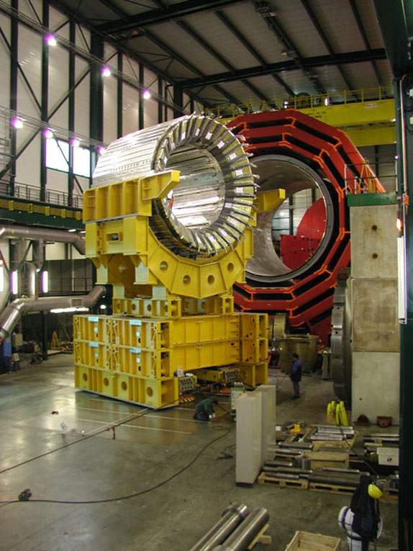
Figure 1. The first half-barrel of the CMS HCAL, assembled at Point 5. The assembled Barrel section of the magnet yoke can be seen in the background

Muon System
The Barrel Muon System uses Drift Tube Chambers (DTC), together with Resistive Plate Chambers (RPC). Cathode Strip Chambers (CSC) and RPCs are used in the endcaps. The production of cathode strip chambers is on schedule at all three sites (Fermilab, PNPI-Russia and IHEP-China). Delivery to CERN has started and installation will begin early in 2003. Assembly of Drift Tube Chambers for the Barrel is under way at all three production sites (CIEMAT, Aachen and Legnaro). The rate of production is a concern. The revised manufacturing target for the end of 2002 is 60 chambers and 48 have been produced so far. There are also delays in the production of on-detector electronics (‘minicrates’) which complicates the installation, now due to start in mid-2003.
Qualification of the Resistive Plate Chambers using the Gamma Irradiation Facility (GIF) at CERN is continuing. Small chambers under irradiation since June have now received more than half of the estimated ten-year dose and are operating satisfactorily. A decision was taken in October to oil the endcap chambers up to η=1.6.

Trigger and Data Acquisition System
The Trigger design is proceeding well. Testing of second-generation prototype calorimeter trigger cards is underway, and final prototypes of many other elements are being constructed and tested. An optical link system for the RPC trigger has been successfully tested and the control logic for the Global Trigger has been designed.
The design of the Event Builder for the DAQ has evolved into a more modular architecture with eight independent slices, each able to handle trigger rates up to 12.5 kHz. This simplifies commissioning and staging for initial low luminosity running, and provides an easier upgrade path to benefit from future advances in technology. The DAQ TDR was submitted on schedule on 15 December.

New Collaborators
Brazil (7 institutions, 19 physicists, 8 engineers) has been accepted by CMS following a presentation in September. Funding will be clarified following a change of government at the start of 2003.
University College Dublin has joined the Collaboration. The Director of the Irish Science Foundation has visited CERN. A proposal will be submitted when the appropriate funding agency has been defined.
Two New Zealand universities, Auckland and New Zealand, joined CMS in September. They have received start-up funding and will submit a proposal in mid-2003.
Heavy-ion groups within the US Nuclear Physics community have submitted a proposal to the DoE to work on CMS. They have requested US$2.5M to contribute to the DAQ and to build a zero-degree calorimeter. A decision is expected early in 2003.
A group from Yale has applied to join CMS to work on the ECAL.

The following sections of this report describe the progress made by the UK groups within CMS in the past year.

TRACKER AND DATA ACQUISITION
The CMS tracker is a system of 9.3 million silicon microstrip sensors, containing pixel detector layers at small radius. The Collaboration is presently embarking on large scale assembly of the system. The UK hardware contributions are in the electronic readout system, Figure 2, in the form of the APV25 front end electronics and the Front End Driver modules which digitise data for transmission to the Data Acquisition System.
A unique feature of the CMS system is the analogue readout. Each microstrip is read out by a charge sensitive amplifier whose output voltage is sampled and stored in an analogue pipeline for 3-4µs. Each APV25 channel contains a preamplifier and shaper followed by a 192-location memory into which samples are written at 40MHz. Following a trigger, three samples are processed to re-filter the data with a shorter time constant. The APV25 also contains system features including programmable bias networks, remotely controllable internal test pulse generation system and a control interface and will operate to 100kHz trigger rates with minimal system deadtime.

Figure 2. CMS Tracker readout and control system
Pulse height data, without zero suppression, are transmitted from the front-end via linear semiconductor lasers over fibre optic cables to the counting room adjacent to the underground cavern. The optical data are converted to electrical and digitised on the Front End Driver (FED) which performs several signal processing operations and stores data locally until required by the CMS data acquisition.

General progress and project status
There has been significant further progress towards production of the tracker and large scale production of modules is about to begin. All assembly centres and tooling are well equipped and ready to go and finalisation of components is almost complete. Pre-production deliveries of several hundred silicon sensors have been received from the two companies, Hamamatsu and ST, and the quality has been excellent, although the yield of within-specification ST devices can still be further improved.
All electronic ASICs are available in final form. The main remaining obstacle has been the completion of development of the final hybrid and its commercial assembly and testing, which has taken longer than hoped. The obstacle has been to produce flexible kapton circuits which could be laminated to a rigid support with sufficient flatness and, at the same time, ease of bonding to allow highly reliable large scale automated module production. A key point was to choose the lamination temperature, which avoided distortions after temperature cycling and a sufficiently flexible glue, to allow for thermal mismatches in materials, which provided enough rigidity for reliable bonding. This has now been done, subject only to improved module statistics. After many tests in the last few months a design laminated to a ceramic substrate has been adopted and final tests of about 10 commercially-produced versions have been successful. The first 100 hybrids have been delivered and several hundred modules for the outer barrel will begin production in January 2003. In the early part of 2003, following verification of inner barrel and endcap hybrids, modules for other parts of the tracker will also be produced, so full scale tracker assembly should be in full swing by mid-2003.

UK contributions to the CMS Tracker

Front End electronics
A large number of measurements have been made using the APV25. The performance of the chip has been found to be excellent and the radiation tolerance and robustness well established. Specific tests in heavy ion beams were carried out to establish Single Event Upset rates, which are in excellent agreement with circuit simulations combined with nuclear interaction simulations. The results were verfied in a high intensity, low energy pion beam which provides the closest approximation to LHC conditions in the CMS Tracker.
One unexpected result was obtained in the most recent LHC-like beam test. A series of modules were inserted in a 25ns test beam in CERN in November 2001. An effect was seen which was quickly correlated with nuclear interactions in the silicon whereby, following a nuclear recoil which can deposit ~1000x minimum ionising particle (MIP) signal, the analogue baseline in the whole APV25 is lowered to its minimum level. It is mainly due to a shared power line to the inverter stage following each preamplifier. The chip experiences some deadtime due to the high current drawn by a transistor which has been switched hard on following an enormous signal, which occurs very infrequently (~few x10⁻⁴/incident pion). However, as the effect is then felt by all channels on the chip it is multiplied by a factor of about 50-100, compared to inevitable single, and nearby, channel saturation.
The effect was studied in the laboratory, in data taken during the test, and by simulations of nuclear events in the tracker. Rates, dead-times and effects on tracker efficiency were calculated. It was concluded that the maximal data loss will be at the 1% level and it may be reduced further by careful choice of resistors mounted on the front-end hybrid. A beam test was carried out in May 2002 at PSI in a 300 MeV 50MHz pion beam to verify the rates. Measured rates are in good agreement with predictions. The detailed behaviour of the chip can be further scrutinised using the data taken, and results support the previous conclusions.
The only problem encountered with APV25 production is that some recent deliveries showed unexpectedly variable yield. From engineering runs (mid-2000) 10 wafers were obtained with an average yield of ~75%, which appeared to be consistent with many results from multi-project runs for APVs and other chips. However, the first 48 wafer order (January 2002) delivered two 24 wafer lots with quite low yield and the company exchanged the wafers, although they were within specification, acknowledging a possible processing fault. The replacement lot had a very high yield (~79%) but two subsequent lots have shown lower values (~40%). There are clear circular patterns of high and low yield on the wafers (Figure 3). Details are still under investigation using more recent deliveries but it is not expected to present an obstacle to detector assembly and about 20% of the required tested APV25s are already available.
A similar effect has also been observed in other projects but statistics from APV wafers are far greater. However, despite considerable efforts by the manufacturers and users the origin of the reduced yield has not been linked to any aspect of the processing, nor to any feature of the design or chip layout. Radiation tolerance is not correlated to yield; there is no evidence for any degradation of radiation quality in any wafers. Samples from 23 wafers were irradiated at Imperial to 10Mrad, of which 13 are from 2002 wafer deliveries, with dies selected to be near regions of low yield to look for any possible correlation. Further irradiations in Padova support these conclusions.

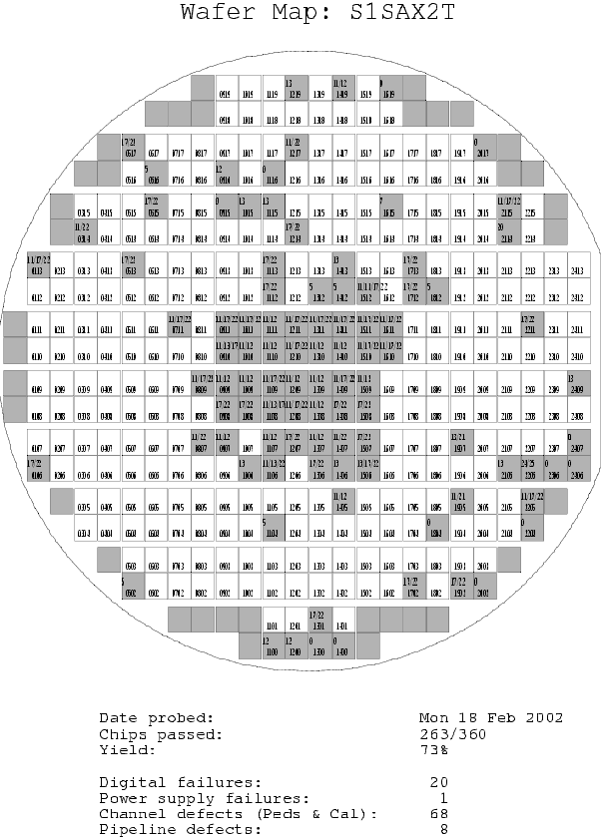
Figure 3. An example of a wafer with a high yield but showing evidence of a systematic variation across the wafer.

Front End Driver
The FED has progressed considerably in the last year and the first version of the final FED has been submitted for manufacture and assembly.
Technology changes have had important repercussions. In 1999 it seemed likely that parts of the digital processing would be implemented in an ASIC. However, Field Programmable Gate Array (FPGA) developments have been so rapid that large, fast FPGAs can now be afforded. The benefits are that the risk of including design errors is reduced to a very low level and the FED can even respond to late changes in requirements. Given the complexity of the digital logic, this is a great advantage. This has repercussions for skills required, e.g. firmware programming.
Conversely, some technical developments have slowed the FED progress. The novel optical receivers which must be placed on the FED must perform to link specifications and experience is limited to prototypes. The optical link development has been lengthy and challenging but is now concluded and the optical receiver modules, which was the final component to be developed, is now in commercial production. The first samples have been received and have been qualified and are ready to be mounted on the FEDs.
The FED must also be compatible with the CMS Data Acquisition System (DAQ). Digital data are transferred via a high speed switch network to the CMS computer farm whose input from the FED conforms to the S-link protocol. There are important data monitoring, control and synchronisation requirements also imposed at the system level, with which the FED must be fully compatible. The DAQ TDR submitted in December 2002 should now freeze this part of the system.

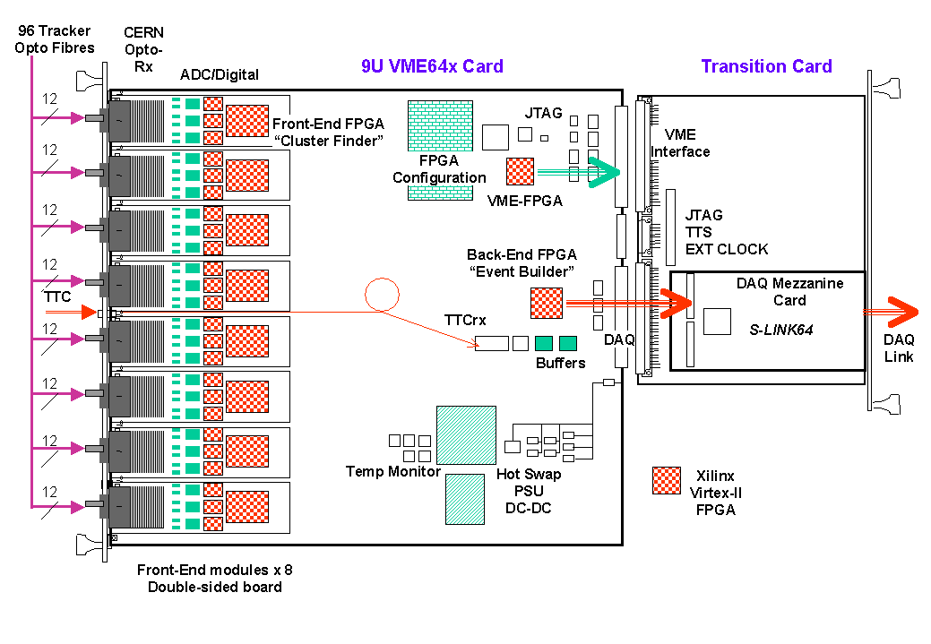
Figure 4. 9U VMEbus FED board layout with transition card.
The design of the 96 ADC channel FED is complete. The lengthy and complex process of board layout and routing complete and the first pair of prototype cards is being assembled; delivery will follow at the beginning of January 2003. Following exhaustive testing of the design, a further dozen cards will be produced for CMS users for large-scale module (end-cap petals, outer barrel rods, inner barrel units) testing in 2003. Full production should commence in 2005 following a small pre-production series.
The FED has been implemented to minimise PCB manufacturing and assembly costs. All components (apart from the DAQ interface card) are located on the 9U mother-board. Commercial components and solutions have been used wherever possible. The card is double-sided to accommodate the high density of components. The number of signal termination resistors is reduced by the use of Digitally Controlled Impedance feature of Virtex-II. Digital links are kept separated from analogue signals to avoid interference.
The FED has been designed with testing and monitoring in mind. Interconnections between all digital devices can be tested using JTAG Boundary Scan test chains. The JTAG chain may also be used for FPGA configuration directly from a PC via a standard cable. A dedicated opto-test card is under design at Imperial, which will be able to drive all 96 FED optical channels simultaneously. The electrical part of the chain can also be tested independently by injecting signals on to connectors at the opto-receiver outputs. About 500 FEDs, including spares, must be provided.

Software development
Part of the UK commitment to the Tracker system is supporting and operating the items we have designed and produced. There is also a natural link to the physics activity since the data will be formatted by the FED before transmission to the farm. During 2001, two internal CMS MoU’s highlighted the need for substantial manpower to produce the on-line and off-line software for the tracker. The UK will participate in both these areas.
In the on-line software Imperial College and RAL propose writing the software used to control, calibrate, readout and monitor the final tracker FEDs. This choice follows naturally from our FED responsibility and builds on the software experience we have gained from regular participation in test-beams.
Concerning off-line software, the UK has taken charge of the CMS Tracker Data-Handling group. This is responsible for providing the basic tools used for off-line analysis of test-beam data, and will ultimately also ensure that data from the final tracker can accessed by the off-line reconstruction software. The group will also play a role in preparing the DAQ TDR. Staff from RAL, Imperial and Brunel are now actively involved.

Milestones and future planning

Front end electronics
Production of modules should ramp up during 2003, to meet the schedule foreseeing CMS operation in 2007. Several hundred modules will be manufactured during the Spring 2003. No major difficulties are anticipated in moving to the production phase; all assembly and test systems are in place. However, this pre-production period will be needed to reach full efficiency.
The remaining tasks for the UK team are:
- Automated wafer probing of all dies.
- Sample radiation qualification of 10% of production wafers (+10% to be studied in Padova).
- Maintenance of a database of results.
- Delivery of dies to CERN for transmission to production centres.
- Maintenance of designs and documentation.
The bulk of the testing and radiation studies will be carried out at Imperial College, as has been the case so far following the schedule summarised below:

Front End Driver
The development schedule of the Final FED is shown below. It has three main phases:
- Construction of a final prototype and evaluation as described above.
- Tendering, and pre-production to finalise manufacturing and test procedures.
- Final production, matched to the schedule and budgetary profile.

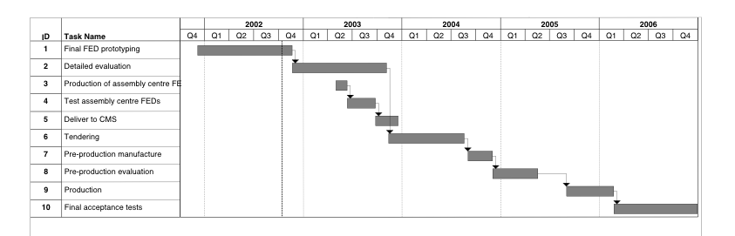

Summary
The CMS Tracker is very close to starting large scale production. There are no major technical problems foreseen in providing the UK deliverables. The UK technical contributions to the tracker have been outstandingly successful, resulting in substantial cost savings to the Tracker detector as it was originally foreseen.

ELECTROMAGNETIC CALORIMETRY

Overview
The UK has the lead responsibility for the design and construction of the CMS crystal Endcap Electromagnetic calorimeters (EE). This work is being carried out in close collaboration with institutes from Russia together with groups providing common items that will be used throughout the Barrel and Endcap regions of the detector.
The Endcap calorimeters comprise a total of 14,648 slightly tapered lead tungstate crystals, each approximately 3x3x22 cm³ in size, read out with one-inch diameter Vacuum Photo-triodes (VPTs). The majority of the EE crystals are contained within identical 5x5 units (25 channels) known as Supercrystals (SCs). The crystals are supported within the SCs by thin walled (400 μm) carbon fibre alveolar structures, as shown in Figure 5. The EE comprises a total of 552 such SCs.

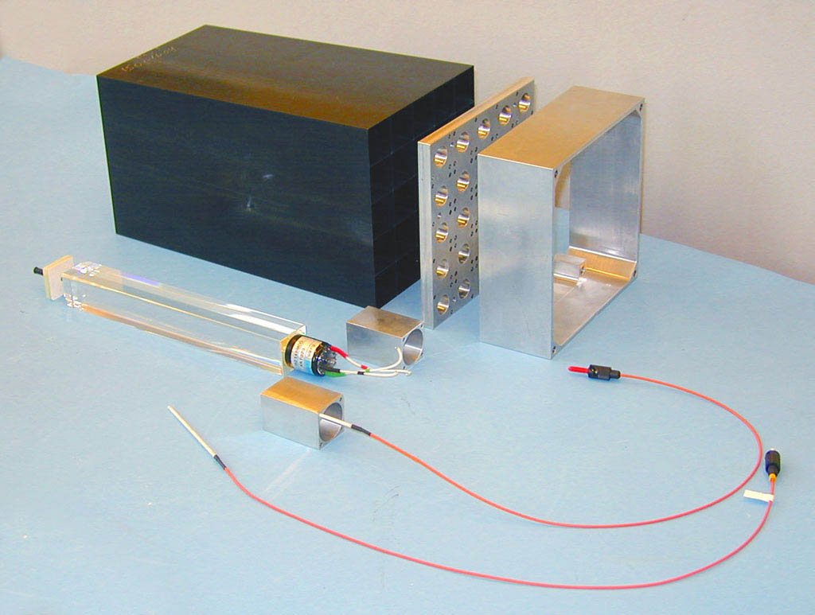
Figure 5. A photograph of the principal components of a Supercrystal, including a PbWO4 crystal with VPT, fibre optic monitoring components, an alveolar unit and mechanical parts
The EE has made significant progress over the past year. The VPTs are in production. Of the 15,500 devices ordered, 3800 devices have been delivered to RAL of which 3200 have been visually inspected and tested to 1.8T at RAL. Over 265 VPTs have been tested to 4T at Brunel. Details of these tests are described below. The producer, Research Institute Electron (St Petersburg, Russia), is meeting the planned delivery rate of 4000 devices per annum.
The first pre-production set of 100 EE crystals, delivered to CERN in May 2001 from the Bogoroditsk plant in Russia, has been extensively studied at the Crystal Laboratory at IC. A procedure has been found, involving the shading of the crystal chamfers with graphite, to improve the uniformity of light collection along the length of the crystals should this be necessary. A second order for a further 100 pre-production crystals has been placed, with delivery expected in March/April 2003.
The aerospace company Myasishchev, situated near Moscow, has now made a total of 332 alveolar structures for the SCs. This quantity represents 60% of the total required in CMS. A further 100 alveolar structures are expected in 2003.
The tender action for the mass production of the SC mechanics was completed in November 2002 with the contract awarded to a UK company based in Reading. The components comprise the rear inserts, interface plate and aluminium housing for each SC, as shown in Figure 5. The SCs will be produced at the Regional Centre at RAL. The SC assembly area has been completed and the facility fitted out with jigs and tooling. The test equipment is being assembled.
A successful Engineering Design Review (EDR) for the large EE mechanical items, comprising the Dee backplates, the support rings to the Endcap HCAL (HE), and the environmental screens, was held at CERN in September 2002. Figure 6 shows a Dee backplate, with the SCs cantilevered off the front face and part of a support ring.

EE design completion and prototyping
The integration of the new ECAL readout electronics, into the EE and Barrel (EB), is one of the last major design issues and is now a top priority. At the request of CMS, a UK engineer has been appointed as the deputy co-ordinator for ECAL electronics integration in order to bring much needed design expertise to this area.
The electronics redesign involves a significant change to the method of triggering in the Endcaps. The analogue signals from each SC will be re-grouped to form appropriate inputs to the new on-detector trigger by specific re-ordering of the signal cables between each SC and the preamplifiers.
An accurate full sized prototype section of a Dee, known as E0′, has been constructed to study electronics integration, as shown in Figure 7 and Figure 8. It has the capacity to take up to four SCs. At present it consists of two prototype SCs with 50 channels of discrete component readout. This system has been used for noise studies and will be tested in a CERN test beam in September 2003 with initial versions of the ECAL digital electronics. The system will be tested with final electronics and four SCs in 2004.

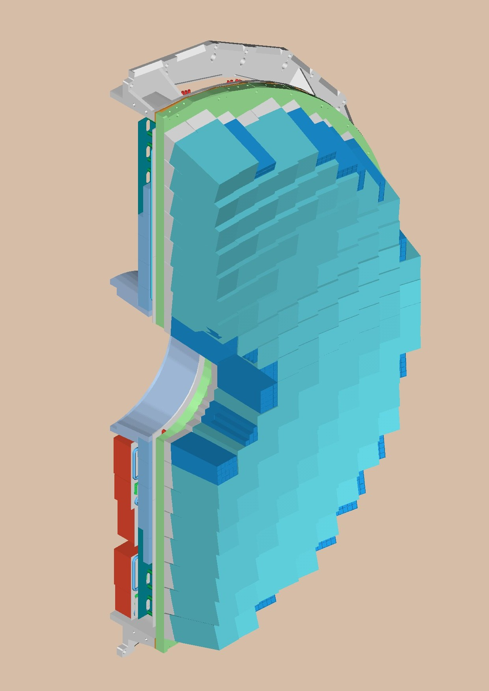
Backplate
Supercrystal array
Figure 6. The arrangement of Supercrystals on a Dee.

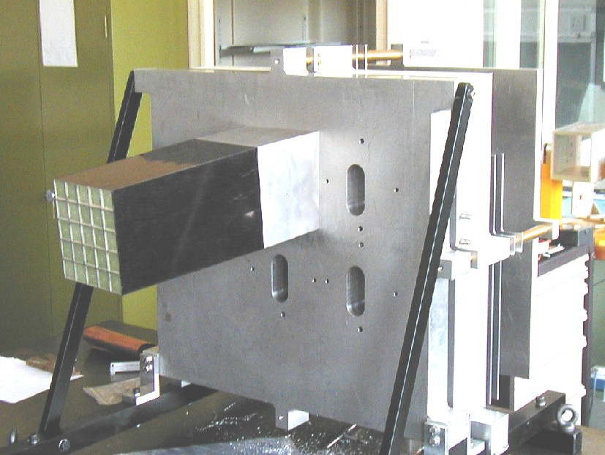
Figure 7. The prototype section of a Dee, E0′, with a capacity for 4 Supercrystals.
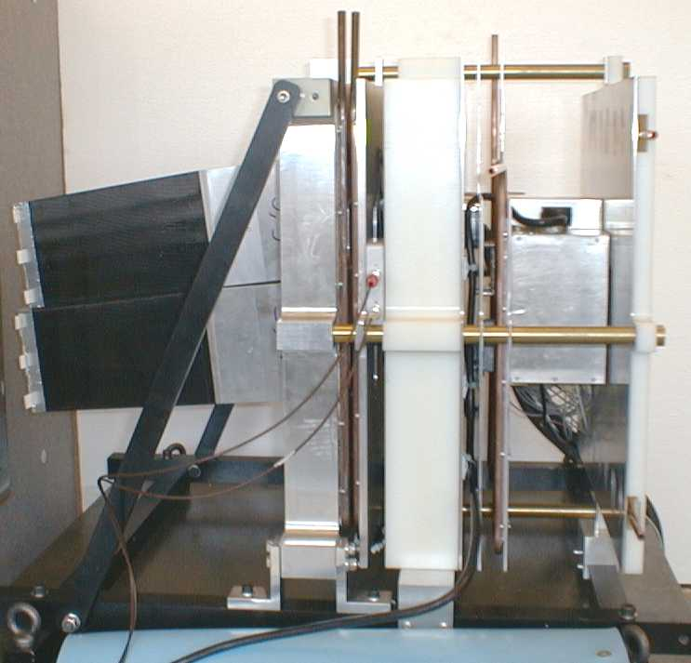
Figure 8. Side view of the Dee prototype, E0′, with two Supercrystals, the backplate, neutron moderator and 50-channel discrete component readout unit.

VPT testing

The RAL variable-angle test rig
The test rig at RAL is based on a water-cooled magnet providing fields up to 1.8T over an area of approximately 0.5 m². The vertical distance between the pole tips is approximately 10 cm. VPTs are held in rows of 8 aluminium cans. Up to 6 such rows can be mounted in the rig, and the rows are rotated in unison to present the VPTs to the magnetic field at any desired angle up to 90°. At present three rows of cans are installed in the rig.
Figure 9 is a photograph of the RAL test rig, with three rows of cans mounted. In operation, the rig slides forward into the region of uniform field between the pole tips. The 1.8T magnet was formerly used as a bending magnet in a beam line. A stepper motor, visible on the left hand side of Figure 9, is used to rotate all of the VPTs simultaneously by means of a system of drive belts.

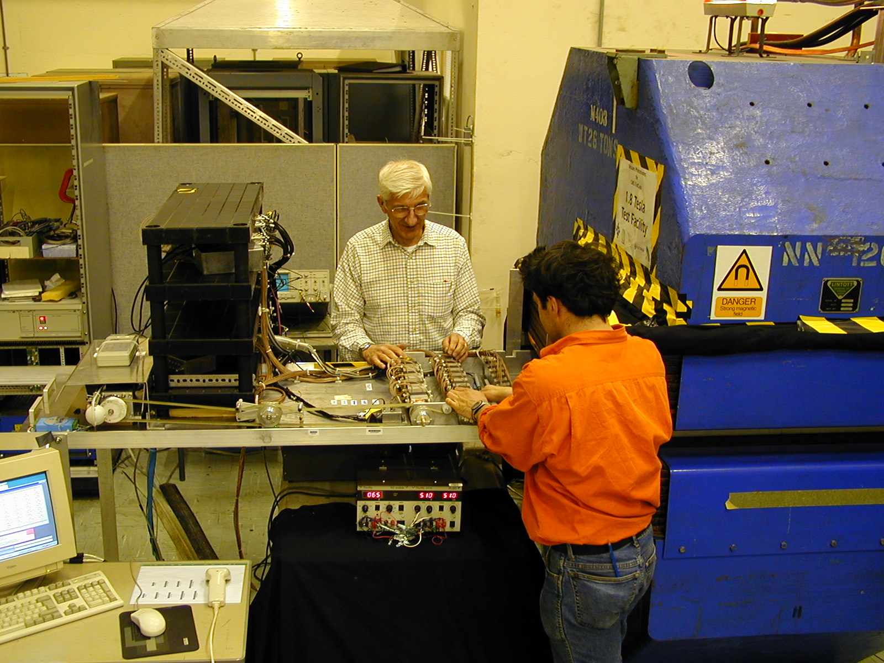
Figure 9. General view of the RAL test rig

Measurements in the RAL 1.8T test rig
In the CMS endcap detector, the VPTs will be operated at a range of angles from 7° to 24° to the magnetic field. In the RAL test rig, the devices can be placed at any desired angle with respect to the field. In the standard angle scan, measurements are taken at 35 positions from 30° to –30° with a short settling period after every movement so that any induced instabilities in the VPTs can decay before taking data. Figure 10 shows the variation in output with angle for a typical VPT.
The periodicity shown in this figure is seen in all of the VPTs supplied by RIE, and is dependent on the alignment of the anode grid with the axis of rotation. In the standard measurement procedure the grid lines are aligned with the axis of rotation.
3200 tubes have so far been tested in the 1.8T test rig, comprising a pre-production batch of 500 and 2700 production VPTs. Figure 11 shows the distribution of anode pulse heights measured in the rig at 1.8T for the production VPTs; the quantity plotted is the mean pulse height over the angular range 8° – 25° to the magnetic field. The measured pulse heights have been converted into the expected experimental yield of electrons per MeV of energy deposited in the CMS calorimeter. The performance of the devices is acceptable, being generally superior to a set of prototype tubes from the same manufacturer which achieved the CMS energy resolution requirements in test beams at CERN. Figure 12 shows the correlation between the mean pulse height in the 1.8T magnetic field and the quality factor (quantum efficiency × gain at 0T measured by the manufacturer).

Figure 10. Angular scan at 1.8T for a typical VPT

Figure 11. Mean anode pulse height over the angular range 8° – 25° in a 1.8T magnetic field

Figure 12. VPT response at 8° – 25° and 1.8T plotted against quality factor PG measured by the manufacturer.

Brunel test rig
The Brunel group has designed and built an automated system for evaluating the response of VPT devices at full the CMS field of 4.0T. Tubes are held in a ‘torpedo’ which is then placed in a superconducting solenoidal magnet (see Figure 13). The system is controlled by a number of IEEE-488.2 instruments controlled using LabView on a PC running Windows-NT. One hundred pre-production tubes, and 165 production tubes have now been evaluated.

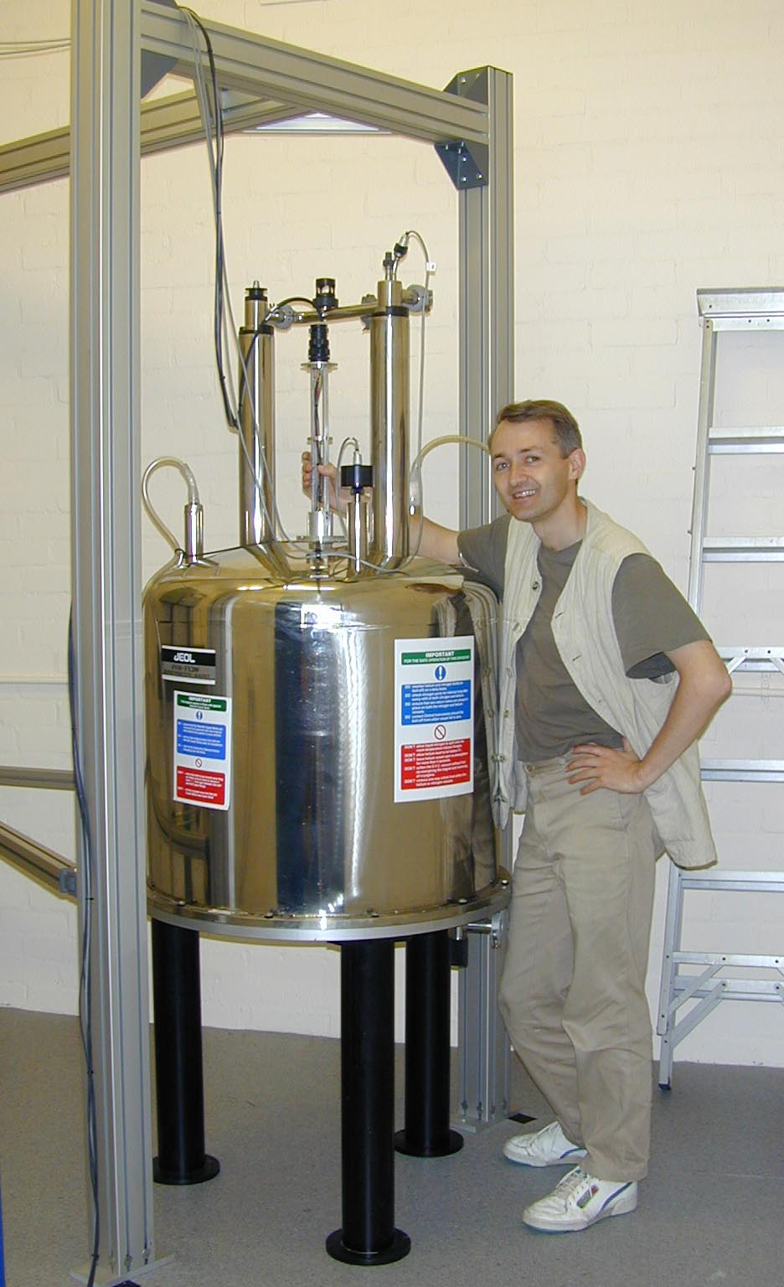
Figure 13. A view of the Brunel VPT testing area, showing the 4.0T magnet with the torpedo ready to slide down the bore of the solenoid
Figure 14. Distribution of relative gains at 15° to the 4T field for typical production VPTs
The Brunel VPT testing system is designed to evaluate the gain, noise, and leakage current of tubes operating at nominal HT in the full CMS field. The tubes are positioned at the mean angle in the CMS endcap of 15°. Figure 14 shows the distribution of relative gains for random samples from the first batch of production tubes. It can be seen that all but one of the tubes passes our acceptance criterion of > 80% relative gain at 4.0T.
Detailed measurements of radiation induced absorption, using a new Hitachi U4100 spectrophotometer, are carried out on batches of glass faceplates before they are approved for use on production devices. Figure 15 shows a typical measurement. Our work in this area has enabled affordable VPTs to be produced since we have discovered a glass that is tolerant to 20 kGy and which, unlike quartz, does not require expensive graded seals.

Evaluation of crystal properties
The CMS Crystal Laboratory at Imperial College has been developed into a state-of-the-art facility capable of making precise measurements of the optical properties of endcap crystals. Quick and precise measurements of longitudinal and transverse transmission are made using a mini-spectrometer containing a CCD array. This equipment has been used extensively to investigate the transmission properties of lead tungstate crystals. One result of particular note is that a correlation has been established between a gradient along the crystal in the transverse transmission around 360 nm and the anomalously high light collection non-uniformity seen in some of the pre-production crystals. This correlation is shown in Figure 16. This provides a quick method of identifying such crystals.
Over the last year, direct measurement of the light collection non-uniformity has been perfected using a hybrid photomultiplier tube (HPMT) to count individual photons. Figure 17 shows a photograph of the HPMT rig. To extract precise measurements, a detailed fit was developed to describe the data. The quality of the fit is illustrated in Figure 18. The laboratory now provides the best measurement, by a considerable margin, of the light collection uniformity in lead tungstate crystals and has shown that the technique used to screen crystals at CERN overestimates the non-uniformity of endcap crystals. This is significant because it was previously feared that the crystals would need ‘uniformisation’ by grinding one surface. This in turn would have required the development of wrapping material and had large cost, schedule and performance implications. In addition, a simple technique for further improving the uniformity of the crystals, based on evidence from earlier simulations done at Imperial, has been confirmed in the laboratory.

Figure 15. The radiation induced absorbance of a VPT faceplate (1 mm thick) after irradiation of 19.3 kGy with Co⁶⁰ gamma rays. This faceplate cuts the transmitted PbWO₄ scintillation light by only 8% after irradiation

Figure 16. Correlation between the rear light-collection non-uniformity (RNUF) and the change in the slope of transverse transmission between 350 and 365 nm

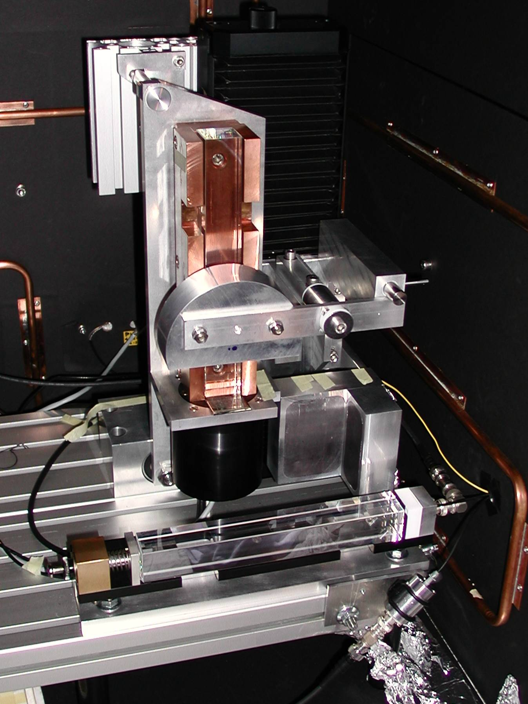
Figure 17. The HPMT rig in the IC Crystal lab used to measure the light collection uniformity along the length of the crystals mounted vertically on top of the HPMT
An annealing oven has been installed to allow controlled investigations of the radiation hardness and recovery of crystals. After annealing to establish the ground state, crystals are irradiated at the Brunel ⁶⁰Co source. Both the transmission and HPMT rigs have been used to investigate the amount of damage, and the recovery kinetics. The results have been fed back directly to the crystal producers in Bogoroditsk, Russia. Recent work has produced results for, and a new understanding of, the R-parameter that characterises the relationship between monitoring data and the physics signal. This work continues.
Exceptional support has been provided to the CMS Crystal laboratory by the HEP mechanical and electronic workshops. The electronics workshop constructed power supplies for the HPMT in the crystal laboratory and provided extensive support in tracking down interference that initially degraded the detector resolution. The mechanical workshop designed, built and refined the HPMT rig as the measurement technique was developed.
Figure 18. Data from the HPMT (points) and the fit (line)

Global Calorimeter Trigger
The calorimeters provide two types of information to the Level-1 trigger: electron/photon and jet candidates, collectively known as trigger ‘objects’; and sums of transverse energy and its components over the whole region up to |η|=5. The job of the Global Calorimeter Trigger (GCT) is to sort the different types of object, passing on the best four of each type for use in the Level-1 decision, and to calculate total and missing energy for the whole detector. These functions will be performed using a single, generic design of trigger processor module making extensive use of Field-Programmable Gate Array (FPGA) technology. The logic of the GCT is illustrated schematically in Figure 19.
The UK has conducted an extensive programme of technology evaluation to demonstrate that the generic processor concept can meet the performance requirements of the GCT. We have shown that the required sort and energy sum algorithms can be performed using the Xilinx Virtex family of FPGAs, providing significant cost advantages over fixed-function ASICs for the small quantities required in the GCT. A preliminary design for the GCT based on generic processors was written up for the Level-1 trigger Technical Design Report (TDR), published in December 2000. The publication of this document represented a significant milestone for the trigger project as a whole.
The final processor design for the GCT has demanding requirements on data input/output capabilities as well as logic performance. The input data of 5040 bits per beam crossing will be received by eight processor modules, giving an input rate of more than 25 Gbit/s per module. Recent developments in commercial serialiser/deserialiser (serdes) chipsets allow us to achieve this density using readily available, low cost components. Tests of different serdes chipsets together with FPGA processing have been performed. For these tests we have used a Virtex test module designed at RAL, in collaboration with ATLAS-UK, together with a series of daughter-boards designed and built in Bristol. Design work on a prototype processor module and other components of the GCT is now well under way.

The algorithms implemented in the Level-1 trigger are under continuous review as the simulation tools available to the collaboration are developed. In late 1999, a major revision of the jet finding algorithm was proposed. The new algorithm provides significant improvements in the physics performance and coverage of jet-based triggers. The adoption of configurable logic for the GCT has allowed CMS to incorporate new ideas into the baseline trigger design as they develop, and the UK has played an important part in generating and studying new algorithms.
Prototypes of the components of the GCT will be produced in early 2003. The final specification for the algorithms to be implemented is now being finalised. The system will be produced in 2004 and installed and commissioned during 2005.
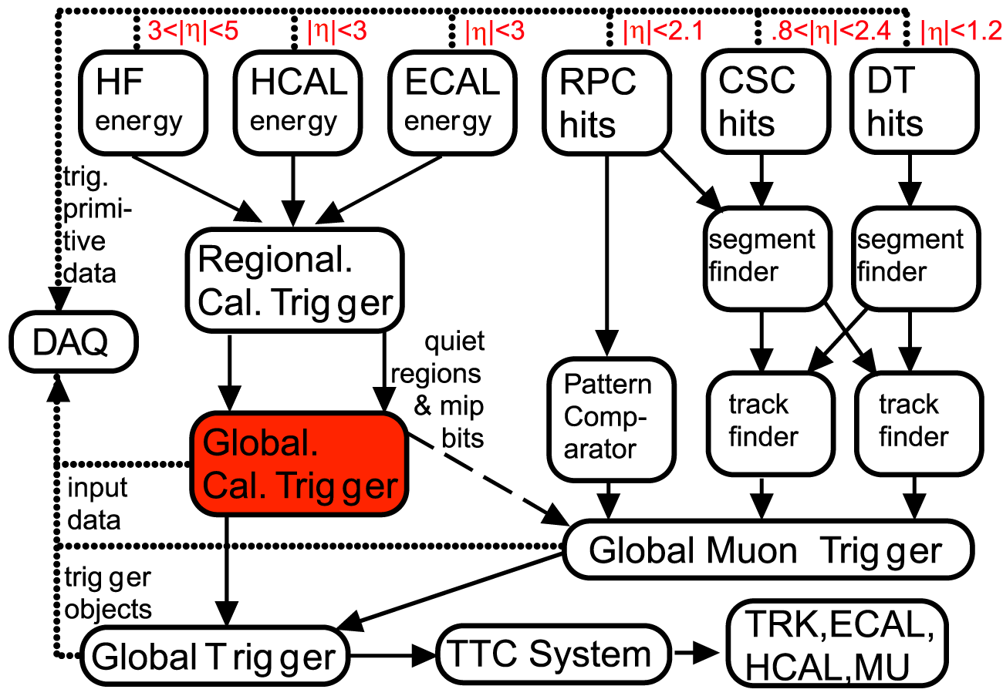
Figure 19. Schematic diagram of the CMS Global Calorimeter Trigger

PHYSICS AND COMPUTING

Overview
Over the last year, we have continued to make substantial progress in refining the triggering, reconstruction and physics analysis strategies for CMS. In particular, detailed simulation studies have been made of the performance of the high-level trigger (HLT), which is implemented entirely in software on a large CPU farm. We have successfully demonstrated that this approach will meet the data reduction and physics requirements of the experiment. These results were reported in the DAQ TDR, published at the end of 2002. UK physicists made a significant contribution to this programme of work, in management, execution and support roles. The physics performance of the final CMS detector is under continuing study, with our Physics TDR due in 2005.
In order to support these physics and detector studies, a fully operational prototype computing system has been developed, and was used on a large scale during the last year. Since 1999, CMS has moved from Fortran-based simulation code to a modular object-oriented simulation, reconstruction, analysis and data management framework. Fully simulated data samples of significant size (many millions of events, occupying tens of terabytes) have been produced and reconstructed along with appropriate background, in order to provide sufficient numbers of events for detailed HLT studies. The UK has been a leading contributor in this effort. The worldwide data production programme undertaken by CMS has also been essential in helping to define the requirements for our final software and computing system, to be documented in the forthcoming Computing TDR (2004). The CMS computing system is making increasing use of Grid technologies, and the UK plays a major role in this area of development.

Physics Reconstruction and Selection

The PRS project
The four PRS groups – e/gamma, muon, b/tau and jets/missing energy – were set up in May 1999. The basic task of these groups was the reconstruction and selection of physics objects, starting from the output of the Level-1 trigger. It is intended that the HLT will use the same code as will be used for offline reconstruction. The idea was that the reconstruction and selection algorithms would be developed as they were needed for successively higher levels of the trigger. In 2000, the remit of the groups was broadened to include all software tasks related to their corresponding subdetector. The PRS project is unique among the CMS projects in having direct control of no resources. PRS must obtain its resources from the sub-detector projects, and the coordinators of the four PRS groups must work to link the domain of physics and software with those of hardware, electronics, test-beam and so on.

ECAL – e/gamma Group
The e/gamma group is now responsible for all ECAL software and reconstruction and physics-related tasks, including calibration, test-beam analysis and simulation. A UK physicist has led the e/gamma group since its inception, and the ongoing UK contribution consists of two physicists and two students working full-time, plus a number of additional part-time contributors.
The important milestone up to 2001 was the delivery of a complete selection chain, from the Level-1 trigger to the final sample of events that will be written to permanent storage. This milestone was delivered in late 2001, and included a detailed breakdown of the signal and background in the 36 Hz event rate to offline storage, together with details of the cuts, thresholds and algorithms needed to achieve this. The efficiency of the chain for signal events, together with plots of efficiency versus background rejection, for most of the selection cuts, was also presented.
The primary milestone for 2002 was to repeat the HLT study of the complete selection chain with an improved geometrical description of the detector (in particular the Tracker), and to obtain results also for high luminosity running. These results appear in the DAQ TDR. It was also necessary to obtain estimates of the CPU time used by the selection code, demonstrating that the selection could be performed on the DAQ HLT farm.
In 2002, UK physicists were responsible for examining the impact of proposed changes to the ECAL readout scheme, with particular reference to the possibility of degraded performance of the Level-1 trigger in the endcap region. A detailed simulation study was carried out, confirming that the proposed changes resulted in only a small change in trigger rate; a new layout of the endcap trigger towers was defined during the course of this study, building on previous work by the UK Level-1 trigger group. Work in this area continues, with further potential optimisations of the layout under study.

Other milestones for 2002 included the presentation of a credible scheme for ECAL calibration. Work was carried out on many aspects of this problem, including an important study by a UK student of in situ intercalibration using electrons from W decay. A scheme for the intercalibration of ECAL crystals through monitoring the energy flow due to minimum-bias events was developed. This work demonstrated that a 2% intercalibration is achievable in a very short time, which is particularly important at start-up since the installation schedule now makes it impossible for us to pre-calibrate all channels in an electron beam. A detailed simulation was carried out of the selective readout and zero-suppression algorithms, which reduce the raw data volume from the ECAL by a factor of about 15 with little or no impact on the reconstructed physics objects. A UK student developed flexible software to address this need, improving upon the crude 2σ noise cut used hitherto.

HCAL – jet/missing energy Group
During 2002, a UK student studied various aspects of Level-1 jet and missing-E_{t} trigger performance. This has involved calculating standard trigger performance plots, including E_{t} resolution, trigger turn-on and rate plots at the initial LHC luminosity of 2.10³³ cm⁻²s⁻¹. These confirm and add to previous studies by the Level-1 group.
A study of the trigger tower segmentation in the very forward calorimeters was carried out at the request of the HCAL and Level-1 groups to quantify the difference between two proposed schemes. Both schemes were simulated using a full GEANT detector simulation, and a bit level simulation of the trigger electronics. The results show that the segmentation choice affects the Level-1 E_{t} resolution and trigger rate at the 1% level, but that both schemes provide acceptable performance.
Topological di-jet triggers have been studied in the context of Higgs production via weak boson fusion. This production mechanism includes two jets well separated in rapidity. The proposed triggers included cuts on the spatial separation of the two jets, thereby allowing the E_{t} threshold to be reduced. However, separate jets from two pile-up events cause sufficient rate such that these triggers are no more effective than the single jet trigger at selecting general weak boson fusion events. The particular case where the Higgs decays invisibly was also studied. It was found that a di-jet trigger including a cut of Δη>3.5 provides better performance than the single jet trigger for this channel. The addition of missing E_{t} to this trigger gives a trigger efficiency of 87% for invisible Higgs at a trigger rate of 410 Hz.

Tracker – b/tau Group
A UK physicist leads the tracker ‘data-handling’ group, which is responsible for those aspects of the off-line simulation/reconstruction software, which are related to the tracker readout or electronics. Several UK physicists are involved in the simulation and reconstruction aspects of this activity.
During 2002, The CMS simulation program (ORCA) was used to identify the best zero-suppression algorithm for use in the tracker FEDs, to verify that the FED dynamic range is large enough not to degrade tracker performance, to estimate the expected data rates from the tracker (for use in the DAQ TDR), and to identify the data format which minimises this data rate. In addition, work is underway to find the best algorithm to calibrate/monitor the tracker pedestals and noise during LHC running. Whilst performing these studies, UK physicists identified many shortcomings in ORCA, such as inappropriate signal to noise ratios and incorrect simulation of Landau fluctuations, and ensured that these problems were fixed.
The group is also responsible for ensuring that real tracker data can be read into the reconstruction program. The group is already providing the software needed to access and analyse test-beam data, and it is foreseen that this software will eventually evolve to allow access to data from the final CMS tracker. UK physicists are not only providing these software tools, but are also playing an important role in the actual analysis of the test-beam data, notably in the study of tracker readout performance in a 25 ns test-beam and in the study of the effect of highly ionising particles on the tracker readout.

Core Computing and Software
The roles of the CMS CCS project include:
- Development and support of the software framework which underlies CMS physics and reconstruction tools, and implements data management,
- Review of technologies and approaches, in order to make policy decisions on their use,
- Build up of the world-wide computing infrastructure needed for all CMS activities,
- Management of resources in support of the computing needs of the collaboration,
- Testing of the CMS software and computing approach and infrastructure, demonstrating that it performs at the necessary level to support the planned analysis activities from LHC start-up.
During 2002, CMS-UK has continued to increase its contribution in each of these areas, and now plays a substantial role in the CCS project. We have continued to work towards the definition and construction of a national Tier-1 computing centre for CMS reconstruction and analysis, in direct support of our physics goals. This will take the form of a fraction of a joint central LHC computing facility at the Rutherford Appleton Laboratory. CMS physicists have taken a leading role in the planning and setup of a prototype T1, and we have continued to cement our excellent working relationship with CLRC computing support staff. A new development during 2002 has been planning for Tier-2 centres. CMS will have direct access to at least two such centres in the UK, in London (via Imperial College and Brunel) and the South of England (via Bristol and RAL). These more specialised facilities will form the focal points for CMS-UK analysis computing in the future.
A major activity in the UK during the last year has been participation in the CMS monte carlo production activities. In 2002, the scope of the UK production expanded greatly to include computing facilities at RAL, Bristol and Imperial College. The UK contributed several TB of data in total, with six personnel participating. Most of the data produced has directly supported the work of physicists within the e/gamma PRS group. CMS is certain to remain one of the largest users of UK HEP computing and networks in the coming years, as the scale of CMS computing challenges grows. In 2003 – 2004, we will produce and analyse of the order of 100 TB of data over six months, in an extremely demanding 25% scale test of our full computing system. Planning for this major milestone is currently under way.
In addition to the development of large-scale computing facilities, we have continued to improve the support available to UK physicists in the use of local computing facilities. The complete CMS prototype software chain is available and supported within the UK, and may be used on excellent analysis and simulation resources at each institute. We anticipate that full use will be made of these local resources and expertise in the preparation of the Physics TDR. UK physicists are contributing directly to the development of the new CMS GEANT4-based simulation package, OSCAR, and the fast simulation package, FAMOS, both of which are beginning to be heavily used.
A new and important aspect of our computing programme is the use of Grid technology. CMS collaboration members have long been leading proponents of a DataGrid approach, and the collaboration was the first in HEP to develop, test and deploy Grid-based production tools. CMS-UK has benefited from a strong early involvement in this area. We have received a contribution of 3.5 FTE of manpower via the PPARC GridPP project during 2002, in addition to e-science studentships; more than any other UK experiment. This effort is being used directly toward the development of a Grid-based computing system for CMS, with particular emphasis on the construction and testing of the prototype Tier-1 system. Our main contributions are in the area of workload management (Imperial College), monitoring (Brunel) and data management (Bristol). We are contribuing directly to the development and testing of a new event storage layer for CMS, to be deployed in 2003. CMS-UK physicists also occupy a variety of management roles in the GridPP and LCG projects, and have represented CMS within international Grid collaborations.

Conclusion and summary
2002 has been a successful year for the CMS collaboration, with the construction of many subdetector systems making substantial progress. The excavation of the experimental caverns is nearing completion, and the construction of the magnet is progressing well, with the production of the superconductor for the magnet expected to be complete in June 2003. The Collaboration continues to grow, with new groups joining CMS from Brazil, New Zealand and Ireland.
The UK groups have played leading roles in the development of the Electromagnetic Endcap Calorimeter and the Tracker; in both cases, large-scale production of vital components is under way. In addition, the UK continues to play a leading role in designing and implementing the CMS global calorimeter trigger system.
UK physicists and students continue to play an active role in preparing for the physics exploitation of the experiment, making important and timely contributions within both the PRS and CCS projects. A clear roadmap towards CMS physics analysis in 2007 is being established, and is supported by a strong UK effort in the development of the necessary computing and software systems. As the exploitation phase of the CMS experiment nears, UK interest is expected to focus on the preparation of the Physics TDR, for which our existing contribution to PRS activities, and our expertise in software and computing, will stand us in excellent stead.

PUBLICATIONS

Journal papers
Single event upset studies on the CMS Tracker APV25 readout chip
E. Noah et al
Nuclear Instruments and Methods A492 (2002) 434-450
Study of radiation damage and substrate resistivity effects from beam test of silicon microstrip detectors using LHC readout electonics
J. Coughlan et al
Nuclear Instruments and Methods A488 (2002) 85-93
Test results from a prototype lead tungstate crystal calorimeter with vacuum phototriode readout for the CMS experiment
M. Apollonio et al
Nuclear Instruments and Methods A484 (2002) 287-288
CMS silicon tracker developments
B.C. MacEvoy, G. Hall, A. Santocchia et al
Nuclear Instruments and Methods A477 (2002) 440-445.
Cryogenic investigations and modelling of inter-defect charge exchange in silicon particle detectors
B. C. MacEvoy, G. Hall, A. Santocchia
Nuclear Instruments and Methods B186 (2002) 138-143.
An enhanced approach to numerical modelling of heavily irradiated silicon devices
A. Santocchia, B.C. MacEvoy, G. Hall et al
Nuclear Instruments and Methods B186 (2002) 171-175.

Conference contributions
The effect of highly ionising events on the APV25 readout chip
R. Bainbridge et al
Paper presented at 8th Workshop on Electronics for LHC Experiments, Colmar, September 2002.
Results from the first CMS Tracker system test
N. Marinelli et al
Paper presented at 8th Workshop on Electronics for LHC Experiments, Colmar, September 2002.
APV25 production testing and quality assurance
M. Raymond et al
Paper presented at 8th Workshop on Electronics for LHC Experiments, Colmar, September 2002.
The implementation of the production version of the Front End Driver card for the CMS silicon tracker readout
J. Coughlan et al
Paper presented at 8th Workshop on Electronics for LHC Experiments, Colmar, September 2002.
The APVE emulator to prevent front-end buffer overflows within the CMS silicon strip Tracker
W. Cameron et al
Paper presented at 8th Workshop on Electronics for LHC Experiments, Colmar, September 2002.
The front-end driver card for the CMS silicon strip Tracker readout
S. A. Baird et al
Paper presented at 8th Workshop on Electronics for LHC Experiments, Colmar, September 2002.
The response to high magnetic fields of the Vacuum Phototriodes for the Compact Muon Solenoid endcap electromagnetic calorimeter
K W Bell et al
Paper presented at 3rd Beaune Conference on New Developments in Photodetectors, Beaune, France, 17-21 June 2002

Refereed CMS Notes
CMS ECAL User Requirements for CRISTAL2
H. F. Heath, B. W. Kennedy, J. H. Williams at al
CMS NOTE 2002/045
Expected Data Rates from the Silicon Strip Tracker
I. Tomalin et al
CMS NOTE-2002/047
The Effect of Highly Ionising Events on the APV25 Readout Chip
R. Bainbridge at al
CMS NOTE-2002/038
Energy Flow Objects and Usage of Tracks for Energy Measurement in CMS
A. Nikitenko, T. Virdee at al
CMS NOTE-2002/036
Intercalibration of ECAL Crystals in Phi Using Symmetry of Energy Deposition
C. Seez et al
CMS NOTE-2002/031
Observing Anomalous Di-boson couplings in Zγγ and ZZγ vertices at CMS
C. K. Mackay, P. R. Hobson
CMS NOTE-2002/028

CMS Internal notes
Re-Examination of Some Aspects of the ECAL Very Front End Specifications
A. Nikitenko, C. Seez
CMS IN-2002/070
CMS Level-1 Global Calorimeter Trigger to Global Trigger and Global Muon Trigger Interfaces
J. J. Brooke et al
CMS IN-2002/069
Implementation And Use Of The ECAL Selective Readout Algorithm
S. Rutherford
CMS IN-2002/027
Jet Rejection Using ECAL Isolation
O. Sharif
CMS IN-2002/025

PhD Theses
Level-1 Jet Trigger Studies for the CMS Experiment
J. J. Brooke
University of Bristol Ph.D. Thesis, 2002
Development of Digital Readout Electronics for the CMS Tracker
E. Corrin
Imperial College of Science, Technology and Medicine Ph.D. Thesis, 2002
Radiation and Temperature Effects on the APV25 Readout Chip for the CMS Tracker
E. Noah Messomo
Imperial College of Science, Technology and Medicine Ph.D. Thesis, 2002

 Associated institute

