Report on the testing of the proposed ATLAS Inner Detector barrel thermal enclosure bulkhead power tape grommets and proposed sealant.

Author(s) | B. E. Anderson, D. Attree

Document number | ATLAS SCT UCL grom001
Document status | For discussion

Issue date | 23.04.2001 | Issue number | 1.2
Revision dates |  | Revision number
22.05.2001 |  | 1.1
28.02.2002 |  | 1.2
25.02.2003 |  | In progress

Note: The title of this document has changed as new tests have been defined.
1. Scope of document.

This document describes
- the leak tests conducted on the proposed silicone rubber grommets that allow the power tapes to pass through the ATLAS thermal enclosure envelope,
- tests to determine the extension under load of the grommet flange,
- tests of the strength and elasticity of the proposed sealant.

2. Purpose of tests.

To determine the leak rate of the proposed method of leak sealing the grommet and power tape assembly, to test the elasticity of the grommet flange and to test the elasticity, bond strength and tensile strength of the proposed sealant.

3. Leak testing

3.1 Apparatus and assembly techniques for leak testing.

The grommets tested are based on RAL drawing number A2-TB-0049-155-00-A (Feedthough sleeve [SCT] [Inner detector services]) but were fabricated (rather than moulded) from silicone rubber sheet. Four of the grommets were each mounted with a group of six power tape segments and sealed with a mixture of Techsil 6166 RTV silicone rubber and BDH fine talc (silica) in the ratio 10:5. A schematic of the assembly is given in Figure 1.
Slotted aluminium alloy test plate
Power tape
RTV
Grommet
sealant

Figure 1. Power tapes and grommet shown mounted through alloy plate with RTV sealant.

The power tapes were cleaned with ethanol and then glued together in groups of six by spreading a small amount of RTV sealant on the tape surfaces and then stacking and loading with a 1kg weight and leaving the RTV sealant to cure for 16 hours. Care was taken to ensure that the tapes were aligned accurately within their respective groups. The slotted test plate and grommets were cleaned with ethanol and the groups of tapes passed through the grommets. A bead of RTV sealant was run around each slot in the test plate and the grommet-power tape assemblies fitted to the slots. RTV sealant was then added as shown in Figure 1, ensuring that all potential gaps were filled or covered with RTV sealant. The RTV sealant was applied using thin wooden spatulas cut from cotton bud sticks. This assembly was then allowed to cure for 16 hours

Test plate with 4 x 6 power tape segments
Manometer

Test box
N₂ supply

Figure 2. The test apparatus for leak-testing the grommet-power tape assemblies.

Before the test plate with the power tapes was tested, the box was qualified using an unslotted plate with the same external dimensions as the test plate. This test methodology is essentially the same as that described in versions 1.0 and 1.1 of this document, using the apparatus shown in figure 2. However, the following changes were made to the procedure:
- the amount of silica was reduced from 10 parts Techsil : 8 parts silica to 10 parts Techsil : 5 parts silica (described below as Techsil + 50% silica) in order to improve the applicability and wetting while maintaining a sufficient viscosity to avoid excessive slumping or run-off,
- the water in the manometer was replaced with a low vapour pressure silicone oil,
- the overpressure inside the box was raised from 5.5 to 10 mbar,
- the test period was extended from around 4 to 720 hours (30 days),
- as a result of which corrections had to be made to allow for changes in temperature and barometric pressure.

3.2 The leak test results.

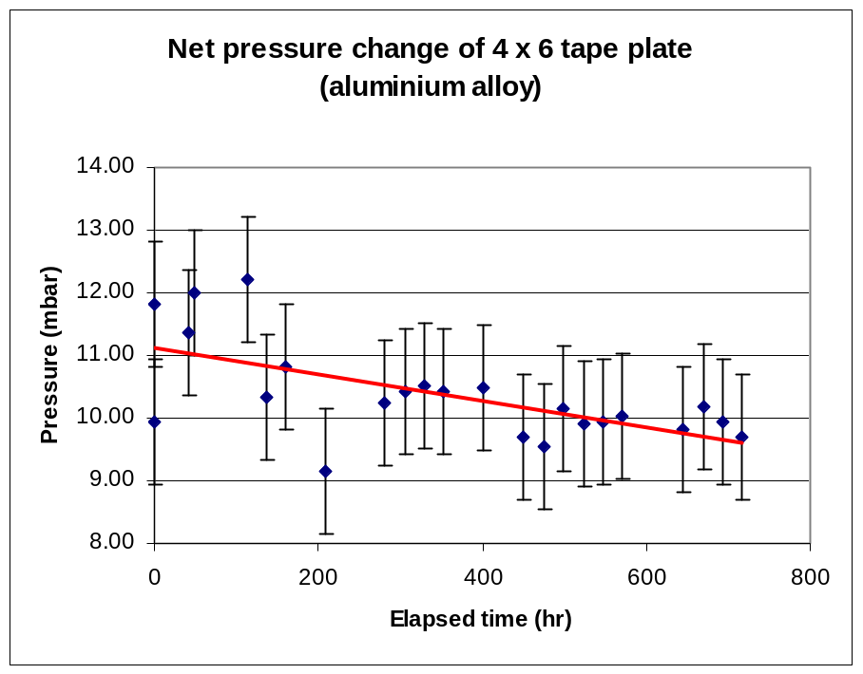Figure 3 shows the net pressure drop over a 720-hour period. There is a net pressure drop over the period of about 1.3 mbar, giving a leak rate of 2.4 x 10⁻⁶ mbar.l.s⁻¹. (Note: the box has a volume of 4.5l). The error bars are dominated by the precision of the digital barometer (± 1 mbar).

Figure 3 Overpressure vs. time results for the test box with the test plate plus 4 x 6 power tape assemblies.

Note that for the full set of power tapes from all barrels, the inferred leak rate will be 1.2 x 10⁻⁴ mbar.l.s⁻¹, assuming there are 12 (not 6) tapes per grommet.

4. Testing the extension under load of the grommet flange.

There is a possibility that the material of the grommet might harden as a result of irradiation. We decided to test the elasticity of the grommet material to determine whether any hardening was detectable after irradiation. This initial test measures the elasticity before the sample is irradiated. The grommet flange was chosen as the test subject because it is flat (unlike the sleeve or the complete grommet) and therefore less likely to distort in planes non-parallel to the direction of the applied load.

4.1 Test apparatus.

The apparatus is shown in Figure 4. Essentially, the equipment consists of a pair of carefully machined clips that allows the flange to be held in a repeatable position while the measurements are taken, an upper support, a scale pan and a vernier height gauge to measure the extension. It is, in effect, an apparatus to test Hooke’s Law.
Grommet flange
Height gauge
Surface plate

Figure 4. Apparatus for testing grommet flange extension under load.
4.2 Grommet flange elasticity test results.

These are shown in Figure 5. The extension vs. load curve is essentially linear.
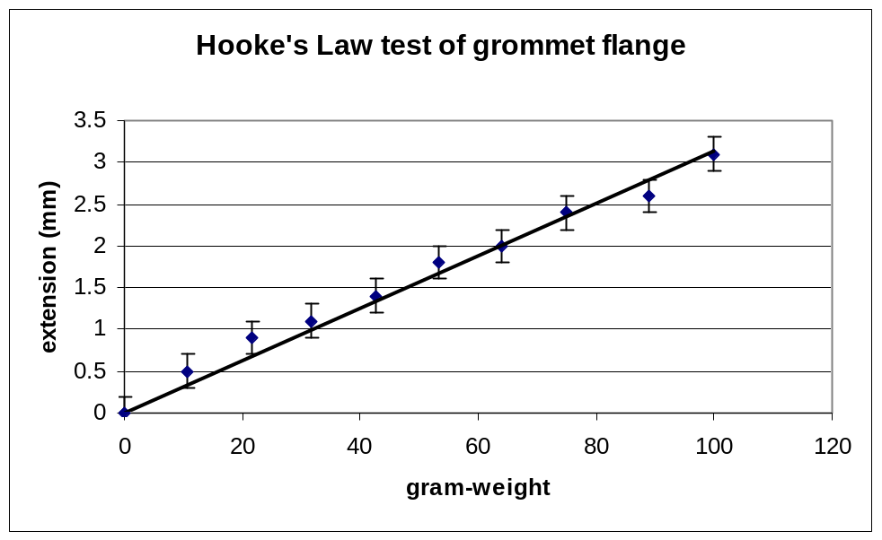
Figure 5. Load vs. extension plot of grommet flange

We allowed the sample to relax after loading and measured the length again. We found that it had returned to its original dimension, indicating that it had not been loaded to the elastic limit.
The post-irradiation test is still to be done.

5. Inducing failure in the sealing mechanism.

Although the leak testing described in section 3 allows considerable confidence in the sealing method, we considered the possibility that stresses on the power tapes during installation (especially high force traumatic incidents) might cause the seal to fail. We therefore conducted a series of tests designed to challenge the robustness of the seal.

5.1 Flexing the power tapes within the seal.

We manufactured another slotted test plate with only one slot and mounted a grommet and 6 power tapes in a manner similar to the one described in section 3. The tapes were flexed by 90º in a direction normal to the plane (test axis A) of the tapes and by about 5º in a direction parallel to the plane (test axis B) (the deviation of the tapes in this direction was limited by the fairly small clearance between the tape bundle and the internal surface of the grommet and slot).

This is shown schematically in Figure 6.

Test plate with grommet, RTV and 6 power tapes
Test axis A
Test axis B

Figure 6. Test arrangement for power tape flexing

We pressurised the test box to 10 mbar overpressure and flexed the tapes close to the grommet, firstly on axis A at ±10º intervals (with a relaxation at θ = 0º after each reading), then on axis B at very approximately 1º intervals with a similar relaxation. About 5 minutes was allowed for each position. The whole test series lasted about 90 minutes.
At no point did we observe a pressure drop, indicating that the seal integrity and elasticity of the RTV sealant is sufficient to withstand “normal” power tape handling.

5.2 Testing the seal under axial load.

We considered this test to be representative of the kind of load that the power tapes and seal might experience if they were suddenly tugged.
The tape arrangement described in section 5.1 was repeated and the box again pressurised to 10 mbar.
A strong relatively inflexible line was attached to the power tape bundle via a hole drilled through the set as shown in Figure 7. The load was gradually increased in 10g wt intervals from 0 to 120g wt (1.17N), then in 50g wt intervals to 400g wt (3.9N). About 10 minutes were allowed between loadings. Until 300g wt there was absolutely no detectable movement of the tapes or distortion of the seal. At 350g wt, there was a discernible stretch in the seal, although the assembly remained stable. At 400g wt, the RTV sealant began to tear and the seal failed after 35 minutes.

The test was then repeated the following day (by cleaning off the residue of sealant from the original test and then re-gluing) with a 300g wt (2.9N) load and the assembly carefully watched for changes. Table 1 shows the changes observed.

Inside of box
(10 mbar)
Point A

Figure 7. Test arrangement for axially loading the tape bundle and seal

Elapsed time (minutes) | Observed changes | Box overpressure (mbar)
0 | No change | 10
10 | No change | 10
20 | No change | 10
30 | No change | 10
45 | No change | 10
52 | Tear in RTV sealant at point A | 10
85 | Tape bundle slipped through grommet by 5mm. Tear now extensive | 10
87 | Tape bundle slipped by 10mm | 8.3
90 | Tape bundle slipped by 15mm | 6.9
93 | Failed | 0

Table 1. Observed changes with 6-tape bundle and seal under axial load of 2.9 N

When we examined the tape bundle, it seemed that the failure was primarily caused by the weakness of the adhesive bond between the polyimide of the power tape and the RTV. There was, however, enough uncertainty about the failure mode to prompt a further series of tests.

5.3 Bond strength of Techsil 6166 + 50% silica

We conducted two essentially similar tests. Firstly bonding two power tapes together and testing the bond strength to failure, then doing a similar test bonding a power tape to silicone rubber (RS 246-1659). Figure 8 shows the test arrangement. Figures 9a and 9b show the test results. The bond area was 40 x 21 mm in each case and the RTV thickness around 0.2mm. 5 minutes were allowed between each increase in load.
Test sample

Figure 8. Test arrangement for bond testing Techsil 6166 + 50% silica for two adherends.

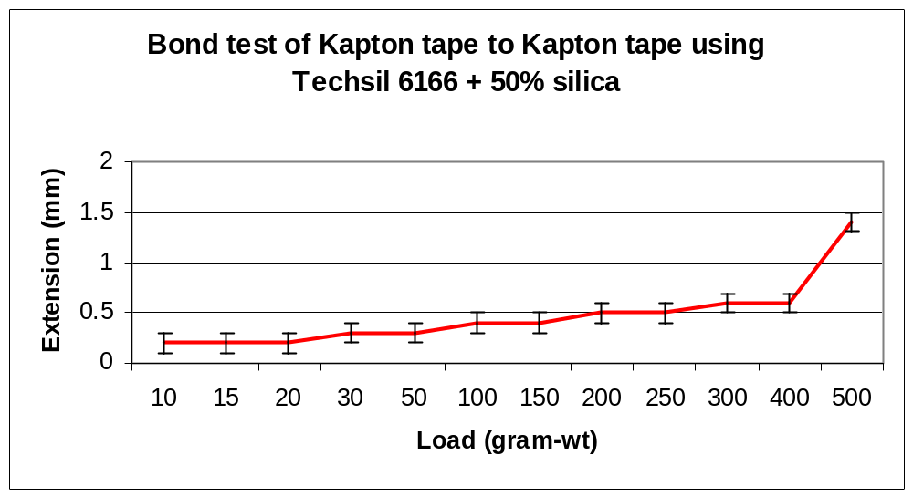

Figure 9a. Bond strength of Kapton-to-Kapton.
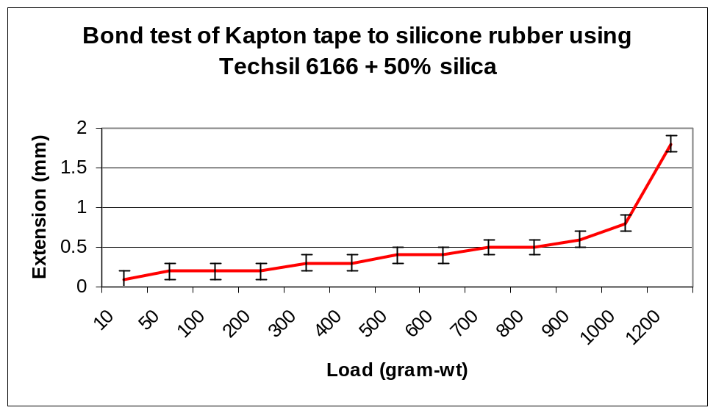

Figure 9b. Bond strength of Kapton-to-silicone rubber.

In the case of Figure 9a, we conducted an independent series of measurements on the silicone rubber alone, which allowed us to subtract the effect of its elasticity from the test.
It is clear from the plots at Figures 9a and b that the bond strength in the case of silicone rubber-to-Kapton (failure at approx. 1200 g wt, 11.8N) is more than twice as great as for Kapton-to-Kapton (failure at approx. 500 g wt, 4.9N). Since Kapton is often very difficult to bond to without preparation unacceptable to the electrical breakdown integrity of the power tapes, it is unsurprising that the failure occurs at a much lower load when two Kapton surfaces are involved compared with just one.

5.4 Modulus of elasticity (Young’s modulus) and tensile strength of Techsil 6166 + 50% silica.

We designed this test to gather some idea of the elasticity and bulk strength of the sealant. We made a PTFE mould that allowed us to cast a strip of the sealant 50 x 11 x 2.5 mm. The sealant strip was left to cure for 16 hours before being removed from the mould. The sample was secured to the apparatus by gluing four small strips of glass-reinforced epoxy to the ends with unfilled Techsil. This gluing operation was done without loading the glue joint (in order to preserve the profile of the strip) and was also left for 16 hours. We then measured the extension with increasing load to a precision of 0.2mm. The sample was allowed to relax back to its unloaded position after loads of 5, 15 and 25g had been applied. There was no discernible plastic deformation. The apparatus and test arrangement is shown at Figure 10 and the resulting curve at Figure 11.

Test sample of filled Techsil
G10 fixtures
23mm

Figure 10. Measurement arrangement for the tensile strength and modulus of elasticity of Techsil 6166 RTV sealant + 50% silica

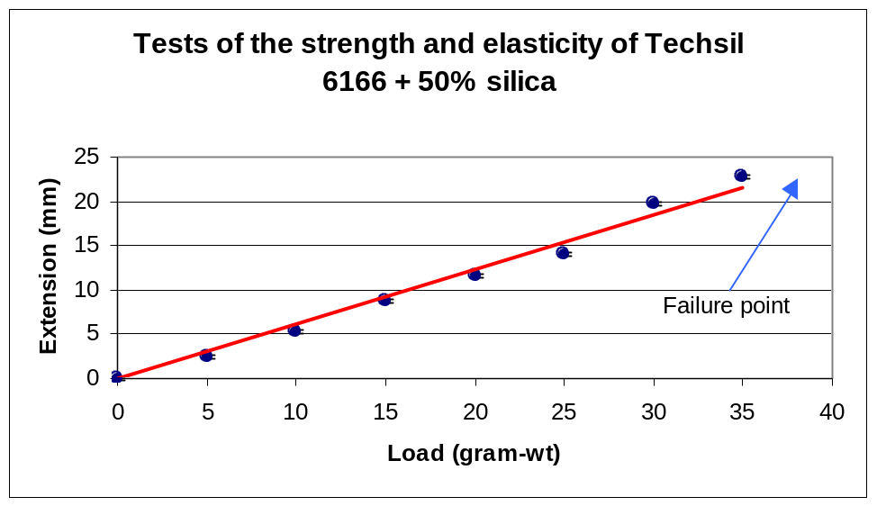

Figure 11. Results of the tests on the elasticity and strength of 50% silica-loaded Techsil 6166

The test results allowed us to determine both the modulus of elasticity and the tensile strength of the material. Table 2 shows the results:

Modulus of elasticity [Y = (F/A)/(e/L)] | 1.75 x 10⁻⁵ GPa
Tensile strength | 1.38 x 10⁻² MPa
Elongation at break | ~100%

Table 2. Derived parameters for filled Techsil

It can be seen that the material has impressive elongation properties but is very weak.

6. Discussion

6.1 Comments on the test results.

1. The Techsil 6166 RTV sealant + 50% silica sealant is capable of retaining an overpressure of 10 mbar over a period of one month with a pressure loss of only 1 mbar.

2. The tests on the strength of the material suggest that it should be capable of withstanding a higher pressure for a considerable period. None of the tests of the material strength caused failure or irreversible change at forces below 200 g wt (approx. 2N). The total force on the grommet, sealant and power tape bundle at 10 mbar overpressure is < 7 x 10⁻² N.

3. We think that the failure mechanism when sufficient force is applied is the simultaneous (or near simultaneous) rupturing of the bulk material and the bond to the Kapton.

6.2 Recommendations.

1. It proved to be quite difficult to apply the RTV sealant-silica mixture despite the reduction in the amount of silica over the tests reported in versions 1.0 and 1.1. It does not readily wet to surfaces and tends to be rather “clumpy”. This is due to the large amount of silica present (33% by weight) that is necessary to prevent the mixture flowing under gravity during its pot life (about two hours). Therefore:
We recommend the use of a pneumatic glue dispenser with drop-dispensing control and a fairly wide-bore cannula (say 1.5mm ID).

2. Paradoxically, the mixture acts as quite a good lubricant, so care has to taken that the grommet and/or the tapes do not move or fall out when the grommet slot is vertically aligned (i.e. the hole is parallel to gravity). Therefore:
We recommend that consideration be given to some form of retaining fixture for any grommet mount with that orientation in the thermal enclosure.
3. The seal is prone to failure following any large tensile force on the power tapes (such as the tapes being snagged or trodden on after the seal has been made) Therefore:
We recommend that the power tapes have a restraint immediately above and below the thermal enclosure bulkhead exit.

4. Great care will be needed to ensure that the application of the sealant is of high quality at every power tape entry. Therefore:
We recommend that the exercise be modelled with realistic geometry and a procedure manual written.

6.3 Future work.

1. Irradiate and retest the 4-bundle test plate described in section 3. (Done – see below)

2. Irradiate and retest the grommet flange described in section 4. (Done – see below)

3. Conduct similar tests to those described in section 3 for the planned grommeted exits for optical fibres and DCS.

4. Conduct similar tests to those described in section 3 with PEEK as the test plate material.

5. Conduct assembly trials and leak tests on a representative section of the thermal enclosure bulkhead.

New test results yet to be incorporated.



