 | Transport of SCT Barrels
ATLAS Project Document No: | Institute Document No. | Created: 12/02/03 | Page: 1 of 17
 |  | Modified: 25/03/03 | Rev. No.: 5

Draft
Transport of SCT Barrels

Abstract
This document describes the transport of SCT barrels from RAL to the macro assembly sites at Oxford University and KEK and from there to CERN.
Prepared by:  Georg Viehhauser | Checked by:  Richard Apsimon, Nick Brooks, Susumu Terada, Heinz Pernegger, Eric Perrin, Allan Clark | Approved by:
Distribution List

History of Changes
Rev. No. | Date | Pages | Description of changes
2  3  4  5 | 24/02/03  25/02/03  10/03/03  25/03/03 | 8-9  8  4  4  4  14  16 | Added drawing of KEK assembly area.  Updated dimensions of KEK loading area.  Correct mistake in table 1.  Add new section 2 describing transport of carbon fibre cylinder from CERN to RAL.  Update information about shock data logger.  Update Section 5.3 with results from calculations of isolation properties of wire rope isolators.  Update Table 5 (contact person for KEK).

Table of Contents

1 Overview 4
2 Transport of carbon fibre cylinders from CERN to RAL 4
3 Environment requirements during transport 4
3.1 Mechanical shocks 4
3.2 Thermal environment 4
3.3 Humidity 5
3.4 Pressure 5
4 Reception areas 5
4.1 Rutherford Appleton Laboratory – Didcot, UK 5
4.2 Oxford University – Oxford, UK 6
4.3 KEK – Japan 8
4.4 CERN – Geneva, Switzerland 9
5 Transport containers 13
5.1 Inner container 13
5.2 Outer container 14
5.3 Mechanical connection between inner and outer container 14
5.4 Air-tight bagging – Nitrogen supply 15
5.5 Additional goods to be delivered with the barrels 15
6 Pick-up/delivery procedures 15
6.1 Interface between assembly sites and shipping company 15
6.2 Handling during pick-up/delivery 16
7 Road Transport (RAL – Oxford, Oxford – CERN) 16
8 Air transport (RAL – KEK, KEK – CERN) 16

Overview
The scope of this document is to describe the transport of the four SCT carbon fibre barrels (labeled barrel 3, 4, 5, and 6) during the assembly.
Several different transfers with varying configurations will have to be performed. The first transport will be of the bare carbon fibre cylinders only equipped with the carbon fibre brackets from CERN to RAL. As this partial assembly is less sensitive to external influences its transport will be less demanding. It will be described in section 2.
The rest of the document will deal with the transport of barrels at a later stage of the assembly, equipped with delicate components. During these transports the barrels will be inside the transport box. These boxes consist of an inner part (section 5.1), which will be stay around the barrel all the time until the final 4-barrel assembly at CERN. The outer transport box (section 5.2) will only be used during the actual transport. Inside the outer transport box the inner transport box will be wrapped in a polyethane sheeting to maintain a dry environment (section 5.4).
The barrel will be supported inside the inner transport box on its spindle and the service cages will be mounted. Services (harnesses, cooling loops, DCS sensors) will be mounted and stored in the service cages. During the transport from Oxford to CERN or from KEK to CERN they will also be completely equipped with Silicon detectors.
The sequence of transports is given in Table 1. A description of the reception areas of the different sites can be found in section 4. There are at maximum two barrels at a given time at any location except CERN.
Table 1: Sequence of transports. Dates are rough indications.
Date | Barrel 3 | Barrel 4 | Barrel 5 | Barrel 6
April ‘03 | RAL → Oxford
August ‘03 |  |  |  | RAL → Oxford
November ‘03 | Oxford → CERN
November ‘03 |  |  | RAL → Oxford
January ‘04 |  | RAL → KEK
March ‘04 |  |  |  | Oxford → CERN
May ‘04 |  |  | Oxford → CERN
June ‘04 |  | KEK → CERN

Transport of carbon fibre cylinders from CERN to RAL
For the transport of the barrels from CERN to RAL the original wooden box, which was used to ship the carbon fibre cylinders from the manufacturer to Geneva University, will be used again. The properties for this wooden box for the different barrels as well as the expected shipping dates are given in Table 2.
Table 2: Properties of wooden box used for shipment from CERN to RAL.
 | Barrel 3 | Barrel 4 | Barrel 5 | Barrel 6
Estimated shipping date | Week 14 | xxx | xxx | xxx
Length | 1.90 m | 1.90 m | 1.90 m | 1.90 m
Width | 0.84 m | 0.98 m | 1.17 m | 1.27 m
Height | 0.94 m | 1.10 m | 1.30 m | 1.40 m
Total weight | ~120 kg | ~150 kg | ~200 kg | ~250 kg

Environment requirements during transport

Mechanical shocks
During the transports mechanical shocks to the inner transport box should not exceed xxx N in any direction. To mechanically insulate the inner box from the outside world it is suspended from the outer box using wire rope springs (section 5.3). Mechanical shocks to the outer transport must not exceed xxx N in any direction. Accelerometers (CDF Shocklog) with a measurement range of 3g will be added to the transport boxes to monitor this requirement.

Thermal environment
During the transport the ambient temperature outside the transport box is not allowed to exceed xxx and or be below xxx for extended times (>1h). These limits are allowed to be exceeded by xxx during shorter periods. Thermometers will be added to the transport boxes to monitor this requirement.

Humidity
The relative humidity inside the inner transport box has to be below xxx%. This will be achieved by bagging the inner transport box and flushing it with nitrogen at a rate of about 5.5 l/min. This system is specified in section 5.4. No requirement regarding the humidity outside the transport box is necessary.

Pressure
No requirement regarding the pressure outside the transport box is necessary.

Reception areas

Rutherford Appleton Laboratory – Didcot, UK
The barrels will be assembled and put into their transport boxes in building R12 at Rutherford Appleton Laboratories. Access to this build is shown in Figure 1 . Also, note that a new building will be constructed next to R12 from April-December 2003 as shown in Figure 2. During this time an alternative access might need to be used. There is no weight limit for the transport of the transport boxes.
The access door to R12 is 2.8m wide x 4m high. No vehicular (including fork lift) access should be planned inside this building. The maximum wheel load inside part of R12 is restricted to 750kg. The outer container will be manually moved inside the building using multi-wheeled machine skates. The area outside R12 is not subject to any load restrictions.
The inner box, containing a barrel, will be removed from the cleanroom inside R12 and secured inside the outer container. This will be carried out inside a tented extension to the cleanroom. This tent (for an example see Figure 3) is a structure of anodized aluminium, covered by impermeable polyester (see also the manufacturer’s website at www.mastertent.de).
The dimensions of the tent will be 3.3m high (at the highest point), 3m wide and 6m long. The height of the side walls will be 2.44m, of which only 2.01m can be open. The tent will have two side and one end wall, the side towards the clean room being open. The air inside the tent will be recycled through a mobile HEPA filter unit to protect the integrity of the cleanroom and to ensure that both the inside and outside of the inner container are dust-free. The weight of the basic tent (no side walls) is 45kg. When the tent is collapsed, it measures 31cm x 52cm x 154cm (without side walls). It is envisaged that this tent and air purification unit will travel to Oxford with barrels 3, 5 and 6 to assist in the transfer of the inner container at that site.
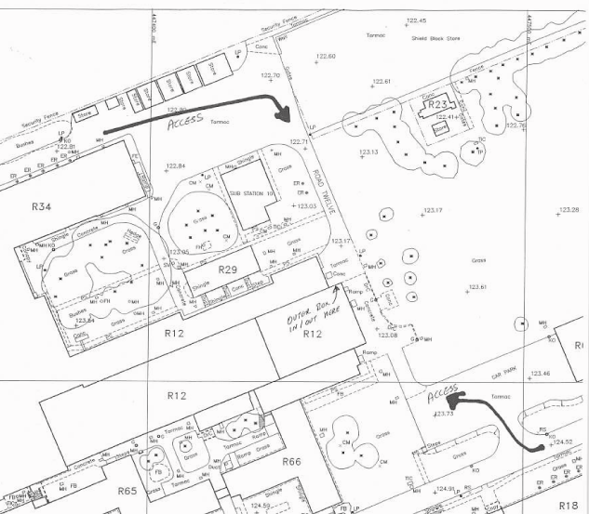
25m
Delivery point
Figure 1: Access to RAL building R12. The main access will be along the right lower arrow. An alternative access route is along the upper left arrow.

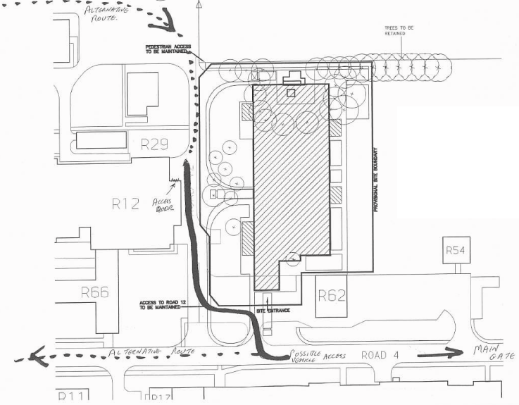
Figure 2: Construction of new building (shaded). The primary access path is shown with the full line. The alternative access path is given by the dashed line.
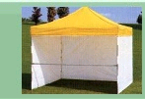
Figure 3: Example of the tent to be used to protect the inner transport box during preparation for shipping outside cleanrooms.

Oxford University – Oxford, UK
Access to the assembly area at Oxford University (‘Heavy Lab’) is from Banbury Road (Figure 4) through the covered yard (Figure 5). The covered yard (4.9m high) is separated by a fence from the access road. The fence has a gate of 4.2m width. The transport containers are to be delivered to and picked up from the right door to the heavy lab in Figure 5.

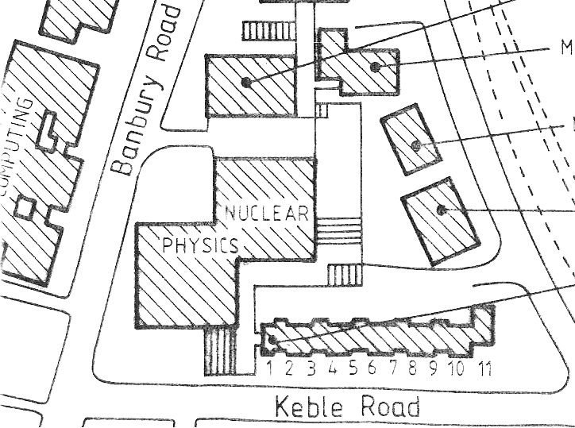
Access to covered yard
7.5m
2m
Crane
Figure 4: Oxford University physics building surroundings. The crane in the engineering building reception area is protruding into the access road by 1m opposite to the entrance to the covered yard of the Nuclear Physics Building.
Delivery Point
Fence
Figure 5: Oxford University. Covered yard and heavy lab access. The arrows indicate access path.

KEK – Japan
The SCT barrel 4 assembly work is planned to be carried out in the 2nd basement of the Fuji Experimental hall (Building 42) at KEK (Figure 6 and Figure 7).
In the 2nd basement, there is a clean booth for the assembly in the SCT work area. A procedure for transferring the B4 into the assembly booth is outlined in the following:
- The B4 encapsulated in the inner and outer container is transported in a lorry from Narita Airport to KEK.
- The lorry enters the loading yard of the Fuji experimental hall through a 5m(W)×6m(H) door. The height of the loading area is 12m. A crane lifts the complete barrel 4 container to unload from the lorry.
- The complete transport container is lifted down into the loading pit of the experimental hall, which is about 16m deep.
- The transport container is set on the loading carrier which shuttles between the pit and the detector hall.
- The transport container is moved into the detector hall using the loading carrier.
- The outer container is unpacked and removed in the detector hall.
- A crane carries the inner container with barrel 4 across the detector hall to the gallery of the 2nd basement which is about 8m below ground level.
- A temporary catwalk is installed for accepting the inner transport container carried by the crane.
- After landing on the catwalk, the inner container is pulled and steered into the SCT room through the reception area.
- The inner container is placed in the clean assembly booth in the SCT room.
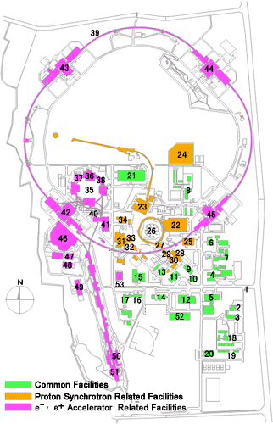
Figure 6: Building 42 at KEK, where the macro assembly of barrel 4 will take place.
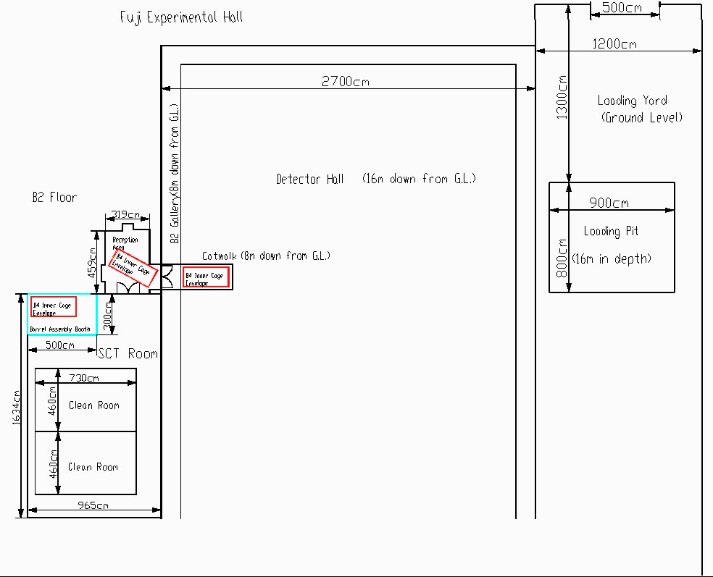
Figure 7: Macro assembly area at KEK with loading area.

CERN – Geneva, Switzerland
Transport containers and parts shall be delivered to the entrance of the clean room inside the SR1 building (Bat. 2175). The point of delivery is shown schematically in Figure 8. The deliverables shall be placed on the platform in front of the entrance. The platform is the grey area shown in the figure at axis 21. Access to this platform is through the folding door shown adjacent to the platform. The folding door opening is 4m wide and 4m high. Figure 8 also gives coarse dimensions inside the SR1 building.
The admissible loads to SR1 floor support structures are shown in Figure 9. The admissible load to the delivery platform is 5000 kg/m² (listed under ‘S2’ in the figure).
Location and access to the SR1 building at LHC Point 1 is shown in Figure 10.
Figure 11 shows recent (10/2/03) photographs of the delivery platform, the entrance to the clean room and SR1 entrance folding door.
Figure 12 shows the path inside the clean room and approximate location for unpacking, visual inspection and acceptance tests. Note that the maximum floor load is 500kg/m2 in the clean room except areas marked where it is 2000kg/m2. The barrel shall be moved along the central moving corridor wherever possible.
The free door opening to the airlock and cleanroom entrance is 298cm×298cm. Note that the door from the platform to the airlock opens to the outside (see Figure 11) and not like drawn on Figure 8 or Figure 12.
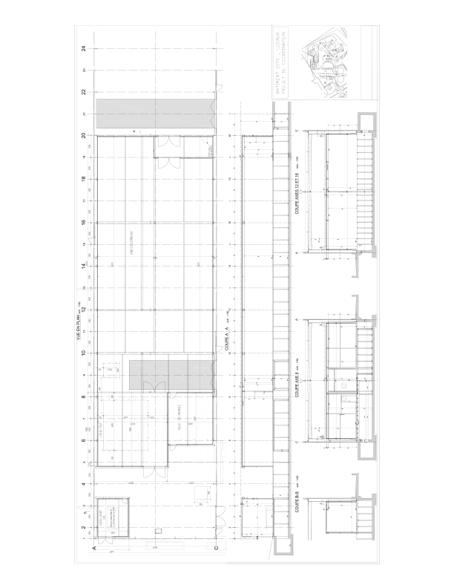
Point for Delivery at SR1
Folding door
Figure 8: Drawing of ID SR1 facility. Note that the door from the platform to the airlock (at line 20) opens to the outside not as shown in the drawing to the inside.
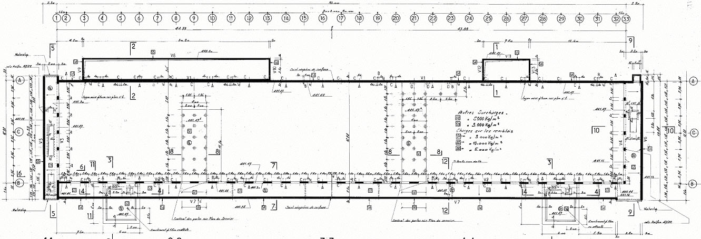
Weight limit
Figure 9: Admissible loads to the floor structure and entrance in SR1. Note that the false floor inside the clean room has been partially modified, which is not shown in this drawing.
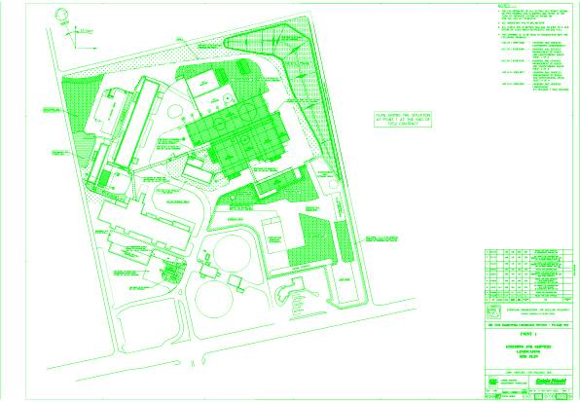
SR1
Figure 10: Location of SR1 at LHC point 1.
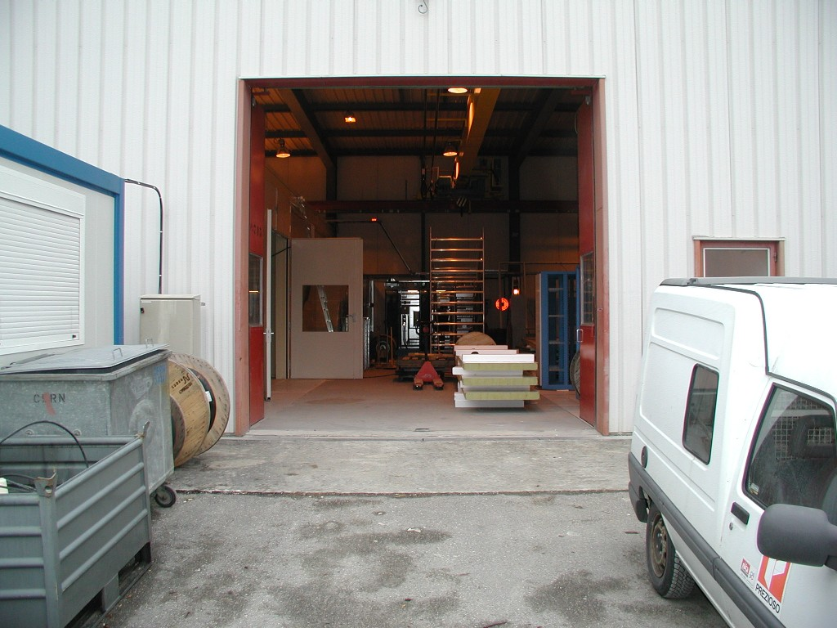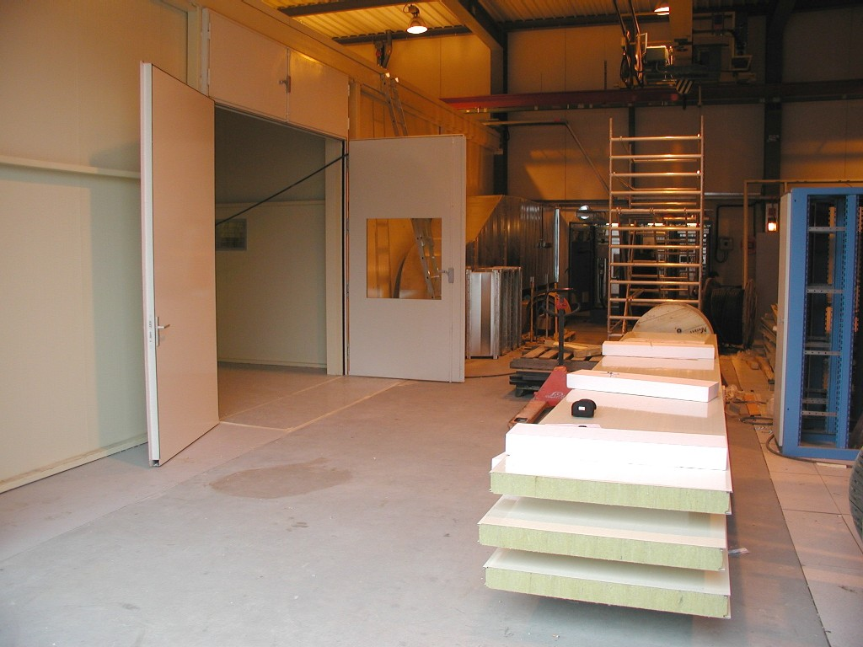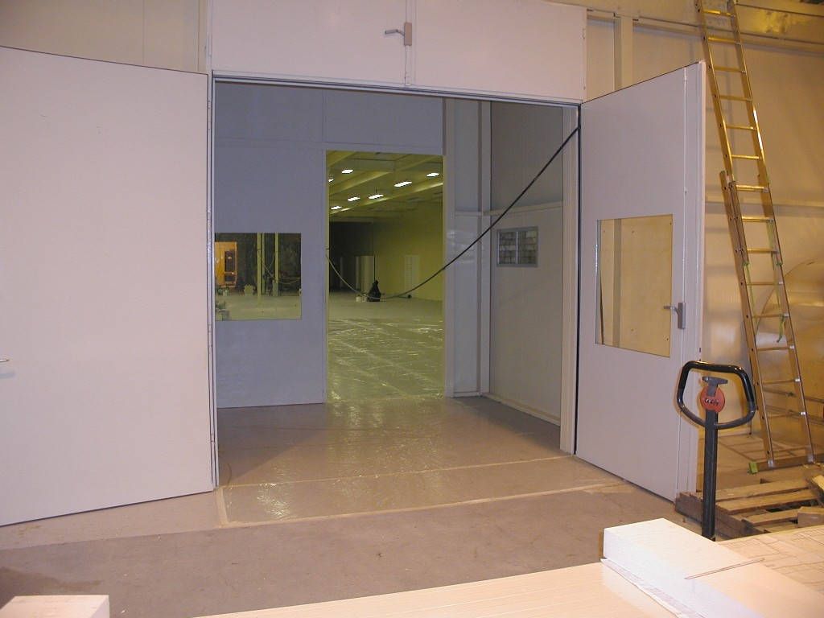
Figure 11: Pictures of (from left to right) entrance doors to SR1, unloading platform and entrance to clean room airlock at LHC point 1.

1. Unpacking of outer container
2. Clean & inspect inner container
Alternative location for visual inspection
3. Visual inspection and acceptance test of barrel
Path of movement
(on reinforced floor where possible)
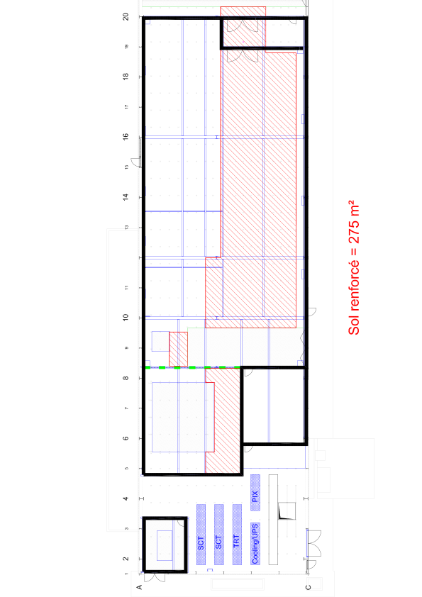
platforms
Figure 12: Movement of SCT barrel in SR1 at LHC point 1 from delivery to acceptance test. Part of the floor (red-hatched) has been modified to allow a load of 2000kg/m² instead of 500kg/m². Note that the door from the platform to the airlock (at line 20) opens to the outside not as shown in the drawing to the inside.

Transport containers

Inner container
Each barrel will have its specific inner transport box. The inner box is constructed from extruded aluminium channels with panels of conductive antistatic plastic (TRESPA). The specifications for the inner boxes can be found in Table 3. Drawings for the inner transport boxes are given in Figure 13. During assembly and testing at the assembly sites and at CERN the inner transport box will be covered by an air filter unit. This will be not present during the transport. Instead the center part of the transport box will be covered by a regular panel. The air filter unit will have to be shipped together with the transport box and the barrel from the macro assembly sites at Oxford and KEK to CERN.
All four inner transport boxes including the air filter unit will be supplied by Oxford University.
Table 3: Weight and Dimensions of inner transport box.
 | Barrel 3 | Barrel 4 | Barrel 5 | Barrel 6
Weight of barrel (incl. service cage, spindle and tooling ring) | 69kg | 77kg | 86kg | 95kg
Weight of transport box (including pedestals and wheels) | 656kg | 699kg | 747kg | 784kg
Total weight | 725kg | 776kg | 833kg | 879kg
Size (H×W×L, in mm³, excluding wheels) | 1645×828×3250 | 1633×984×3250 | 1694×1127×3250 | 1765×1268×3250

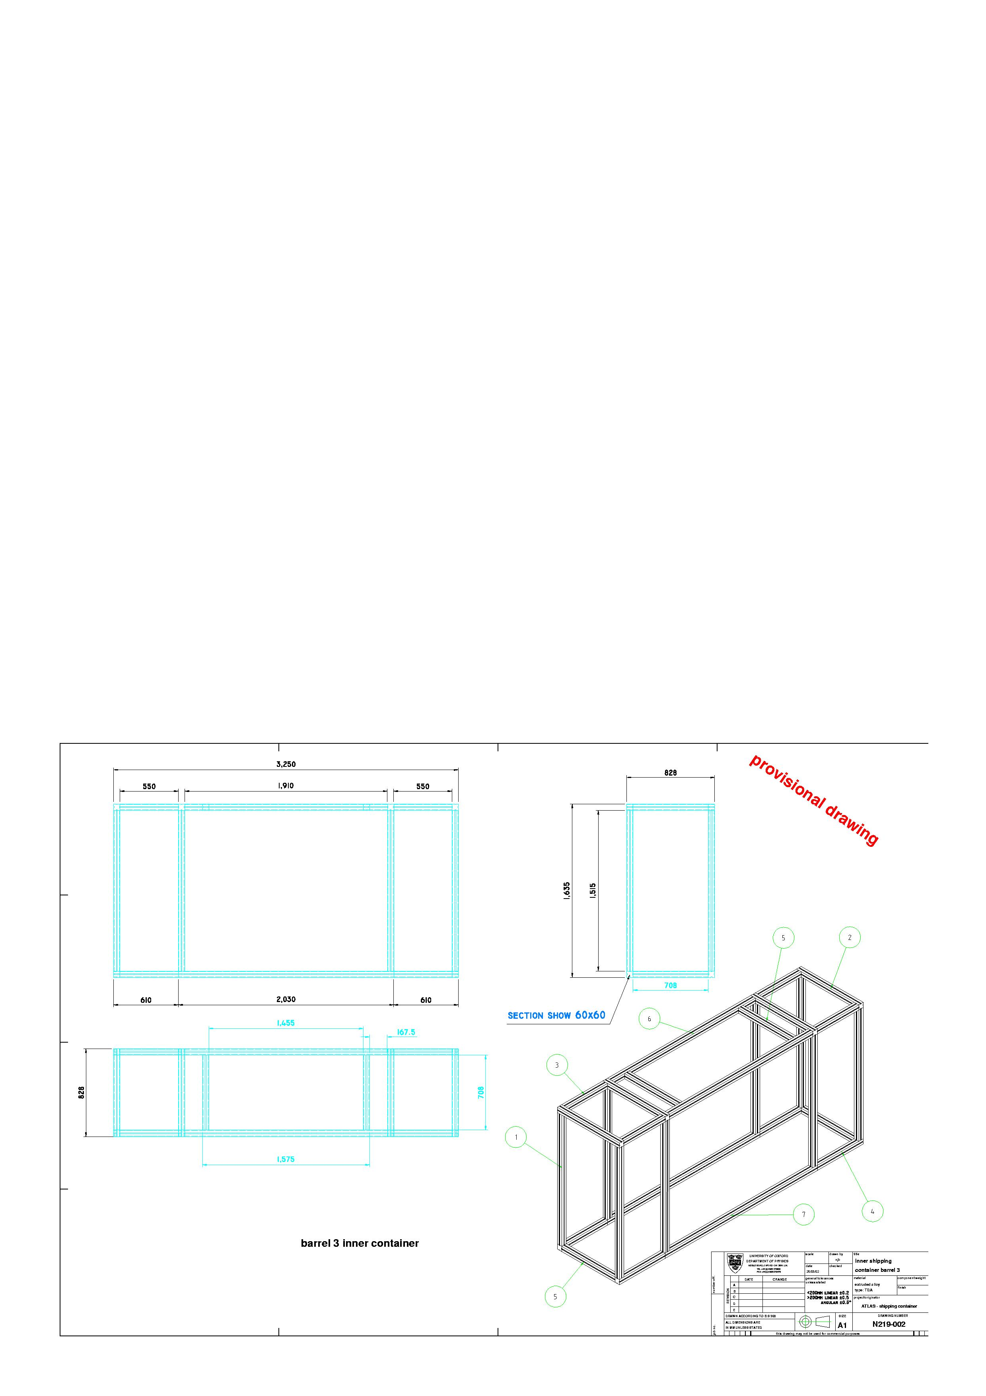
Figure 13: Inner transport box for barrel 3.
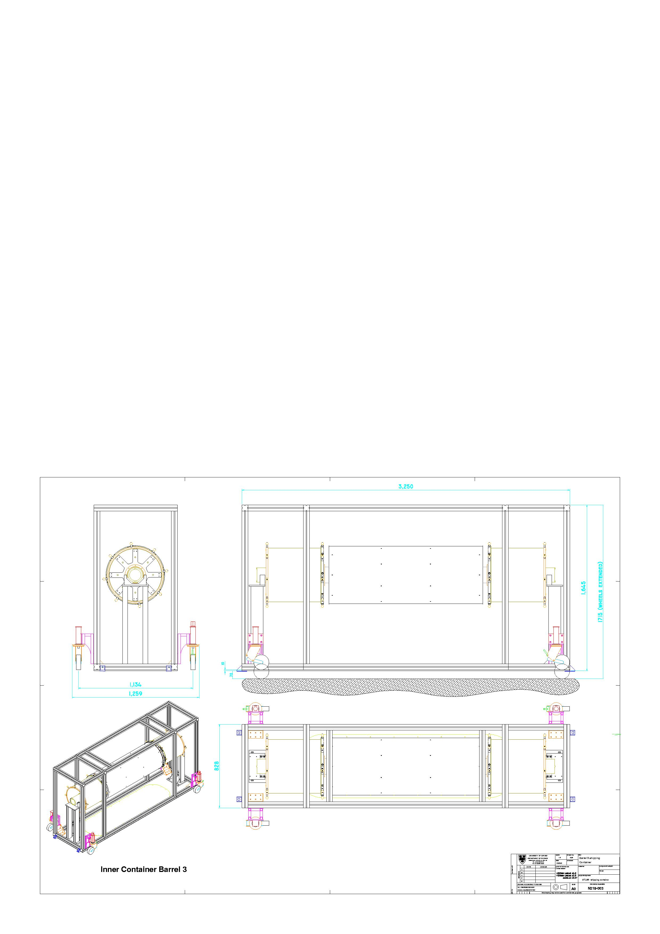
Figure 14: Assembly of barrel 3 inside the inner transport container.

Outer container
The size of the outer transport box is 4000mm(L)×1900mm(W)×2255mm(H). The weight is approximately 900kg.

Mechanical connection between inner and outer container
The inner transport box is connected to the outer box by eight wire rope insulators (Enidine WR20-700-08-BM; www.enidine.co.uk) to reduce mechanical shocks (Figure 15). Calculations of the dynamic behavior of the system (inner box of 700kg) under a periodic force of 25 Hz will yield a resonance frequency of this suspension of 8 Hz with an isolation of 85%. The force on the inner box after a drop from 10cm would be 10.4g, deflecting the springs by 38mm.
Figure 15: Suspension of the inner transport box inside the outer transport box. Note the eight wire rope insulators and the nitrogen cylinder.

Air-tight bagging – Nitrogen supply
The inner transport box will be wrapped with polyethane foil. It will be flushed with nitrogen from a standard high pressure cylinder (80l/300bar), which will allow a flow rate of 5.5l/min for three days. The flow will be controlled by a standard flow meter. No exhaust will be provided but the nitrogen will bleed off through leaks in the polyethane bagging. The gas cylinder will be placed on the floor of the outer transport box at the end of the container (Figure 15). Is the wrapping also needed during transport from RAL to Oxford/KEK?

Additional goods to be delivered with the barrels
Several items, which belong closely to a given barrel, but are not to be transported inside the transport box, have to be shipped together with the transport box. These are listed in Table 4.
Table 4: Additional goods to be delivered with the barrels.
Item | Number of items | Weight | Size
Air filter unit | 1 | 83kg (unit alone)  100kg (incl. crate) | 445mm(H)×870mm(W)×1795mm(L) (unit alone) approx. 0.5m(H)×1m(W)×2m(L) (incl. crate)
Cable support rings | 2 | 25kg (incl. crate) | Approx. 0.5m(H) ×0.5m(W)×1m(L)
Tent | 1 | 45kg (no walls) | 310mm×520mm×1540mm  (collapsed, no walls)

Pick-up/delivery procedures

Interface between assembly sites and shipping company
Each assembly site will name one contact person. This person will be present at pick-up and delivery (or assign a replacement). The contact person will be responsible that the transport boxes are properly prepared for pick-up. The contact person will observe that the pick-up and transport procedures are followed properly (until the transport box is leaving the site) and will generally liaison with the local moving company. A list of the contact persons is given in Table 5.
Table 5: Site contact persons.
Site | Contact person
RAL | Richard Apsimon
Oxford | Georg Viehhauser
KEK | Susumu Terada
CERN | Heinz Pernegger

Handling during pick-up/delivery
To be specified by the shipping company.

Road Transport (RAL – Oxford, Oxford – CERN)
These transports will be performed using a temperature controlled, spring loaded truck.
The channel will be crossed using xxx. Time allowed? What happens if driver rests over night? Customs/Borders?

Air transport (RAL – KEK, KEK – CERN)

