 | ATLAS SCT End-caps
ATLAS Project Document No: | Institute Document No. | Created: 31/05/05 | Page: 1 of 11
ATL-IS-CS-0023 |  | Modified: 12/10/05 | Rev. No. 4

Transportation for the ATLAS SCT End-cap (EC-C)
PROCEDURES

Abstract
This document gives the details of the Transportation of the ATLAS SCT End-cap which is being assembled at Liverpool University (UK) and being transported to CERN (Geneva, Switzerland).

Prepared by:  Stephen Haywood, CLRC,  s.haywood@rl.ac.uk | Checked by:  Phil Allport  Peter Cooke  Richard French  Neil Jackson | Approved by:
Distribution List
Richard Apsimon
Craig Buttar
Janet Carter
Cor Duisters
Didier Ferrere
Tim Jones
Nigel Hessey
Jo Pater
Corijn Snippe
Mike Tyndel
Patrick Werneke

History of Changes
Rev. No. | Date | Pages | Description of changes
1  2  3  4 | 31/5/05  11/6/05  8/6/05  12/10/05 |  | SH: First document.  Additions following observations for transportation of B6.  After Review.  Small mods.

Table of Contents
1 Contractual Arrangements 5
1.1 Contractual Arrangements 5
2 Preliminary Work 5
2.1 Mock-up of the End-cap 5
2.2 Trial Assembly 5
2.3 Preliminary Test-run 5
3 Preparation for Transportation of the End-cap 5
3.1 Arranging Actual Transportation 5
3.2 Checking Weather 6
4 Packing of End-cap into Transport Box 6
4.1 Build Transport Frame around End-cap 6
4.2 Move End-cap into Loading Bay 6
4.3 Seal Transport Box 6
4.4 Movement of End-cap 6
5 Loading of Transport Box at Liverpool 6
5.1 Transport Lorry 6
5.2 Final Test-run 7
5.3 Pick up Transport Box and Place in Lorry 7
5.4 Secure Transport Box in Lorry 7
6 Transportation to CERN 7
6.1 Instructions 7
6.2 Route 7
6.3 Stops 8
6.4 Customs 8
6.5 Early Check 8
7 Unloading of Transport Box at CERN 8
7.1 Removal of Transport Box from Lorry 8
7.2 Move Transport Box into SR Building 8
8 Movement of End-cap into Clean-room 8
8.1 Preparation of Transport Box in Packing Area 8
9 Appendix: Movement of End-cap 9
10 Actions Required 10
10.1 Items to be Obtained 10
10.2 Additional Checks to Undertake 10
10.3 Issues from Review 10

Contractual Arrangements
Undertaken by Stephen Haywood with help from Tom Wegelius.

Contractual Arrangements
When agreed by UK Collaborators, the Technical Specification, accompanied by these Procedures, will be transmitted to Danzas through CERN.
It will be requested that the Insurance is obtained through AXA.
Contractual prices should be established.

Preliminary Work
Supervised by Neil Jackson.

Mock-up of the End-cap
A representation of the End-cap on its Assembly Frame should be constructed.

Trial Assembly
When Liverpool have all the components for the Transport Frame, Inner and Outer Transport Box and Pallet, they should undertake a trial assembly, building up the Transport Box around the Mock-up of the End-cap.
Just before the Box is sealed up, a ShockLog should be attached to the Mock-up of the End-cap

Preliminary Test-run
The intention of the Preliminary Test-run is:
- Confirm the assembly of the Transport Frame and Boxes.
- Ensure that the Pallet is compatible with the requirements for lifting the End-cap by the Forklift, that the procedures work and there are no unforeseen problems.
- Obtain measurements of the vibrations which might be experienced by the End-cap on an air-sprung lorry and to check any shocks which might be experienced in moving the End-cap in and out of the Lorry.
This stage should be undertaken by Andy Park and his team.
What follows is a brief version of what is required; more details are provided in the subsequent sections.
Danzas should be notified well in advance of the desired date for the Preliminary Test-run.
The Transport Box should be carried from the Loading Bay into the Lorry by the Forklift.
The Lorry should be air-sprung, but need not be air-conditioned.
The Wheels of the Transport Box (attached to the Pallet) should be raised, allowing the complete Box to rest on the floor of the Lorry.
The Transport Box should be secured.
The Lorry should drive around for at least an hour before turning to the Physics Department.
The Transport Box should be removed from the Lorry and returned to the Loading Bay.
The ShockLog data should be analysed immediately to ensure that it is useful.

Preparation for Transportation of the End-cap
Undertaken by Janet Carter in collaboration with Neil Jackson.

Arranging Actual Transportation
As soon as possible, Danzas will be notified through CERN of the required Transportation date; at least 2 weeks notice should be given.
The value of the End-cap (with or without on-Cylinder Services) should be clarified.

Checking Weather
The weather should be checked before the Transportation is undertaken, and if there are serious concerns, the Transportation should be postponed.

Packing of End-cap into Transport Box
Supervised by Neil Jackson.

Build Transport Frame around End-cap
Racks containing the electronics for testing the End-cap need to be moved out of the way. The CMM may also need to be moved – see Appendix.
In the Clean-room, the Transport Frame will be built around the End-cap which is held on the Assembly Frame.
The floor of the Assembly Frame will be removed.
The Inner Transport Box will be added, and attached to the Transport Frame.
The Services and Thermal Plug will be covered with ESD-safe film to keep them clean when the End-cap is moved into the Loading Bay. This action may require a light frame to ensure that the film does not stress the Services.
The struts of the Box should be connected electrically with short wires which bite into the aluminium. Alternatively, special bolts which ensure electrical connections should be used.
A Shock-log should be attached to the Assembly Frame.
The End-cap on its Transport Frame will be wheeled over the lifting “Pallet”.
The wheels on the Transport Frame will be removed and attached to the Pallet.
The Outer Transport Box will be assembled around the Inner Transport Box and mounted on the Pallet.
Before the Box is sealed, Silica Gel desiccant should be added.
It may be helpful to mark the longitudinal location of the CoM on the box – this is expected to be close to the Services end.
A Shock-log should be attached to the Outer Transport Box.
As much as possible, the Box should be covered in dissipative Cling-film – may not be needed, depending on outer panels.

Move End-cap into Loading Bay
The Transport Box will be wheeled from the Assembly Clean-room to the Packing Room and then the Loading Bay.

Seal Transport Box
If it is raining, the Box should be loosely covered in Cling-film which can be disposed of after loading.

Movement of End-cap
See Appendix.

Loading of Transport Box at Liverpool
From this point, responsibility is transferred to Danzas and their representatives (Andy Park).
We would like to use the same Forklift operator at Liverpool as used in Oxford.
The loading should be observed by both Liverpool and CERN responsibles.
Plenty of photos should be taken of the End-cap, Transport Box and Lorry as a witness in case of damage.

Transport Lorry
The internal dimensions of the Corrado Lorry supplied by Danzas will be 13.46 m (L) × 2.48 m (W) × 2.85 m (H).
Ensure car-park is cleared.
The Lorry should be positioned with its rear close to the Loading Bay.
The Forklift should already be in the Loading Bay.

Final Test-run
Before the End-cap is loaded (ideally preceding afternoon), a Test-run consisting of ~1 hour drive around Liverpool should be undertaken with a ShockLog. The results recorded by the ShockLog should be looked at immediately.

Pick up Transport Box and Place in Lorry
The Forklift should pick up the Transport Box by inserting it forks into the Pallet. The same Forks as used by the Barrel of length 213 cm will be adequate.
Chocks should not be necessary to fill the pockets, since the CoM should be close to the near end of the Box. Nevertheless, chocks could be used to increase safety. If there is any concern that the CoM is close to the end of the forks, extra ballast could be inserted in the Pallet.
The Forklift will carry the Transport Box through the Loading Bay into the Car-park.
The Transport Box should be presented horizontally to the Lorry, due to the small amount of vertical clearance.
The Forklift will place the Transport Box in the entrance of the Lorry.
If it is raining and the Box is covered with a sacrificial layer of film, this should be removed and the Box and insides of the Lorry dried.

Secure Transport Box in Lorry
Ideally, access to front of Transport Box should be by a front door in the Lorry. If there is no door, the Transport Box must be placed to one side, so that there is sufficient room for a person to get down the side. The Lorry is expected to be 2.48 m wide; the Transport Box is 2.16 m wide, of which 5 cm is taken by wheels protruding. This means there will be 37 cm clearance at most for someone to gain access to the front of the Transport Box. 30 cm is sufficient for a thin person (e.g. SJH).
The Transport Box should be wheeled towards the front of the Lorry where it will benefit from the Lorry’s suspension.
The Wheels of the Transport Box (attached to the Pallet) should be raised, allowing the Box to rest on the floor of the Lorry.
If it proves impossible to access the wheels at the front of the Box, the wheels must be raised before the Box is inserted into the Lorry and the Box must be placed as far inside the Lorry as the Forklift can reach.
The Transport Box should be secured longitudinally in the Lorry using the load-lock bars which fit into the side rails embedded in the walls of the Lorry.
Straps around the load-lock bars should further support the Transport Box.

Transportation to CERN
The Lorry could be accompanied by an ATLAS person, although this is probably a logistical complication.

Instructions
The driver should be given a Cover Letter (English & French) from Mike Tyndel, with instructions for Customs to ring Neil Jackson (or someone similar) in the event of problems. Neil will need a mobile switched on during the journey. Some relevant photos may be useful.
The driver should also be given instructions in French explaining our expectations (copy Barrel).

Route
Motorway from Liverpool to Folkestone.
Folkestone to Calais by Channel Tunnel.
Motorway from Calais to CERN (French side).

Stops
At no time should the End-cap be unaccompanied (except for toilet breaks).

Customs
See Section 6.1, for Cover Letters. The driver will need the appropriate documents from CERN Transportation.
The End-cap should enter France during a weekday.
The End-cap should be taken to Bat 904 in CERN/Prevessin (France) for customs clearance. See:
http://service-logistics.web.cern.ch/service-logistics/shipping/formalites%20douanieres.htm

Early Check
For the first part of its journey, the lorry should be followed by a responsible physicist.
30 mins after departure from Liverpool University, the lorry should stop so that the ShockLog can be read out (requires long leads from ShockLog to rear of lorry). If there is a significant concern, the lorry will be instructed to return carefully to Liverpool.

Unloading of Transport Box at CERN
Carried out by Danzas representatives.
The unloading should be observed by the same Liverpool and CERN responsibles who observed the loading.
Plenty of photos should be taken of the End-cap, Transport Box and Lorry as a witness in case of damage.

Removal of Transport Box from Lorry
The wheels on the Transport Box should be lowered and rotated into correct orientation.
The Transport Box should be moved to the end of the Lorry.
If it is raining, the Transport Box should be covered in some sacrificial Cling-film.
The Transport Box should be picked up by the Forklift.

Move Transport Box into SR Building
The Forklift Truck will carry the Transport Box into the entrance of the SR Building.
Before setting the Box down, it should be grounded via a 1 MΩ lead.
The Forklift Truck must not enter the SR Building itself (floor not strong enough), but the Transport Box should be placed just inside.

Movement of End-cap into Clean-room
Supervised by Jo Pater & Didier Ferrere.

Preparation of Transport Box in Packing Area
Any sacrificial Cling-film should be removed from the Transport Box.
The Shock-logs should be recovered and their data examined immediately.
The Outer Transport Box should be removed.
The wheels on the Pallet should be removed and attached to the Transport Frame.
The Transport Box will be rolled longitudinally (on the reinforced concrete base) off the Pallet.
The Transport Box should be wheeled into Clean-room.
The Inner Transport Box should be removed.
The End-cap should be examined for obvious breakage. If significant damage is identified, it should be photographed and Stephen Haywood should be informed immediately.

Appendix: Movement of End-cap
Superseded … now attach both Boxes in Clean Room.
Move End-cap from Clean-room to Loading Bay:
.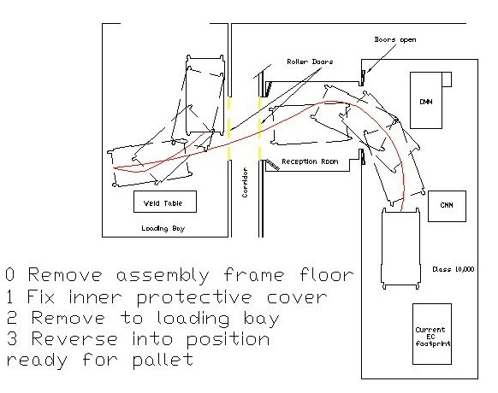

Add Pallet:
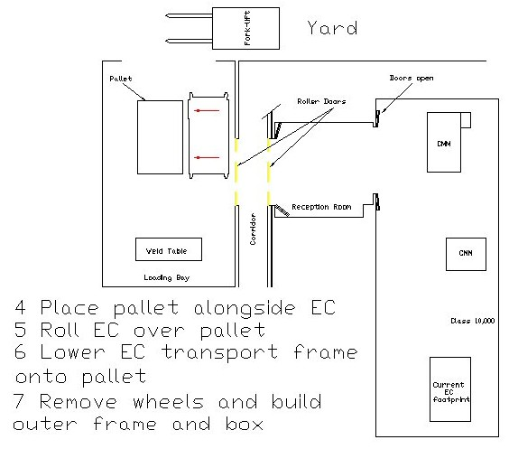

Remove End-cap with Forklift:
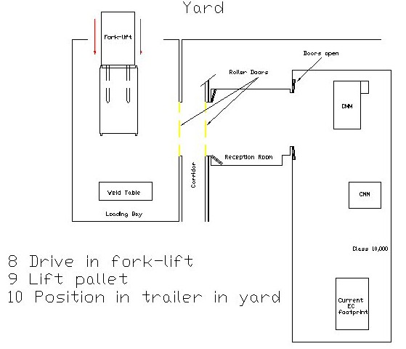

Actions Required

Items to be Obtained
- Pallet & wheel plates (Cooke)
- Chocks (Cooke)
- Inner & Outer Boxes: Bosch profiles & fittings, plywood sides (Cooke)
- Dissipative Cling Film (Cooke)
- Silica Gel (Cooke)
- Grounding “tail” – 1 MΩ (CERN)
- ShockLogs – propose to use those used by Barrel – need long read-out cables, exiting Box (Jackson)
- ShockLog Software can be obtained from Lewis Batchelor (Jackson)
- Tilt-device (Cooke)

Additional Checks to Undertake
- Test ShockLog software.

Issues from Review
- Expert evaluation of FEA – to be arranged by Mike T.
- Customs – get details from Barrel.
- Is a light frame required to support ESD-safe film draped over the End-plug ?
- Ensure can insert Pallet under Transport Frame length-ways (wheels on side of Frame, but end of Pallet). Ensure enough room to rotate wheels inside Lorry.
- ESD safety of End-cap:
Need a Grounding scheme … how is EC connected to ground ? (for Lpool to understand).
How are Asics protected from ESD ?
- Nigel & Peter to determine where additional springs are to go.

